

The Go4 Analysis Framework
Introduction V5.2

J.Adamczewski-Musch, M.Al-Turany, S.Augustin, D.Bertini, H.G.Essel, S.Linev
28 July 2026

Content

The Go4 Analysis Framework Introduction V5.2 1
1 Introduction 7
1.1.1 Go4 tasks with all communications 7
1.1.2 Go4 analysis steps 7
1.1.3 Other analysis functions 9
2 Go4 Analysis 10
2.1 Event base classes 10
2.2 Event classes, interface to MBS 10
2.2.1 A simple event loop 10
2.3 Analysis step classes 11
2.4 Object management 11
2.4.1 Go4 objects 11
2.4.2 Go4 parameters 12
2.4.3 Go4 conditions 12
2.5 Analysis base class TGo4Analysis 14
2.5.1 User subclass of TGo4Analysis 14
2.6 Main analysis program 16
2.6.1 The go4analysis main program 16
2.6.2 Command line mode (batch) 16
2.6.3 Creating the user analysis 17
2.6.4 Default user analysis 17
2.6.5 Analysis controlled by Go4 GUI 17
2.6.6 Analysis as server for multiple Go4 GUIs 18
2.6.7 Configuration of analysis 18
2.6.8 Support of older analysis code 18
2.6.9 Setting up ssh keys 18
2.6.10 Start-up of GUI controlled analysis 20
2.6.11 Submit settings and run analysis 21
2.6.12 Shutdown of the analysis client 21
2.6.13 Disconnect or shutdown analysis server 21
3 Analysis Examples 22
3.1 Analysis design 22
3.1.1 Simple 22
3.1.2 One step 22
3.1.3 Two step 22
3.2 Using the examples at GSI 22
3.3 Prepare the packages 23
3.4 Simple example with one step 24
3.4.1 Event processor 24
3.4.2 Parameters 24
3.4.3 Auto-save file mechanism 24
3.4.4 Example log file 24
3.4.5 Adapting the example 25
3.5 Example with one step 26
3.5.1 Analysis class 26
3.5.2 Analysis step 26
3.5.3 Parameters 26
3.5.4 Auto-save file mechanism 26
3.5.5 Example log file 26
3.5.6 Adapting the example 27
3.6 Example with two steps 28
3.6.1 Setup in setup.C 28
3.6.2 Step one: unpack 28
3.6.3 Steering methods in processor function BuildEvent 29
3.6.4 Step two: analysis 29
3.6.5 Parameters 29
3.6.6 Conditions 29
3.7 Example with some advanced tecniques 30
3.7.1 Step one: unpack 30
3.7.2 Step two: analysis 30
3.7.3 Parameters 30
3.7.4 Conditions 31
3.8 Example of analysis with a user defined event source 32
3.9 Example of analysis mesh 32
3.9.1 Structure 32
3.9.2 Execution steps 33
3.9.3 Provider steps 33
3.9.4 Configuration 33
3.9.5 Usage of the example 34
3.10 Examples of embedded stream analysis 34
4 How to Use the Go4 GUI 35
4.1 GUI menus 36
4.1.1 File, Tools, Analysis menus 36
4.1.2 Help menu 37
4.1.3 Settings menu 37
4.1.4 Windows menu 39
4.2 Load libraries to GUI 39
4.3 Launch analysis 40
4.3.1 Launch analysis task in client mode 40
4.3.2 Launch analysis task in server mode 41
4.3.3 Connect to existing Go4 analysis server 41
4.3.4 Launch analysis task as HTTP server 42
4.3.5 Connect to existing Go4 HTTP server 42
4.4 Analysis configuration 44
4.4.1 Configuration window 44
4.4.2 Multiple input files 45
4.4.3 User defined event sources 45
4.4.4 Auto-save file mechanism 45
4.5 Analysis control 47
4.5.1 Analysis terminal window 47
4.5.2 Macro execution in the analysis 47
4.5.3 Python macros in the analysis 48
4.5.4 User defined macro command buttons 48
4.6 MBS status monitor 49
4.7 The Go4 browser 50
4.7.1 Browser columns 50
4.7.2 General functionality 51
4.7.3 Analysis folder controls 51
4.7.4 The monitoring mode 52
4.7.5 The workspace folder 52
4.7.6 Browsing files 52
4.7.7 Resetting and deleting objects 52
4.7.8 ROOT web server connection 53
4.7.9 DABC server connection 54
4.7.10 Histogram server connection 55
4.8 The Go4 tree viewer 56
4.8.1 Local mode 56
4.8.2 Remote mode (dynamic list histogram) 56
4.8.3 Creating a new histogram 56
4.9 The Go4 view-panel 57
4.9.1 File menu 58
4.9.2 Edit menu 58
4.9.3 Select menu 58
4.9.4 Options menu 58
4.9.5 Zoom toolbox 59
4.9.6 Draw options and axis scaling 60
4.9.7 Color Palette tool 62
4.9.8 Channel and window markers 63
4.10 Conditions 65
4.10.1 Conditions editing in viewpanel marker editor 65
4.10.2 Full condition editor 66
4.10.3 Editor tabs 67
4.10.4 Conditions bound to pictures 69
4.10.5 Creating conditions 69
4.11 Pictures 70
4.12 Fit GUI 72
4.13 Parameters 74
4.13.1 Parameter objects 74
4.13.2 Parameter editor 74
4.13.3 Parameters containing fitters 75
4.14 Dynamic lists 76
4.14.1 Dynamic list editor 76
4.14.2 Entry for tree draw 77
4.14.3 Entry for event loop 77
4.15 Histogram/condition information 79
4.16 Event information 79
4.17 Hot start 80
4.18 User GUI 80
4.18.1 Qt3, Qt4 and Qt5 80
4.19 Macro execution in GUI 81
5 Analysis Server for ROOT macros 82
5.1 Methods for object registration 82
5.2 Methods for run control and execution 82
5.3 Examples: 83
6 Control of remote Go4 analysis from a ROOT session 84
6.1 Initialization 85
6.2 Connecting the analysis 85
6.3 Controlling the analysis by command 85
6.4 TBrowser extensions 86
7 Go4 analysis with http web server 87
7.1 Startup of go4analysis with webserver 87
7.2 The Go4 web browser GUI 88
7.2.1 The object hierarchy view 88
7.2.2 The display frame 89
7.2.3 The web browser analysis configuration web editor 90
7.2.4 Displaying and editing conditions 90
7.2.5 The web browser parameter editor 91
7.2.6 The web browser analysis terminal 92
8 The Go4 Composite Event Classes 93
8.1 Introduction 93
8.2 Application Programmers Interface 94
8.3 Example 95
9 Icon Table 98
10 Table of Menu and Toolbar Keyboard Shortcuts 100
11 Event Classes Diagrams 104
12 Release Notes 106
12.1 New features in Go4 v5.2 (January 17) 106
12.2 New features in Go4 v5.1 (March 16) 107
12.3 New features in Go4 v5.0 (June 15) 108
12.4 New features in Go4 v4.6 (November 13) 109
12.5 New features in Go4 v4.5 (July 11) 111
12.6 New features in Go4 v4.4 (November 09) 111
12.7 New features in Go4 v4.3 (June 09) 113
12.8 New features in Go4 v4.2 (April 09) 113
12.9 New features in Go4 v4.1 (October 08) 114
12.10 New features in Go4 v4.0 (February 08) 114
12.11 New features in Go4 v3.3 (May 07) 115
12.12 New features in Go4 v3.2 (July 06) 116
12.13 New features in Go4 v3.1 (May 06) 116
12.14 New features in Go4 v3.0 (November 05) 117
12.15 New features in Go4 v2.10 (June 05) 118
12.16 New features in Go4 v2.9 (February 05) 118
12.17 New features in Go4 v2.8 (September 04) 119
12.18 New features in Go4 v2.7 (June 04) 120
12.19 New features in Go4 v2.6 (May 04) 120
12.20 New features in Go4 v2.5 (December 03) 121
12.21 New features in Go4 v2.4 (August 03) 122
12.22 New features in Go4 v2.3 (May 03) 123
12.23 New features in Go4 v2.2 (April 03) 123
13 Editorial 124
14 Index 125

Introduction
The Go4 (GSI Object Oriented On-line-Offline) Analysis Framework has been developed at GSI. It is based on the ROOT system of CERN. Therefore all functionality of ROOT can be used.

Go4 tasks with all communications
Go4 has two parts: the analysis framework itself and a Qt based GUI. Both can be used independently, or together. The separation of the analysis and GUI in two tasks is especially useful for on-line monitoring. The analysis runs asynchronously to the GUI which is (almost) never blocked. The same analysis can be run in batch/interactive mode or in remote GUI controlled mode. The GUI can be used stand alone as ROOT file browser and as histogram viewer for GSI standard histogram servers like MBS. Moreover, the analysis task can be run either as a client bound to one GUI (default), or can be started as an analysis server with the possibility to connect several GUIs (one controller and arbitrary number of observers with restricted commands).

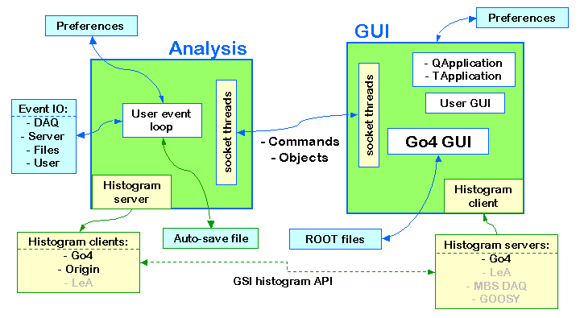
gui150

Go4 analysis steps
The Go4 framework handles event structures, event processing, and event IO. The analysis event loop is organized in steps: Each step has an input event, an output event, and an event processor. The output event calls the event processor to be filled. The event processor has also access to the input event. In the current design the analysis is data driven. A first event object (input1) is filled from some event source (input). An output event object (output1) is filled by an event processor object (process1) which has access to both, input1 and output1. Optionally the output event may be written to a file (file1). In the next step the input event object (input2) can be either the output event object (output1) from the previous step or retrieved from the file. The second output event object (output2) is filled by the second event processor object (process2) and can be optionally written to a second file.
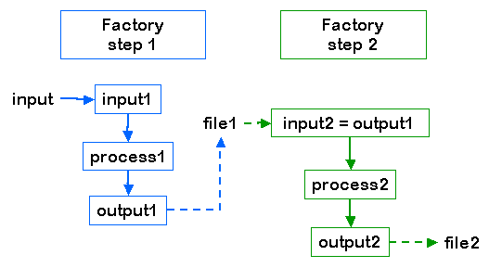
gui147
The information needed to create the event and processor objects (which are deleted when the event loop terminates) is stored in step factories which are kept in the analysis.
The processor and output event classes have to be provided by the user. The input classes for standard GSI event sources are provided by Go4 (see chapter 2, page 10). Analysis and step factory classes are provided by Go4 or can be implemented by the user as subclasses.
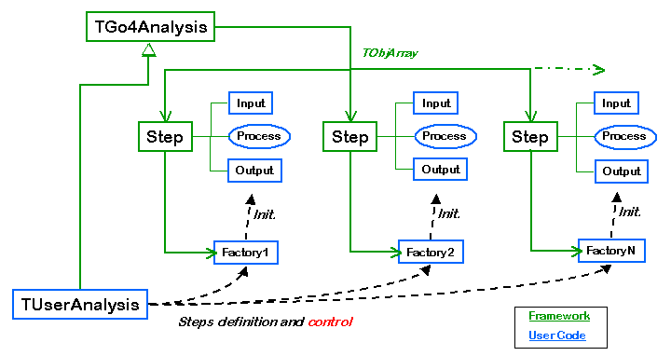
gui148

For normal operation, the Go4 analysis steps are designed to run subsequently. But in addition, each analysis step has access to the output events of all other previous analysis steps, so it would be possible to let analysis steps logically run “in parallel”, all starting with the output event of the first step, and all delivering their results to the last step that may collect and combine them.

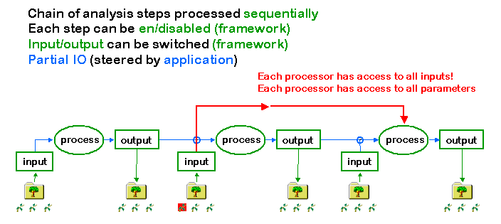
gui149

Other analysis functions
Outside the analysis steps the user functions UserPreLoop(), UserPostLoop(), and UserEventFunc() located in the user analysis class are executed as shown in the figure. In principle, they could be used to implement the full analysis without using the step mechanism. But for setting up a new analysis the use of steps is strongly recommended, because steps can be controlled by the GUI and offer event and IO management.
In the event loop, after processing the steps and UserEventFunc() the Go4 dynamic list processor is executed. This processor can be dynamically configured from the GUI to check conditions and/or fill histograms.

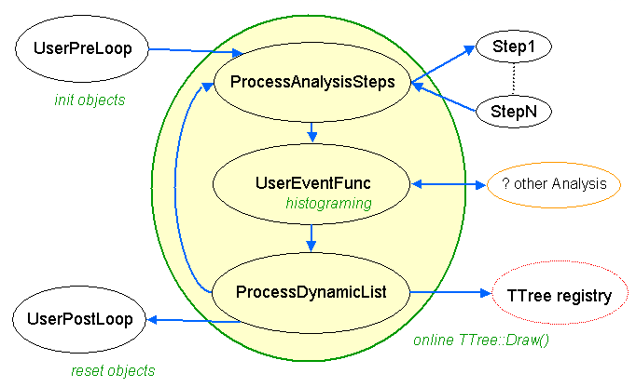
gui146

Go4 Analysis
The Go4 concept consists of base classes (interfaces) for event structures, algorithms, and IO, which can be implemented by user subclasses or by framework plug-ins (general service classes) delivered with Go4. Class descriptions and reference guides are available on the Go4 Website http://go4.gsi.de.

Event base classes
The interface classes provided by Go4 (a detailed description is in the reference manual) are normally not seen by the user. Starting with the examples (see chapter 3, page 22) one can better study derived working classes.
TGo4EventElement: Defines the event structure and methods to clear this structure. Input and output event structures of each step of the analysis are instantiated once at initialization. In the event loop event first cleared (via Clear() method call) and than filled by the source class, where BuildEvent function is defined.
TGo4EventSource: The source of the event data. This can be e.g. a file of a certain format, or a socket connection to an event server. The event source class has a BuildEvent(TGo4EventElement*) method, which fills event structures. In addition, CheckEventClass(TClass*) method can be implemented to check event class during initialization. The class constructor should open (connect) the source; the destructor should close (disconnect) it properly.
TGo4EventStore: An object responsible for storing the event data. This can be e.g. a local file of a certain format, but may as well be a connection to some storage device. The virtual method Store(TGo4EventElement*) is used to store the pointed event object. The class constructor should open the storage; the destructor should close it properly.
TGo4EventProcessor: An object that contains the algorithm to convert an input event object into an output event object (both of class TGo4EventElement). This is a subclass of TGo4EventSource, since it delivers the filling of the output event from the input event. The event processor implementation has to “know” the input and output event classes. Actual code of converting the data (i.e. actually performing the analysis) should be implemented in BuildEvent method.
TGo4EventFactory: Defines the actual implementations of all the above. Go4 uses a factory design pattern to create all event class objects at initialization. The virtual methods:
CreateInputEvent(), CreateOutputEvent(), CreateEventSource(TGo4EventSourceParameter*), CreateEventStore(TGo4EventStoreParameter*), CreateEventProcessor(TGo4EventProcessorParameter*) have to be defined in the user factory. They create the respective objects and return the pointer to it. The default factory provides methods
DefEventSource(classname), DefEventProcessor(objectname, classname), DefInputEvent(objectname, classname) and DefOutputEvent(objectname,classname).
Simple examples of a running Go4 analysis can be found on directories $GO4SYS/Go4ExampleSimple, $GO4SYS/Go4Example1Step, and $GO4SYS/Go4Example2Step.

Event classes, interface to MBS
Go4 offers predefined implementations of the event base classes, including an interface to the GSI data acquisition Multi Branch System MBS, the GSI list-mode files, and ROOT files.

TGo4EventElement (base class):
TGo4MbsEvent MBS event format 10-1
TGo4MbsSubEvent MBS subevent format 10-1
TGo4CompositeEvent Base class for all composite event structures
TGo4ClonesElement Clonesarray container for composite event
TGo4EventSource (base class):
TGo4MbsFile (read from *.lmd list-mode file with format 10,1)
TGo4MbsEventServer (connect to MBS event server)
TGo4MbsStream (connect to MBS stream server)
TGo4MbsTransport (connect to MBS transport server)
TGo4RevServ (connect to remote event server)
TGo4FileSource (read from *.root file from Go4 tree, i.e. one file containing one TTree per analysis step)
TGo4EventStore (base class):
TGo4FileStore (write to *.root file with Go4 tree, this file can be used as TGo4FileSource later)
TGo4BackStore Use TTree existing only in memory to view and analyze event structures.
These classes can be used directly to write simple analysis.

A simple event loop
Using these implementations, getting MBS event data into ROOT (without Go4 framework) could look like this:

#include "Go4EventServer/Go4EventServer.h"
#include "Go4Event/TGo4EventEndException.h"
int main() {
TGo4EventSource* input = new TGo4MbsFile("file.lmd"); // MBS list-mode file
// TGo4EventSource* input= new TGo4MbsTransport("node"); // MBS transport server
// TGo4EventSource* input= new TGo4MbsStream("node"); // MBS stream server
// TGo4EventSource* input= new TGo4MbsEventServer("node"); // MBS event server
// TGo4EventSource* input= new TGo4RevServ("node"); // Remote event server
TGo4EventStore* output = new TGo4FileStore("output",1,5); // split level, compression
TGo4MbsEvent* event = new TGo4MbsEvent();
event->SetEventSource(input);
event->Init();
Int_t eof = 0, numEvents = 0;
while(eof==0) {
try{
event->Fill(); // read event
numEvents++; // eof throws exception
output->Store(event); // write to file
}
catch(TGo4EventEndException& ex) { eof=1; } // mark end of file
catch(...) { cout << "Error" << endl; eof=2; } // any other error
}
cout << "EOF after " << numEvents << " events" << endl;
}
The events in the ROOT file can be retrieved by program, but not in tree viewers. For the use of tree viewers, a new output event object should be filled and stored.

Analysis step classes
As mentioned above a Go4 analysis is organized in steps. The information needed to instantiate a step is kept in the step factory.
TGo4EventServerFactory (base class): (contains factory methods that already know the above implementations. User step factories must inherit from this class!)
TGo4StepFactory This TGo4EventServerFactory can be used in most cases as user factory to set up the analysis steps (example 1Step).
TGo4AnalysisStep objects of this class hold the definition of an analysis step.

Each analysis step has at least an input event object, an output event object and an event processor object. Additionally, it can have an event source (e.g. TGo4FileSource) and an event store (TGo4FileStore) instance. An analysis step is set up by a TGo4EventServerFactory subclass, i.e. TGo4StepFactory or a user defined subclass.

Object management

Go4 objects
Objects used in Go4 are organized in ROOT folders. The folder structure is sent to the GUI. Objects must be registered in the analysis to be seen in the GUI browser. Registered objects can be located in the processors. The top folders as seen in the GUI are shown on the left side. The methods to register/locate objects are (pointer to the appropriate object, optional subfolder as string, name including subfolder as string):
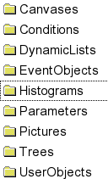

gui151
- AddHistogram(pointer,subfolder), GetHistogram(name)
- AddAnalysisCondition(pointer,subfolder), GetAnalysisCondition(name)
- AddParameter(pointer,subfolder), GetParameter(name)
- AddPicture(pointer,subfolder), GetPicture(name)
- AddObject(pointer,subfolder, ), GetObject(name)
These methods are available in TGo4Analysis and TGo4EventProcessor subclasses. Objects created in a TGo4Analysis subclass can be located in all event processors. Objects created in event processors can be located in all subsequent event processors (steps).
Registered objects are stored/ retrieved to/from the auto-save file, if enabled. Retrieval is done after creation of the analysis singleton before the creation of the steps. When an object retrieved from the auto-save file is created in a processor the retrieved object is replaced (stored data lost). When an object is created in the analysis singleton it will be replaced by the one retrieved from the auto-save file except histograms which are not retrieved in this case. This means that histograms created in the analysis singleton are always empty after startup.
Since retrieved auto-save file objects will be replaced by a second registration of the same object with the “Add...” methods described above, this can be problematic when analysis is configured several times interactively from the GUI: saved contents may be lost, or user defined object references (pointers) may even get invalid. To avoid such problems there are several additional registration methods that are highly recommended:
- MakeTH1(...) - for 1d histogram
- MakeTH2(...) - for 2d histogram
- MakeWinCond(...) - for window conditions (1d and 2d depending on parameters)
- MakePolyCond(...) - for polygon condition
- MakeEllipseCond(...) - for shaped polygon with ellipse parameters
- MakeCircleCond(...) - for shaped polygon with circle parameters
- MakeBoxCond(...) - for shaped polygon with rectangular box parameters
- MakeFreeShapeCond(...) - for shaped polygon with free shape
- MakeParameter(...) - for parameter objects
These functions will either create the object with the given specifications if it does not exist, or will retrieve the object of that name if existing in the Go4 object management (from auto save file if enabled, or from local analysis memory). The pointer to the object is returned as handle to the user. Note that the function parameters except for the name will have no effect if an existing object is retrieved. To replace the existing object by another one with new parameters anyway, method SetMakeWithAutosave(kFALSE) can be called in advance of these registration methods.

Go4 parameters
Parameters used in the analysis are implemented by the user in classes derived from TGo4Parameter. Such objects are registered to the framework and can be edited by a generic parameter editor (see chapter 4.13.2, page 74). Parameter objects can be created in the user analysis or the event processor class. Parameter objects are loaded from an optional auto-save file after instantiation of the analysis and before instantiation of the processor objects. When created in the analysis the values set in the constructor are therefore overwritten by auto-save. To use the GUI editor, the UpdateFrom() method must be implemented to update the local (active) parameter object from the modified one delivered by the editor. In this method it is up to the user to ignore certain members or to execute whatever he wants. E.g. one could use parameters to execute commands. Parameters in the auto-save file can be edited. In the editor they can be saved/retrieved to/from files. Several mechanisms can be implemented to handle the parameter member values. The main question is how restricted the methods of modification should be.
- Modify values only in the class constructor, then recompile. To prohibit changes by editor, the UpdateFrom() method could be just a no-op to avoid undocumented changes. The parameter object should be created and registered in the processor constructor (after possible auto-save restore). Pro: the parameter values are always strictly defined as coded. Con: the parameter values cannot be changed easily.
- Modify values by editor, use auto-save to store. Create parameter object in analysis constructor. Auto-save must be enabled. Pro: parameter can modified by editor (UpdateFrom() method must be implemented) and changes will be restored from auto-save. Con: when the auto-save file must be deleted for some reasons. the latest values are lost.
- Use a macro to set values. This macro must be executed in the processor constructor (after auto-save restore). UpdateFrom() could just execute the macro to avoid undocumented changes. Pro: values are kept in a text file and can be modified without recompile. Con: parameter cannot be changed by GUI editor.
- Best combination: one can use macro saveparam.C([file],wildcard,prefix) from $GO4SYS/macros creating macros (one per parameter) to set all parameters to their current values,. The names are built from prefix and parameter name. The macro can be executed in CINT (then the parameters are taken from a file), or in the GUI or in the analysis. The parameter is created in the analysis. Values are set from macro in processor constructor. By this method parameter values can be edited by GUI, or macro can be edited. Last version will be used independently of auto-save.
Example:
root[0].x saveparam.C("myfile.root","*","setpar")
would produce macros setpar_par1.C, setpar_par2.C etc. The macros have no arguments,
e.g. setpar_par1().
The registration method MakeParameter(fullname, classname, macroname) allows to take into account a parameter set up macro of name macroname even at initialization. By specifiying the class name classname, Go4 can create any user defined parameter class on the fly and will put it at location fullname in the Parameters folder, e.g. fPar=MakeParameter(“gamma/calipars”,”TMyCalibrationPar”,”set_TMyCalibrationPar.C”)

Go4 conditions
Conditions are objects holding window limits or polygons. One or two values can be checked against the limits or the polygon, respectively. In addition the conditions have test and true counters. They can be set to return always true or false or return the inverted test result. They can be edited by the GUI (see chapter 4.10.2, page 66). They can be used to steer the analysis flow. They are saved/retrieved to/from the auto-save file, if enabled. They can be edited in the auto-save file. In the editor they can be saved/retrieved to/from files. If a mechanism like for the parameters (4) is wanted, one can use macro savecond.C([file],wildcard,prefix) from $GO4SYS/macros creating macros (one per condition) to set all conditions to their current values,. The names are built from prefix and condition name. The macro can be executed in CINT (then the conditions are taken from a file), or in the GUI or in the analysis.
Example:
root[0].x savecond.C("myfile.root","*","setcon")
would produce macros setcon_cond1.C, setcon_cond2.C etc. The macros have three arguments: restore flags, restore counters, reset counters (0=no, 1=yes), e.g. setcon_cond1(1,0,1).
There are different object registration methods for the different kinds of supported conditions, such as MakeWiuCond(), MakePolyCond(), MakeCircleCond(), MakeEllipseCond(), MakeBoxCond(), MakeFreeShapeCond() . They define the condition boundaries either directly (class TGo4WindowCond, class TGo4PolyCond), or allow to parametrize a standard shape that defines the limits of a 2-dimensional polygon (class TGo4ShapedCond). The shaped conditions may change their parametrization form (circle, ellipse, rectangular) at runtime and may be even converted into a free polygon shape. This provides a flexible adjustment for the region of interest in various histogram maps, as supported by the GUI condition editor (see chapter 4.10.3 on page 67).

Analysis base class TGo4Analysis
Once the user has defined his/her event class implementations, the analysis steps can be created and registered to the Go4 analysis framework. The actual framework consists of the TGo4Analysis class, which is a singleton (i.e. there is only one framework object in each process). This class provides all methods the user needs, it keeps and organizes the objects (histograms,...), it initializes and saves the data objects.
The user analysis is set up in a subclass of TGo4Analysis, i.e. TUserAnalysis. Constructor and destructor of this user class, in addition with the overridden virtual methods UserEventFunc(), UserPreLoop(), and UserPostLoop() specify the user analysis. If these functions are not needed, one can also use the TGo4Analysis class directly, as shown in the example Simple.
All analysis steps must be created with initial event parameters (input and output filenames) and auto-save settings. Additionally, some user objects may be created and registered here. Note that histograms created and registered here are saved to but not updated from the Go4 auto-save file. Persistent histograms of the analysis should be created in the UserPreLoop function. Existing conditions and parameters, however, are updated when the auto-save file is loaded. In the constructor of the TUserAnalysis class the analysis step objects are created, each containing instances of its user step factory. The analysis steps are registered at the TGo4Analysis framework, input and output events of subsequent steps are checked for matching. Furthermore, other objects like histograms, conditions or parameters can be created in the constructor and registered, so the framework is responsible for their persistence. Such objects can also be created in the step processors.
In addition to the event processors, the UserEventFunc() allows the user to specify analysis operations that are called once in each analysis cycle, e.g. filling certain histograms from the output events of all analysis steps. The UserEventFunc() makes it even possible to call an external analysis framework event by event without using the Go4 Analysis Steps at all, thus taking advantage of the Go4 object management and remote GUI features.
The UserPreLoop() and UserPostLoop() functions may define actions that are executed before starting, or after stopping the main analysis loop, respectively.
Once the user analysis class is defined, there are two modes of operation: The single-threaded batch mode, and the multi-threaded client mode that connects to the Go4 GUI.

User subclass of TGo4Analysis
Up to Go4 version 4.3 the user subclass of TGo4Analysis has been instantiated in the user main program MainUserAnalysis. In this case the arguments of the constructor could be chosen arbitrarily. With Go4 version v4.4 a standard main program (see next section) can replace the MainUserAnalysis. When using this main program the constructor of a TGo4Analysis derived user class is called with a standard argument list as it is used with main programs. The constructor of a user analysis must therefore be:

TUserAnalysis::TUserAnalysis(int argc, char** argv) : TGo4Analysis(argc, argv)
{
cout << "User analysis " << argv[0] << "created" << endl;
...
}
Note that argc is always > 0 and argv[0] is always the analysis name when called from standard main program.

Example
The user analysis could create one analysis step with input from an MBS file with the following code fragments (note that we use the standard Go4 step factory class and a fixed file name):

TUserAnalysis::TUserAnalysis(int argc, char** argv) : TGo4Analysis(argc, argv)
{
const char* userinput = “data.lmd”;
TGo4StepFactory* factory = new TGo4StepFactory("Factory");
// the objects specified here will be created by the framework later:
factory->DefEventProcessor("Proc","TUserProc");// object name, class name
factory->DefOutputEvent("Event","TUserEvent"); // object name, class name

TGo4MbsFileParameter* input = new TGo4MbsFileParameter(userinput);
TGo4AnalysisStep* step = new TGo4AnalysisStep("Analysis",factory,input,0,0);
step->SetSourceEnabled(kTRUE);
step->SetProcessEnabled(kTRUE);
AddAnalysisStep(step);
}

// Example of using the event loop functions for a trivial counting of events
// fEvents must be defined in TUserAnalysis.h:

Int_t TUserAnalysis::UserPreLoop() {
fEvents=0;
return 0;
}
Int_t TUserAnalysis::UserEventFunc() {
fEvents++;
return 0;
}
Int_t TUserAnalysis::UserPostLoop() {
cout << " Total events: " << fEvents << endl;
return 0;
}

Main analysis program

The go4analysis main program
Contrary to previous Go4 versions, it is no longer required to provide a user main analysis program (typically called MainUserAnalysis). Instead, the standard go4analysis program instantiates and runs user code compiled into a shared library (typically called libGo4UserAnalysis.so). Most of the functionality previously implemented in MainUserAnalysis is now in the user analysis class (subclass of TGo4Analysis), which is instatiated by go4analysis. Existing analysis codes with explicit MainUserAnalysis program are still fully supported.

Command line mode (batch)
The main aim of batch mode is to process event data from files or other data source without GUI intervention. To run the analysis in batch mode, go4analysis is called from shell with several optional arguments. For instance, the command:

shell> go4analysis –file test.lmd –asf histos.root

will use file test.lmd as input and store all analysis objects (histograms, graphs) in file histos.root. The full description of the argument list is:

go4analysis [RUN] [ANALYSIS] [STEP1] [STEP2] ...[USER]

RUN: configuration, relevant for application run mode
-lib name : user library to load (default: libGo4UserLibrary)
-server [name] : run analysis in server mode, name - optional analysis name
-gui name guihost guiport : run analysis in gui mode, used by GUI launch analysis
-http [port] : run analysis with web-server running,
optionally port can be specified, default 8080
-dabc master_host:port : run analysis with optional connection to dabc application,
which could receive objects from running analysis
-run : run analysis in server mode (default only run if source specified)
-norun : exclude automatical run
-number NUMBER : process NUMBER events in batch mode
-hserver [name [passwd]] : start histogram server with optional name and password
-log [filename] : enable log output into filename (default:go4logfile.txt)
-v -v0 -v1 -v2 -v3 : change log output verbosity (0 - maximum, 1 - info, 2 - warn, 3 -errors)
-rate : display rate information during run
-print [sub=N] [hex|dec] : print events, see -help print for more info
-help [topic] : show this help or for selected topic

ANALYSIS: common analysis configurations
-name name : specify analysis instance name
-asf [filename] : enable store autosave file and set autosave filename (default <Name>ASF.root)
-enable-asf [interval] : enable store of autosave file, optionally interval in seconds
-disable-asf : disable usage of asf
-prefs [filename] : load preferences (analysis configuration) from specified file (default Go4AnalysisPrefs.root)
-no-prefs : disable preferences loading
-maxtreesize value : define maximum tree size, value can be: 2g, 1900m, 1900000000

STEP: individual step configurations
-step name : select step by it's name, if not found, first step will be used
-step number : select step by it's number (first step has number 0)
-enable-step : enable step processing
-disable-step : disable step processing
-file filename : use file filename (lmd or lml) as MBS event source
-transport server : connect to MBS transport server
-stream server : connect to MBS stream server
-evserv server : connect to MBS event server
-revserv server [port] : connect to remote event server
-port number : select custom port number for event source
-retry number : select number of retries when connection to source was lost
-random : use random generator as source
-user name : create user-defined event source
-source filename : read step input from the root file
-skip num : skip num first events in mbs event source
-mbs-select first last step : select events interval from mbs source
-timeout tm : specify timeout parameter for event source
-enable-source : enable step source
-disable-source : disable step source
-store filename [split buffersize compression] : write step output into the root file
-overwrite-store : overwrite file, when store output
-append-store : append to file, when store output
-backstore name : create backstore for online tree draw
-enable-store : enable step store
-disable-store : disable step store
-enable-errstop : enable stop-on-error mode
-disable-errstop : disable stop-on-error mode
-inpevt-class name : (re)define class name of input event
-outevt-class name : (re)define class name of output event

USER: user-defined arguments
-args [userargs] : create user analysis with constructor (int argc, char** argv) signature
all following arguments will be provided as array of strings, first argument - analysis name

A list of valid arguments can be obtained by launching go4analysis without any arguments. Execution of go4analysis can be terminated by pressing Ctrl-C. The analysis will regularly close all event sources, store results of processing in output files and then exit.

Creating the user analysis
On startup go4analysis loads the shared user library and instantiates the user analysis. There is a possibility to pass extra configuration parameters to the user analysis constructor, calling go4analysis with -args or -x followed by a user specific parameter list. This list is passed to the analysis constructor:

Example
shell> go4analysis –name TestAna –args xxx.lmd

TUserAnalysis::TUserAnalysis(int argc, char** argv) : TGo4Analysis(argc, argv)
{
// argc is 2
// argv[0] is "TestAna"
// argv[1] is "xxx.lmd"
const char* userinput = “default.lmd”;
cout << "User analysis " << argv[0] << "created" << endl;
if (argc>1) userinput = argv[1];
TGo4MbsFileParameter* input = new TGo4MbsFileParameter(userinput);
...
}

Similar to the argument list of the main() function argc defines number of parameters and argv contains parameter values. First parameter in the list is always the analysis instance name (either set in the GUI launch panel or by
–name argument, default is Go4Analysis). When go4analysis is started without user-specific arguments, only analysis name will be in the list and argc is 1. The user argument list can also be specified in the Analysis launch panel of the GUI.

Default user analysis
In simple cases (only one step) it is not necessary to implement a user-specific analysis class at all. It is sufficient to implement a processor (and optionally an output event) class. In this case go4analysis will search for such classes in the loaded library and instantiate them, using the default TGo4Analysis instance and creating one default analysis step (named Analysis).

Analysis controlled by Go4 GUI
In the interactive GUI mode go4analysis provides all the infrastructure needed to manage the connection to the GUI. Usually, the Go4 GUI is started first and than user launches the analysis program via Launch analysis. Mainly for debugging purposes one can instead use in the GUI Prepare for client connection menu command and than start the analysis in an independent shell by command (same as it is called by GUI):

shell> go4analysis –gui SomeName guihost 5000

Here SomeName is an arbitrary analysis name, guihost is the host name where the GUI is started and 5000 is the port number (may be different, is printed when GUI starts). Same input/output arguments, as in batch mode, can be specified behind. On startup go4analysis creates the analysis framework and connects the multi-threaded analysis client to the Go4 GUI. After the connection is established, the complete analysis framework can be controlled from the GUI. In section 2.6.10, page 20 we describe in detail what is happening on startup of the analysis client and what effect the GUI control actions have.

Analysis as server for multiple Go4 GUIs
When started from the GUI the analysis connects only this GUI and absolutely depends from it. If something happens with GUI or GUI just closed, analysis execution will be terminated. However, it is possible to run the analysis as a server, which allows to connect many GUIs (one controlling GUI and many observer GUIs).
The analysis is started as server independently from the GUI from a shell like in the batch mode but with argument –server

shell> go4analysis –server –stream mbs-server -norun

As in batch mode, in server mode analysis will start its event loop if input was specified. To prevent this, the -norun argument can be add. To force event loop execution with default analysis parameters, -run argument should be specified. An analysis to run in server mode can also be launched via Launch analysis menu command of the Go4 GUI when selecting the mode as server.
A Go4 GUI is able to connect any such started server. Login of GUI to the analysis server may be with observer, controller, or administrator role, respectively; their passwords can be set in user analysis code with DefineServerPasswords() method. There can be only one controller or administrator, but multiple observer GUIs. Observers may only view existing objects, but may not modify them or change analysis setup and running state. Controller may view and modify objects and analysis configuration, but is not allowed to terminate analysis server. Only Administrator may shutdown the analysis server.
See section 4.3.2, page 42 for more details on connection of the GUI client.

Configuration of analysis
There are several methods to configure the analysis which can be combined in a defined order:
Constructor of user analysis class
In any case the constructor is called first. All steps must be created. One may set up all steps like setting input and output filenames, enable/disable steps. One may excecute a macro for that. One may use user arguments given by go4analysis command (behind –x) or in the Launch analysis panel (Args).
Go4 preferences file
When launched from GUI, or started from shell by go4analysis command with the –server or –gui option, and settings had been saved before, these settings are now loaded from the file overwriting the coded setup. Default file name is Go4AnalysisPrefs.root. With –noprefs or –prefs <file> one can disable this loading or specify a different file, respectively. In the Analysis configuration panel a different file also can be loaded.
Arguments to go4analysis
When started from shell now the arguments of go4analysis are used and overwrite the settings.
Hotstart file
When launched from GUI with hotstart file the complete setting from that file is used and overwrites the settings.

Support of older analysis code
In previous go4 versions up to 4.3 it was required to have a user MainUserAnalysis program which was launched via the AnalysisStart.sh script. In most cases that executable can be used as is. Since version 4.4 the GUI directly calls the MainUserAnalysis executable (or program or script as specified in the Launch Analysis panel, see section 4.3, page 41) with same argument list as before. When AnalysisStart.sh script had been modified and therefore the old launch sequence is required, one should set shell variable GO4OLDLAUNCH=yes before starting the GUI.
In many real cases the go4analysis is able to correctly instantiate the user analysis, compiled into libGo4UserAnalysis.so library even if no (int, char**) constructor signature is implemented. To facilitate new Go4 functionality and flexibility, it is recommended to move user code from MainUserAnalysis to user analysis class, (i.e. TUserAnalysis) and remove MainUserAnalysis.

Setting up ssh keys
For launching the analysis on remote host from the GUI, password-less ssh login on this host must be enabled. It means, when typing “ssh hostname” command in the shell, no any password shall be requested. To configure such password-less login, a private/public key pair must be created and the public key must be copied to remote host:

shell> ssh-keygen –t rsa

answer all questions by RET or yes

shell> ssh-copy-id -i ~/.ssh/id_rsa.pub hostname

Now check with “ssh hostname” again that keys are installed properly. Normally, at first time ssh will ask to add hostname into list of known hosts. Answer “yes” and try login again. Only if ssh works without prompting at all, you can run analysis on that machine via the Go4 GUI.
There is no longer necessary to configure ssh for running analysis on the same machine (localhost), while now Go4 provides possibility to run analysis directly via exec mode. This solves the nasty problem of configuring ssh and DNS on machines which are not connected to a network at all.
From historical reason there is still rudimentary support of rsh for analysis launch. rsh in no longer supported in GSI, therefore it is not so good tested as other launch methods. For use of rsh, make sure that the file .rhosts exists in user home directory and that it contains entries for the machine names you want to run the Go4 analysis client on. The file .rhosts could e.g. look like this:
node01
node02
localhost

Start-up of GUI controlled analysis
When starting the Go4 analysis from GUI, the following actions take place in that order:

- The Launch Analysis GUI panel started by reads settings from file $GO4SYS/etc/go4.prefs. Based on settings in this file, the launch command is composed and executed. Depending on the analysis mode (client or server) either -server or -gui argument lists are passed to the executable.
- TGo4Analysis or user subclass (e.g. TUserAnalysis) is instantiated and initializes the analysis framework.
- The analysis, if in client mode, connects to the Go4 GUI. Optionally, the Go4 histogram/object server is created. Note that the analysis in server mode does not connect automatically to the starting GUI, but waits for a separate connect request with login and password from any GUI. Only after this explicit connection the GUI gets control over the analysis server!
- The analysis settings are loaded from the default preferences file Go4AnalysisPrefs.root. A message is sent to the GUI (if successful):
“Analysis Client MyClient: Status Loaded from file Go4AnalysisPrefs.root”
Note that all settings specified before in the compiled code (auto-save file name, event sources, etc.) are overwritten if the preferences file exists.
- The configuration settings are now changed by additional arguments, provided to go4analysis executable.
- The analysis objects are loaded and updated from the auto-save file. The file name from the loaded analysis settings is used, if existing. Otherwise, the filename specified in the preceding user code by SetAuto-saveFile(const chart* name) is used. If successful, a message is sent to the GUI:
”Analysis Client MyClient: Objects Loaded”.
If auto-saving was disabled completely by calling
SetAutoSave(kFALSE), the auto-save file is not opened here even if it exists, and no objects are loaded! The “overwrite filename” option in the auto-save settings must be disabled to recover objects of a previous auto-save file; otherwise, all objects in an old file of the same name are lost!
- The analysis settings are displayed on the GUI. At this moment, the analysis configuration window pops up and shows the active settings. Note that a GUI, connected to an analysis server, only in administrator mode can change the analysis configuration.
- End of analysis start-up. A message is sent to the GUI:
“Analysis Client MyClient has finished initialization”.
Note that now the analysis itself is not yet initialized, i.e. the event and processor objects have not been created, and there are still no connections to event sources, etc.

Submit settings and run analysis
At any time the user may apply new settings to the analysis and start/stop the run. Note that if the GUI runs as client connected to an analysis server, these operations are permitted for controller or administrator login only. The following is happening in the described order:
- Submit the analysis settings. The settings as displayed in the analysis configuration window are sent to the analysis client.
    - First, an already existing analysis is closed (see below).
    - The analysis is initialized with the new settings. Objects are loaded from the new auto-save file except auto-save is disabled by SetAutoSave(kFALSE). The file name is as specified in the configuration window.
    - The event objects are created. Event sources and stores are opened. The constructors of all user events and event processors are executed. Note that any object (histogram, parameter, etc) which is created and registered in the user event constructors might replace an object of same name that was loaded from the auto-save file before! To continue working with the loaded objects, the user should request pointer to the object by name from the framework here. Only if the object was not found it should be created anew. Since Go4 v4.4 there are methods to return references to objects which are created only if not loaded from auto-save file.
After submit, the Analysis browser can be refreshed by  . When an analysis was running before, the new analysis is started immediately and the refresh is done automatically.
- Start the analysis with :
- The Go4 GUI will send the start command and refresh the view in the analysis browser.
- The UserPreLoop() function is executed once. Here transient pointers to data might be initialized, values from a user file might be read, etc.
- The Analysis event loop is starting. For each event the analysis steps, the dynamic list entries, and the UserEventFunc() are executed. The loop will run until the event source is at the end, an error occurs, or the stop command is applied by the user.
- Stop the analysis with :
- The event loop is halted. This will not close the analysis itself, i.e. all event objects still exist, event sources and -stores are still open. When restarting the analysis by , it will continue with the next event.
- The UserPostLoop() function is executed once. Here transient pointers should be reset to 0, user files might be written or closed, etc.
- Save configuration settings: At any time the current settings can be saved to a preferences file. This will not affect the running analysis. Note that after changing the settings in the analysis configuration window they must first be submitted to save them!
- Load Settings: Loading analysis settings from a preferences file will immediately close the running analysis. The closing actions are just as described below. However, the loaded settings are not initialized until they have been Submitted again from the analysis configuration window!

Shutdown of the analysis client
The analysis client is shut down with the button. This will take the following actions:
- The connection between analysis and GUI is closed.
- The destructor of the user analysis class is executed.
- Close of the analysis (this step can be executed by button ):
  - Objects are written to the previous auto-save file, if SetAutoSave(kTRUE).
  - The event objects are deleted. Go4 event sources (.lmd files and MBS connections) are closed. Event stores (.root files) are finally written and closed. The destructors of all user events and event processor classes are executed. All references to the event objects are deleted from the Go4 folders.
  - The dynamic list is reset. All pointers to non existing objects are cleaned up.
- The analysis client executable terminates. The Go4 GUI is ready to connect the next analysis client.

Disconnect or shutdown analysis server
The GUI may disconnect the analysis server with the button. This will neither stop the analysis nor shutdown the server task, but just close the connections to this GUI. Additionally, when connected to an analysis server, the GUI has a button in the analysis toolbar and a menu for Shutdown Analysis server. This is permitted in administrator mode only! This will take the following actions:
- Analysis server broadcasts message about shutdown to all GUI clients connected. The GUIs will cease monitoring activities and prepare for disconnect.
- The destructor of the user analysis class is executed.
- Close of the analysis, see details in 2.6.12
- The analysis server disconnects all GUI clients fast, i.e. without handshaking protocol, and terminates.

Analysis Examples
To begin with Go4, there are examples of analysis packages at $GO4SYS/Go4ExampleSimple, $GO4SYS/Go4Example1Step, $GO4SYS/Go4Example2Step, $GO4SYS/Go4ExampleAdvanced, $GO4SYS/Go4ExampleUserSource and $GO4SYS/Go4ExampleMesh. The differences are:

Example | Analysis | Step factories | Event objects | Steps
Simple | TGo4Analysis | TGo4StepFactory | TGo4EventElement | Analysis
1Step | TXXXAnalysis | TGo4StepFactory | TXXXEvent | Analysis
2Step | TXXXAnalysis | TXXXUnpackFact  TXXXAnlFact | TXXXUnpackEvent  TXXXAnlEvent | Unpack  Analysis
Advanced | TXXXAnalysis | TXXXUnpackFact  TXXXAnlFact | TXXXUnpackEvent  TXXXAnlEvent | Unpack  Analysis
UserSource | TYYYAnalysis | TYYYUnpackFact | TYYYRawEvent  TYYYUnpackEvent | Unpack
Mesh | TMeshAnalysis | TGo4StepFactory |  | 13 different

Analysis design
If one is going to develop a new analysis with Go4 it is recommended to start with one of the examples. The question is which one? To make this decision easier, here some considerations:
How many steps do I need? The usage of steps has two aspects:
- modularity of the code: what is the natural granularity. Unpack, calibrate, filter, physics? Subdetectors?
- design of data generations. Are there event filters?
- storage versus computing. Are the processed data bigger than the raw? Is the analysis compute bound?
Modularity of analysis code could be achieved in a single step simply by a chain of function calls of one or several classes. However it would get complicated if one wants to disable functions because their successing function would need their data. This problem is solved by Go4 steps. The events filled by the step processors can be stored in ROOT files (trees). The steps produce data generations. These files can then be used as input for subsequent steps replacing the generating step which can be disabled. With two steps one needs at least one output event (filled and stored by first step) and processed by second step. Note that ROOT files produced by any step can be processed by stand-alone macros. In this sense there can be always a final step outside Go4 processing the files of the last step.
Therefore one should first think about data generations and structures.

Simple
Start with this example if you want just produce histograms from raw data. All coding is in one file. No output event file can be written. Histograms can be saved in ROOT file.

One step
This example has an output event which can be stored in a ROOT file which can be processed by macros. In addition it has a user analysis class where the functions UserPreLoop, UserPostLoop and UserEventFunc are implemented.

Two step
In addition we have here two steps. This example also demonstrates how one can configure the analysis completely by a setup macro.

Using the examples at GSI
When using Go4 at GSI where it is already installed, Go4 is set up by
. go4login
Note that there must be a space behind the dot. To see all relevant environment variables use command
go4version
The output of this command would be helpful if you report problems.
Analysis example programs are started by
go4analysis
or from the GUI which is started by
go4

Prepare the packages
Copy the content of the directory $GO4SYS/Go4Example1(2)Step to a separate location. You can directly make and run the example. The package consists of the following files:
- Readme.txt
- Makefile
- Declaration (*.h) files
- Implementation (*.cxx) files
- XXXLinkDef.h - ROOTCINT class pragma definitions

Cleanup all previously generated files by:

shell> make clean

In all examples there is one string included in all class and file names: “XXX”. It is recommended to replace this by another string more specific for user task. This is done by rename.sh script, provided together with Go4 distribution. For example, change to “Ship” can be done with:

shell> $GO4SYS/build/rename.sh "XXX" "Ship"

Note that "Ship" will be part of all class and file names, therefore do not use a string which is already in any filename!
To build example, just:

shell> make all

This will create shared library libGo4UserAnalysis.so and libGo4UserAnalysis.rootmap.

Simple example with one step
The package $GO4SYS/Go4ExampleSimple contains a simplest running Go4 analysis. It contains only one default analysis step and uses the standard Go4 analysis classes TGo4Analysis, TGo4StepFactory and TGo4EventElement. Therefore the functions UserPreLoop(), UserPostLoop(), and UserEventFunc() are not available. No data can be stored in the output event. The example uses some conditions and some parameter objects. The step is reading events from a standard MBS event source, preferably the MBS random source, filling some histograms. No output file is written. The analysis processes up to eight long word values from up to two sub events.
Analysis must be launched via library libGo4UserAnalysis.so.

Event processor
Processor class: TXXXProc
The analysis, analysis factory, and analysis step (all standard Go4 classes) are created in the go4analysis program automatically. The input can be specified via go4analysis input arguments. The only custom code is implemented in processor class. No user event class is used in this example. Members of TXXXProc are histograms, conditions and parameter pointers. In the constructor of TXXXProc the histograms, parameters and conditions are created. Method BuildEvent() - called event by event - gets a dummy output event pointer as argument, but cannot fill any output data. The input event pointer is retrieved from the framework. In the first part, data from the raw input MBS event are copied to arrays of TXXXProc. Two sub-events (crate 1,2) are processed. Then the histograms are filled, the 2d one with polygon conditions.

Parameters
Parameter class TXXXParam
In this class one can introduce parameters values and use them in all steps. Parameters can be modified from GUI.

Auto-save file mechanism
See also chapter 4.5.3, page 49. By default auto-save is enabled for batch, disabled with the GUI. The name of the file is built from the name of input (file, server) like <input>_AS.root. If autosave file enabled all objects are saved into this ROOT file at the end of the event loop. At startup the auto-save file is read and all objects are restored from that file. From GUI, objects are loaded from auto-save file when the Submit button is pressed. Note that histograms are not cleared. One can inspect the content of the auto-save file with the Go4 GUI.

Example log file
All lines with **** are from the example classes.

shell> go4analysis -random -number 100000
Event processor TXXXProc of name XXXProc
Output event TGo4EventElement of name XXXOutputEvent
GO4-*> Welcome to Go4 Analysis Framework Release v4.3.2 (build 40302) !
GO4-*> Create factory Factory
GO4-*> Analysis: Added analysis step Analysis
**** Main: starting analysis in batch mode ...
GO4-*> Opening AutoSave file Go4AutoSave.root , UPDATE mode
GO4-*> Analysis LoadObjects: Loading from autosave file Go4AutoSave.root
LoadObjects with Dirscan...
GO4-*> AutoSave file Go4AutoSave.root was closed.
GO4-*> Factory: Create input event for MBS
**** Event MbsEvent-10-1 has source Random class: TGo4MbsRandom
GO4-*> Factory: Create event processor XXXProc
**** TXXXProc: Create instance XXXProc
GO4-*> Factory: Create output event XXXOutputEvent
**** Event XXXOutputEvent has source XXXProc class: TXXXProc
GO4-*> AnalysisStepManager -- Initializing EventClasses done.
GO4-*> Analysis BaseClass -- Initializing EventClasses done.
GO4-*> Analysis loop for 100000 cycles is starting...
GO4-*> Analysis Implicit Loop has finished after 100000 cycles.
GO4-*> Opening AutoSave file Go4AutoSave.root , RECREATE mode
GO4-*> AutoSave file Go4AutoSave.root was closed.
**** TXXXProc: Delete instance
GO4-*> Analysis Step Manager -- Analysis Steps were closed.
**** Main: Done!

Adapting the example
Creating a new class
Provide the definition and implementation files (.h and .cxx)
Add class in XXXLinkDef.h
Then make all.

Most probably you will change TXXXParam to keep useful parameters.
Then definitely you will change TXXXProc to create your histograms, conditions, pictures, and finally write your analysis function BuildEvent().

Example with one step
The package $GO4SYS/Go4Example1Step contains a Go4 analysis with one analysis step. It uses the standard Go4 step factory TGo4StepFactory, but a user written TXXXAnalysis. In this class the functions UserPreLoop(), UserPostLoop(), and UserEventFunc() can be used. It uses some conditions and some parameter objects. The step is reading events from a standard MBS event source, preferably the MBS random source, filling some histograms and an output event. The analysis processes up to eight long word values from up to two sub events. All classes are defined and declared in two files (*.h and *.cxx). Additional descriptions are in the source files.
Analysis must be launched via library libGo4UserAnalysis.so.

Analysis class
Analysis class: TXXXAnalysis
In TXXXAnalysis the analysis step is created with the step factory and input and output parameters. Here the defaults are set concerning the event IO. Parameter objects of class TXXXControl also created.

Analysis step
Event class: TXXXEvent
Processor class: TXXXProc
The standard factory created in TXXXAnalysis keeps all information about the step. The TXXXEvent contains the data members to be filled in TXXXProc from the input event (MBS 10-1). The Clear() method must clear all these members (an array for each crate in the example). In the constructor of TXXXProc the histograms and conditions are created, and the pointers to the parameter objects (created in TXXXAnalysis) are retrieved. Function BuildEvent() - called event by event - gets the output event pointer as argument (TXXXEvent). The input event pointer is retrieved from the framework. In the first part, data from the raw input MBS event are copied to the members of output event TXXXEvent. Two sub-events (crate 1,2) are processed. Then the histograms are filled, the 2d one with polygon conditions.

Parameters
Parameter class TXXXControl
This class has one member "fill" which is checked in TXXXProc->BuildEvent() to fill histograms or not. The macro
setfill.C(n), n=0,1 can be used in the GUI to switch the filling on or off. It creates macro histofill.C() which is actually used to set filling on or off (in TXXXProc). You can also modify histofill.C by editor before running the analysis.

Auto-save file mechanism
See also chapter 4.5.3, page 49. By default auto-save is enabled for batch, disabled with GUI. The name of the file is built from the input by
<input>_AS.root
If it is enabled all objects are saved into this ROOT file at the end of the event loop. At startup the auto-save file is read and all objects are restored from that file. When TXXXAnalysis is created, the auto-save file is not yet loaded. Therefore the objects created here are overwritten by the objects from auto-save file (if any), except histograms. From GUI, objects are loaded from auto-save file when the Submit button is pressed. Note that histograms are not cleared. One can inspect the content of the auto-save file with the Go4 GUI. Note that appropriate user libraries should be loaded into GUI to access data from auto-save file (see chapter 4.2, page 40).

Example log file
All lines with **** are from the example classes.

shell> go4analysis -file /GSI/lea/gauss.lmd

GO4-*> Welcome to Go4 Analysis Framework Release v4.3.2 (build 40302) !
GO4-*> Create factory Factory
**** Analysis: Create file input file.lmd
GO4-*> Analysis: Added analysis step Analysis
**** Main: starting analysis in batch mode ...
GO4-*> Opening AutoSave file Go4AutoSave.root , UPDATE mode
GO4-*> Analysis LoadObjects: Loading from autosave file Go4AutoSave.root
LoadObjects with Dirscan...
GO4-*> AutoSave file Go4AutoSave.root was closed.
GO4-*> TGo4MbsFile: Open file /GSI/lea/gauss.lmd
GO4-*> Factory: Create input event for MBS
**** Event MbsEvent-10-1 has source /GSI/lea/gauss.lmd class: TGo4MbsFile
GO4-*> Factory: Create event processor XXXProc
**** TXXXProc: Create instance XXXProc
**** TXXXControl: Histogram filling enabled
**** TXXXProc: Produce histograms
**** TXXXProc: Produce conditions
**** TXXXProc: Create condition
**** TXXXProc: Produce pictures
GO4-*> Factory: Create output event XXXEvent
**** TXXXEvent: Create instance XXXEvent
**** Event XXXEvent has source XXXProc class: TXXXProc
GO4-*> AnalysisStepManager -- Initializing EventClasses done.
GO4-*> Analysis BaseClass -- Initializing EventClasses done.
**** TXXXAnalysis: PreLoop

Input file: gauss.lmd
Tapelabel: DISK
UserName: goofy
RunID:
Explanation:
Comments:
GO4-*> Analysis loop is starting...
**** TXXXProc: Skip trigger event
First event #: 1
GO4-*> End of event source TGo4MbsFile:
/GSI/lea/gauss.lmd -I-f_evt: no more event
**** TXXXAnalysis: PostLoop
Last event #: 16605 Total events: 16605
GO4-*> Go4 EventEndException appeared after 0 cycles.
**** TXXXAnalysis: Delete instance
GO4-*> Opening AutoSave file Go4AutoSave.root , RECREATE mode
GO4-*> AutoSave file Go4AutoSave.root was closed.
**** TXXXEvent: Delete instance
**** TXXXProc: Delete instance
GO4-*> Analysis Step Manager -- Analysis Steps were closed.
**** Main: Done!

Adapting the example
Creating a new class
Provide the definition and implementation files (.h and .cxx)
Add class in Go4UserAnalysisLinkDef.h
Then make all.

Most probably you will change TXXXParam to keep useful parameters.
Then you might change TXXXEvent to represent your event data.
Keep the Clear() method consistent with the data members!
Then definitely you will change TXXXProc to create your histograms, conditions,
pictures, and finally write your analysis function BuildEvent().

In TXXXAnalysis there are three more functions which eventually can be useful:
UserPreLoop () - called before event loop starts,
UserEventFunc() - called after each TXXXProc::BuildEvent(),
UserPostLoop () - called after event loop stopped.

Example with two steps
The package $GO4SYS/Go4Example2Step contains an unpack step and an analysis step. It uses some conditions and some parameter objects. Step one is reading events from a standard MBS event source, preferably the MBS random source, filling some histograms and an output event. Step two uses this event as input and fills another output event and some more histograms. The analysis processes up to eight long word values from up to two sub-events.
The events are read from standard GSI event sources (in the GUI one can switch to MBS or event servers). Then the first user event processor is called (Unpack). This user event processor fills some histograms and the first user event (unpacked event) from MBS input event. Then the second user event processor is called (Analysis). This user event processor fills some other histograms and the second user event (calibrated event) from the first event. The events from the first and second step can optionally be stored in ROOT files (enabled from GUI). When a ROOT file with unpacked events exists, the first step can be disabled, and this file can be selected as input for the second step (from GUI).
In TXXXAnalysis the two steps are created. Here the defaults are set concerning the event IO. Then macro setup.C is executed at the end of TXXXAnalysis. Analysis must be launched from GUI via library libGo4UserAnalysis.so.

Setup in setup.C
The whole step setup is done in macro setup.C. It gets two strings as argument which can be specified in command line
go4analysis –x <type> <name>
or in the GUI Launch panel in the Args field. In setup.C the type string is used to determine the type of the source, the name string is used to compose file names:
idir/name.lmd or if string starts with @ @idir/name.lml
odir/name_AS.root
odir/name_unpacked.root
odir/name_analyzed.root
idir and odir are directories for the input and output files also specified in setup.C.
If the source type specified (-random, -transport, -stream, -file) is no file, name is used as MBS node name. When started from GUI, any Go4AnalysisPrefs file overwrites the settings from setup.C. When started from shell make sure that setup.C is correct!

Step one: unpack
The event filled: TXXXUnpackEvent
The processor: TXXXUnpackProc
The TXXXUnpackEvent contains the data members to be filled from the input event (MBS 10,1). Only the Clear() method must be changed to clear all these members.
The unpacking code is in the event processor TXXXUnpackProc. Members are histograms, conditions, and parameter pointers used in the event method BuildEvent().. In the constructor of TXXXUnpackProc the histograms and conditions are created, and the pointers to the parameter objects (created in TXXXAnalysis) are set. BuildEvent() called event by event and gets the output event as argument. The input event is retrieved from the framework. The first eight channels of crate one and two are filled in histograms Cr1Ch01-08 … Cr2Ch01-08, respectively. His1g is filled under condition cHis1 on channel 0, His2g under condition cHis2 on channel 1. When editing conditions cHis1,2 histograms His1,2 filled by channel 0,1 will be displayed automatically to set/display the condition values. Picture condSet shows histograms His1,2 on top, His1,2g at bottom. Open the condition editor in the view panel of the picture. Conditions cHis1,2 will be selectable. They are displayed in the pad where they should be set. Both conditions are attached to the picture (see chapter 4.10.4, page 69). Histogram Cr1Ch1x2 is filled for three polygon conditions: polycon, polyconar[0], polyconar[1], all on the same values as the histogram.

Steering methods in processor function BuildEvent
Processing the input event and filling an output event it might be necessary to control the following behaviour:
1. Specify if the output event shall be written to output file (if enabled)
Bool_t isValid;
. . . . – code - . . .
out_evt->SetValid(isValid); // isValid must be set before to kTRUE or kFALSE
return isValid;
Note that the default calling Fill method will set the validity of out_evt to the return value! If one would have a Fill method implemented in TXXXUnpackEvent calling BuildEvent the return value could be handled differently there. A subsequent step should check at the beginning if the input event (output event from previous step) was valid. If not, it should mark its own output event also not valid and return:
Bool_t isValid=kFALSE;
if((inp_evt==0) || !inp_evt->IsValid()){ // input invalid
out_evt->SetValid(isValid); // invalid
return isValid; // return the same validity
}
isValid=kTRUE;
. . . . – code - . . .
out_evt->SetValid(isValid);
return isValid;
2. Specify if the following steps shall be skipped (optional message) by macro calls
GO4_SKIP_EVENT
GO4_SKIP_EVENT_MESSAGE("Skipped Event %d",count-1)
3. Specify if the analysis shall be stopped immediatedly by macro calls
GO4_STOP_ANALYSIS
GO4_STOP_ANALYSIS_MESSAGE("Stopped after Event %d",count-1)

Step two: analysis
The event filled: TXXXAnlEvent
The processor: TXXXAnlProc
The step two is build in the same way as step one.
Note that the TXXXUnpackEvent is used two times: once as output of step one, and once as input of step two.
The TXXXUnpackEvent instance can be filled by previous unpack step, or can be retrieved from input file. Step one must be disabled in the second case. The user method BuildEvent() always gets the pointer to the correct event. Histogram Sum1 is filled by first 4 channels of crate 1 and first 4 channels of crate 2. All channels are gated with condition wincon1. Histograms Sum2,3 are filled similar, but without gate, and shifted by XXXPar1,2->frP1. Histogram Sum1calib is filled like Sum1 without gate but with values calibrated by method TXXXCalibPar->Energy() of parameter calipar.

Parameters
With the TXXXParameter class one can store parameters, and use them in all steps. Parameters can be modified from GUI by double click. There is a macro setparam.C which sets the values. One can disable histogramming in both steps. This doubles the processing speed and is useful if one only wants to create listmode files.

Conditions
There are a few conditions created in TXXXUnpackProc. One (polycon) is used in XXXUnpack() for the accumulation of histogram Cr1Ch1x2. Another one (wincon1) is used in BuildEvent() of TXXXAnlProc to fill histogram Sum1. Conditions can be modified by double click in the browser. One can attach a histogram to a condition or attach conditions to picture pads to ensure that the condition is displayed/set on the proper display.

Example with some advanced tecniques
The package $GO4SYS/Go4ExampleAdvanced contains an unpack step and an analysis step. It uses some conditions and some parameter objects. Step one is reading events from a standard MBS event source, preferably the MBS random source, filling some histograms and an output event. Step two uses this event as input and fills another output event and some more histograms. The analysis processes up to eight long word values from up to two sub events.
The events are read from standard GSI event sources (in the GUI one can switch to MBS or event servers). Then the first user event processor is called (Unpack). This user event processor fills some histograms and the first user event (unpacked event) from MBS input event. Then the second user event processor is called (Analysis). This user event processor fills some other histograms and the second user event (calibrated event) from the first event. The events from the first and second step can optionally be stored in ROOT files (enabled from GUI). When a ROOT file with unpacked events exists, the first step can be disabled, and this file can be selected as input for the second step (from GUI).
In TXXXAnalysis the two steps are created with their factories and input and output parameters. Here the defaults are set concerning the event IO. When called with a user argument, setup.C macro is executed at the end of TXXXAnalysis.
Two parameter objects are created (TXXXParameter). They can be used in both steps.
Analysis must be launched from GUI via library libGo4UserAnalysis.so, or from shell by
go4analysis –args file

Step one: unpack
The event filled: TXXXUnpackEvent
The processor: TXXXUnpackProc
The TXXXUnpackEvent contains the data members to be filled from the input event (MBS 10,1). In contrast to the Go4Example2Step, we apply the TGo4CompositeEvent classes here. Details on the event structure are discussed in Chapter 7 on page 87.
The unpacking code is in the event processor TXXXUnpackProc. Members are histograms, conditions, and parameter pointers used in the event method BuildEvent().. In the constructor of TXXXUnpackProc the histograms and conditions are created, and the pointers to the parameter objects (created in TXXXAnalysis) are set. BuildEvent() called event by event and gets the output event as argument. The input event is retrieved from the framework. The first eight channels of crate one and two are filled in histograms Cr1Ch01-08 … Cr2Ch01-08, respectively. His1g is filled under condition cHis1 on channel 0, His2g under condition cHis2 on channel 1. When editing conditions cHis1,2 histograms His1,2 filled by channel 0,1 will be displayed automatically to set/display the condition values. Picture condSet shows histograms His1,2 on top, His1,2g at bottom. Open the condition editor in the view panel of the picture. Conditions cHis1,2 will be selectable. They are displayed in the pad where they should be set. Both conditions are attached to the picture (see chapter 4.10.4, page 69). Histogram Cr1Ch1x2 is filled for three polygon conditions: polycon, polyconar[0], polyconar[1], all on the same values as the histogram.

Step two: analysis
The event filled: TXXXAnlEvent
The processor: TXXXAnlProc
The step two is build in the same way as step one.
Note that the TXXXUnpackEvent is used two times: once as output of step one, and once as input of step two.
The TXXXUnpackEvent instance can be filled by previous unpack step, or can be retrieved from input file. Step one must be disabled in the second case. The user method BuildEvent() always gets the pointer to the correct event. Histogram Sum1 is filled by first 4 channels of crate 1 and first 4 channels of crate 2. All channels are gated with condition wincon1. Histograms Sum2,3 are filled similar, but without gate, and shifted by XXXPar1,2->frP1. Histogram Sum1calib is filled like Sum1 without gate but with values calibrated by method TXXXCalibPar->Energy() of parameter calipar.

Parameters
With the TXXXParameter class one can store parameters, and use them in all steps. Parameters can be modified from GUI by double click.
TXXXCalibPar is an example how to use fitters in parameters to calibrate histograms (more chapter 4.13.3, page 75). Please have a look at the Readme.txt file in this example directory for a detailled description of the calibration procedure.

Conditions
There are a few conditions created in TXXXUnpackProc. One (polycon) is used in XXXUnpack() for the accumulation of histogram Cr1Ch1x2. Another one (wincon1) is used in BuildEvent() of TXXXAnlProc to fill histogram Sum1. As special examples, four shaped polygon conditions ellipsecond, circlecond, boxcond , and freecond are defined to illustrate the usage of elliptical, circular, rectangular, and free parametrized shapes. Two of these (ellipsecond, circlecond) are also checked for filling of histogram Cr1Ch1x2, the others have no effect on the analysis.
Conditions can be modified by double click in the browser. One can attach a histogram to a condition or attach conditions to picture pads to ensure that the condition is displayed/set on the proper display.

Example of analysis with a user defined event source

The package Go4ExampleUserSource shows a simple example of a user defined event source reading data from an ASCII text file. Like the one step example, the package can be copied to a user working environment, and the class names can be renamed replacing the “TYYY-” prefix.
To apply a user defined event source, method CreateEventSource() of the user step factory must be re-implemented to react on a TGo4UserSourceParameter when selected in the controlling GUI, or set as argument for the go4analysis batch executable . It should then create a TGo4EventSource subclass that the user implements for his purpose. Note that method CreateInputEvent() should also be overwritten to create a raw event matching to the user event source, since the default of the base class TGo4EventServerFactory always delivers a TGo4MbsEvent.

In this example the event source class TYYYEventSource is prepared to handle any ASCII file containing columns of data separated by blank spaces. Each row is read and its values are converted in order into the Double_t fdData array of the raw event class TYYYRawEvent. The array expands automatically depending on the number of columns. Lines starting with “!” or “#” characters are treated as comments and are ignored. Thus these two classes need not to be modified for input of any ASCII files of that type. However, both the unpack procedure as specified in the event processor TYYYUnpackProc , and the unpack event class TYYYUnpackEvent, are depending on the column’s meanings here and must be adjusted. Additional information can be found in the README.txt file of the example package.

Example of analysis mesh
This example on Go4ExampleMesh shows how to set up a Go4 analysis of several steps that build a mesh of parallel analysis branches with different result generations. Additionally, one can see how the improved TGo4FileSource class supports partial input from a ROOT tree.

Structure
The setup of the mesh analysis is done in the constructor of the TMeshAnalysis class. As in the Go4Example1Step, the general TGo4StepFactory is used to specify the event objects by name and class name. An overall of 13 analysis steps is defined for this example. Generally, the analysis mesh consists in two different kinds of steps, the execution steps and the provider steps. The unpack step, however, is as in the other examples just delivering sample data from a TGo4MbsSource (standard Go4 gauss example).

The step structure of the example mesh is as sketched in this figure (arrows show dataflow):

Unpack
Input1Provider
Input2Provider
Input3Provider
Exec1
Exec2
Exec3
Output1Provider
Output2Provider
Output3Provider
Exec12
Output12Provider
Final

Execution steps
These analysis steps do the actual analysis work, i.e. they convert some input event into the output event. This is the same as in the more simple examples (2-Step). However, to realize a mesh structure, the execution steps do not work directly on their own input event as assigned from the Go4 framework, but use the input event of one or more provider steps. The execution steps can access the input event pointers of any provider step by the provider step name, using the GetInputEvent("stepname") method. Note that the native input event of the execution steps is never used here (except for the very first "Unpack" step that processes the initial MBS event directly, without a provider step). There are no histogramming actions in the execution steps. To view the result data one has to use a dynamic list histogram or perform a TTree::Draw on the output event's tree, if existing.

Provider steps
These analysis steps do not perform any analysis work at all, but only make sure that their own input event is always set correctly for the following execution steps, depending on the data flow situation. Generally, there are two cases:
- the provider step reads the input event directly from a branch of a ROOT tree (TGo4FileSource). In this case, the input event remains the native input event of this step as created in the step factory.
- the provider step refers to the result event of a previous execution step.
In this case, the provider processor itself has to find the correct event pointer by name from the Go4 object management. The default Go4 framework mechanism to handle these two cases will not suffice here, since it was designed for a subsequent order of steps and not for a mesh with parallel execution branches.
To do this job, all provider steps use the TMeshProviderProc class as general event processor, and the TMeshDummyEvent class as pseudo output event. The TMeshDummyEvent is necessary, because the Go4 framework will always call the Fill() method of the step's output event to execute any action of the step. So TMeshDummyEvent::Fill() calls method TGo4ProviderProc::SetRealInput() to set the pointer to the desired input event correctly.
If the input event is not read from file (native input event of this step), the provider processor has to search for it by name using the method TGo4Analysis::GetEventStructure("name"). However, the Go4 framework so far does not offer any additional parameter to specify the name of the appropriate input for a provider step. Therefore, this example uses the trick to derive the event name search string from the name of the provider processor itself: the name of this processor (up to the "_") is the name of the required event. Note that TGo4StepFactory forbids to use same names for different objects, since the object name is used as pointer name in the ProcessLine() call; therefore the processor name can not be identical with the input event name, but must differ by the "_" extension.
Additionally, the provider steps use the new partial input feature of the TGo4FileSource class (since Go4v2.9). The name of the event structure defines the name of the TTree branch that should be read from the input file. The first three provider steps use different parts of the TMeshRawEvent each. If the input event name is set to the name of the corresponding tree branch (e.g. "RawEvent.fxSub1"), the file source will only read this branch from the tree. If the input event name is set to the full name of the raw event ("RawEvent", commented out in this example), the complete event is streamed, including the not used parts. Note that in both cases the event object must consist in the full TMeshRawEvent, although in the partial input case only one sub-event is filled. This is required for a proper event reconstruction due to the ROOT TTree mechanism. In this example, the partial event input might increase the process speed by a factor of 2 compared to the full event input.

Configuration
Although the step configuration can be defined as usual from the analysis configuration GUI, not all combinations of enabled and disabled steps make sense to process a subpart of the complete analysis mesh. For example, if execution step 2 shall be processed, the corresponding provider step for its input event has to be enabled, too. Note that the standard step consistency check of the Go4 framework is disabled here to run such a mesh at all (SetStepChecking(kFALSE)). So it is user responsibility to ensure that all required event objects are available for a certain setup. Moreover, with >13 analysis steps the standard analysis configuration GUI becomes quite inconvenient.
Therefore, the example uses a Go4 parameter TMeshParameter for the easy setup of the configuration. This parameter has just a set of boolean flags to determine which execution step shall be enabled. Depending on this setup, the UpdateFrom() method of the parameter also enables or disables the required provider steps. However, the parameter does not contain the full information of the input file names for the providers yet (In a "real" application, this could be implemented in a similar way though).
Thus the configuration procedure looks like this. The TMeshParameter is edited on the GUI to enable the desired execution steps. The parameter is send to analysis and switches the steps on and off. Then the analysis configuration GUI has to be refreshed by the user pressing button  to view the new setup. Here the user may change the names of the event sources for the provider steps, if necessary. After submitting these settings again from the configuration GUI, the mesh setup is ready. Note that once the mesh is configured in this way, the configuration can be stored completely in the analysis preferences and restored on the next startup.
One could also think of a user defined GUI that handles both the setup of the TMeshParameter, and the rest of the analysis configuration in one window. This would offer the additional advantage that it could show the structure of the analysis mesh in a graphical way. However, such a user GUI is not delivered here, but can be created according to the hints given in package Go4UserGUI (see chapter 4.18, page 80).

Usage of the example
One way to test the example could look like this:
- Enable the first unpack step, disable the rest of the mesh. Use TGo4MbsRandom as event source for the Unpack and fill the output event TMeshRawEvent into a ROOT tree (switch on TGo4FileStore of unpack step). Do this until a reasonable number of events are processed.
- Disable the unpack step, enable one or more of the subsequent execution steps. The input for the first 3 provider steps should be the ROOT file that was produced before. Note that the first providers could also read their sub-events from different files. Eventually, produce further output trees from the execution steps.
- Change the setup in a way that only one branch of the mesh is processed, e.g. only Exec3 and Final.
- Change the setup in a way that only a certain generation of events is processed, e.g. only Exec1, Exec2, and Exec3, writing output files of their results. Alternatively, let only Exec12 and Final work, reading their provider inputs from these output files.
- Change the example code and recompile to add another execution branch, e.g. with new steps for InputProvider4, Exec4, OutputProvider4, and collect the results in the existing final step. New classes TMeshB4InputEvent, TMeshB4AnlProc, and TMeshB4OutputEvent should be defined for this (these can be derived from the corresponding classes as existing for the Exec3 branch).
- Create a new mesh analysis from this template that matches your analysis structure.

Examples of embedded stream analysis
The stream framework (available at https://subversion.gsi.de/go4/app/stream) is a separate C++ analysis framework intended to work with many parallel data “streams”. It can decouple the event loop from the input data sources and may process an arbitrary number of input buffers into an arbitrary number of output events. It can also treat cases of multiple non-triggered “free-running” data inputs that are synchronized to corresponding event packets no sooner than it appears in the analysis software.
Although the stream framework classes are designed independent of any analysis library, there are interface classes that allow set up, run and control such analysis within a regular Go4 environment. Examples of such analyses are not part of the Go4 distribution, but can be retrieved when downloading the stream framework and compiled against a regular Go4 installation. Currently there are several examples dedicated for testing of different data acquisition frontends. A widely used implementation treats various use cases of the TRB3 hardware read out with DABC data acquisition and written to HADES list mode (hld) format (available at http://dabc.gsi.de/doc/dabc2/hadaq_trb3_package.html).
The actual C++ code for such data formats is written independent of Go4 with different base classes and object organization methods (subdirectory “framework” of stream installation). The application within Go4 will just use a number of ROOT macros to enable parts of the provided functionality, or to extend the stream classes for user defined purposes. For instance, subdirectory “application/trb3tdc” of stream installation contains macros first.C and second.C that are used to set up the TDC mode analysis of the TRB3 hardware. These macros do not contain analysis actions of different Go4 analysis steps, but will both be invoked at initialization time. In these examples the whole stream processing is embedded to one Go4 analysis step, and optionally a Go4 user event source for non-MBS data formats (see subfolder “go4engine” of stream installation). Macro first.C is meant to instantiate all precompiled entities to be used in the event building analysis of the input streams. Additionally, macro second.C may optionally define advanced user subclasses of the stream framework that are compiled at runtime using the ROOT ACliC features. So these macros refer to processing “steps” of the stream framework.

How to Use the Go4 GUI
The GUI ist started from shell by command
go4
The following picture shows the GUI with all elements. On the right side you see the Go4 browser. The left side will be the display panel. Below is the Tree viewer, and under this the message window, the mbs monitor, and the analysis status display. With Show/Hide in the Settings one can configure the layout and save/restore it. All buttons in the top row are also available as pull down menus commands.

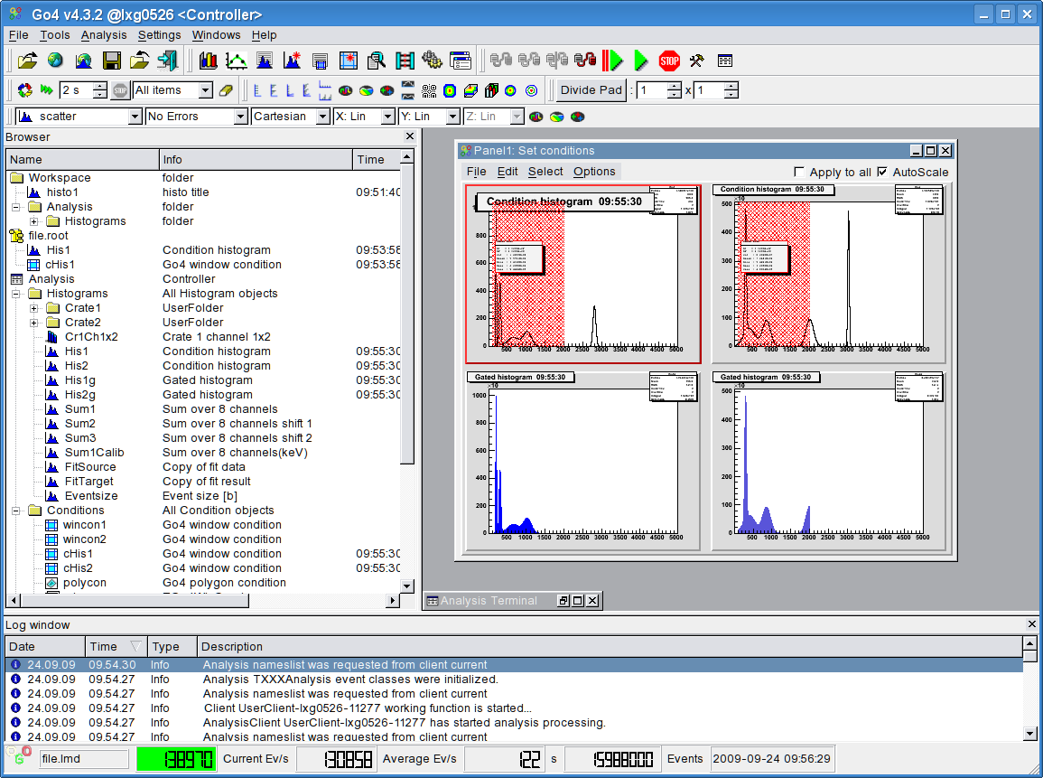
gui300
This would be the minimal look of a running analysis (the date is updated from the analysis):

gui301
There are many keyboard shortcuts to handle windows and actions. See chapter 10, page 100.

GUI menus
The icons in the top line are grouped into three segments corresponding to the first three pull down menus File, Tools, and Analysis.

File, Tools, Analysis menus
Pull down | Icon | Function
File |  | Open: opens local ROOT file
 |  | Open Remote: open TNetFile, TWebFile or TRFIOFile to access remote data
 |  | Connect DABC: open connection to DABC data socket (optional)
 |  | Connect HTTP: open connection to ROOT/GO4 web server
 |  | Open HServer: open connection to gsi histogram server
 |  | Save memory: save content of the memory browser into a ROOT file
 |  | Close all files: close all ROOT files opened in file browser
 |  | Exit: closes window and exit from GUI
Tools |  | View Panel: creates window (canvas) to display histogram(s)
 |  | Fit Panel: opens fit panel
 |  | Histogram properties: opens window showing histogram properties
 |  | Create New His: opens histogram creation window
 |  | Condition properties: opens window showing conditions properties
 |  | Condition Editor: opens central condition editor
 |  | Event Printout: examine current event contents
 |  | Create Dyn. List Entry: histogramming on the fly
 |  | Load Libraries: opens tool to load ROOT libraries
 |  | User GUI: starts user GUI
Analysis |  | Launch Analysis: starts up the analysis task (as client or server)
 |  | Connect to Analysis: login to running analysis server
 |  | Prepare connection: allow external analysis client connect to this gui
 |  | Disconnect Analysis: remove connection without analysis server shutdown.
 |  | Shutdown Analysis server: in administrator mode only!
 |  | Set+Start: submit setting and start analysis
 |  | Start: start analysis events loop (after setup and submit)
 |  | Stop: stop analysis events loop
 |  | Configuration: open the configuration windows
 |  | Analysis Window: opens the output window of the analysis

Help menu
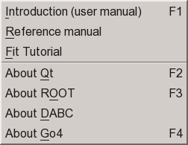
gui357
The help menu provides to read several Go4 manuals on-line. Keyboard shortcut F1 will display the main user manual. Note that you need an external pdf viewer to be installed on your system to read them! Additionally, you can get version information about the Qt, ROOT and Go4 environment here, also available by pressing keys F2, F3, and F4, resp. If Go4 has been installed with DABC framework, this is also shown here.

Settings menu

In the Settings pull down menu as shown on the right side one can set different parameters
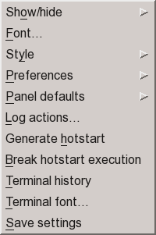

You can adjust all fields according your needs. Then Save Settings. The next start of the GUI will restore the saved layout. Note that settings also contain other preferences, like window geometry and tools visibility, view panel background color and crosshair mode, graphical marker appearance, connection setup parameters, etc. By default, the settings are stored in text files $HOME/.config/GSI/go4.conf (for detailed settings) and $PWD/.config/GSI/go4toolsrc (contains toolwindow layouts). To get the standard setup one may delete these two files. Note that since Qt 4.4 the QSettings are always in the home directory; however, the Go4 toolwindow settings may still be at a different location (usually in the current directory to provide different toolbar setups for different Go4 analyses).
Settings behavior can be changed using environment variable GO4SETTINGS. If this is set, the GUI toolwindow preferences are used from directory $GO4SETTINGS. If GO4SETTINGS contains keyword ACCOUNT, the Go4 toolwindow settings at $HOME/.config/GSI/go4toolsrc are used (like the other QSettings).
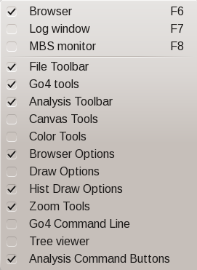
gui355/142
With the Show/hide entry of the settings menu (or with RMB in an empty menu region) one gets the submenu on the right to select which tools shall be visible. The actual content of these windows is preserved even if they are not displayed. This is also available as popup menu when clicking the right mouse button on an empty field of the main window.
Keyboard shortcuts F6, F7, and F8 may toggle visibility of Browser, Log window and MBS monitor tools, resp.
Fonts and Style of the Go4 GUI can be selected from the available ones after clicking the corresponding menu entries.
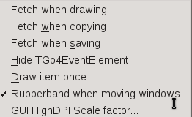
Preferences specifies when objects are fetched automatically from analysis to the GUI cache: each time when drawing object into a view panel, each time when copying object to local workspace, or each time when saving local objects to file. All or none of the above may be selected. Note that refreshing the local view manually or in monitoring mode is not affected by these settings. Option Hide TGo4EventElement toggles if the Go4 Tree viewer may hide, or show all leaves which belong to such event base class. Option Draw item once enforces that each object is displayed uniquely in one view panel only, so double clicking the same item again will not draw it in a new pad, but will activate its existing view panel display. Option Rubberband when moving windows will change the paint mode of all Go4 windows: when enabled, windows will show a “rubber band” outline when moved or resized, otherwise window is rendered completely during resize. This option may avoid graphics flicker on some systems (Qt5).For Qt versions > 5.6.1, menu GUI HighDPI Scale factor.. allows to define a Qt specific scaling factor to boost the size of the entire Go4 GUI for better icon visibility on 4k displays. Note that this scale factor is applied from most recent settings no sooner than the next restart of the Go4 GUI!

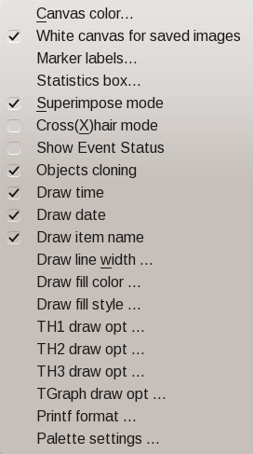

Panel defaults allow to set the default view panel layout.
In Panel defaults►Canvas color menu the default background color for all newly opened view panels can be set. This color may be saved together with the other settings. The option Panel defaults►White canvas for saved images toggles if the canvas background colors are suppressed when the viewpanel is saved as image. Panel defaults►Marker labels specifies the default label layout, Panel defaults►Statistics box defines default fields in ROOT histogram statistics, (see figures below).
The Superimpose mode entry specifies if the view panel is started in superimpose mode, i.e. histograms overlay existing plots instead of replacing them when “drag and dropped” on a pad. The Crosshair mode entry toggles the default crosshair cursor on/off for all newly opened view panels. This crosshair state may be saved together with the other settings. However, the crosshair can be switched independently for each pad in the menu of the view panel (see chapter 4.9, page 58). Similarly, view panel display options Draw Time, Draw Date, Draw item name, and edit mode Show event status can be set to defaults here. The entries Draw line width.., Draw fill color.. , and, Draw fill style..., allow to set defaults of these graphical attributes for all histograms and graphs. This may be useful to improve the plot visibility on a high resolution display monitor. Moreover, default ROOT draw options for TH1, TH2, TH3 histograms and TGraph can be specified as string of keywords when selecting these menu entries. Printf format allows set a format string in printf style controlling the printed range and accuracy for all float values in the histogram statistic box. Finally, the Palette settings allow to specify the default ROOT color palette, and the minimum and maximum palette index to be used in the Go4 color palette tool (see section 4.9.7). By this restriction the user may exclude legacy ROOT palettes <50 which are hardly usable for a proper visualization of 2d histograms.
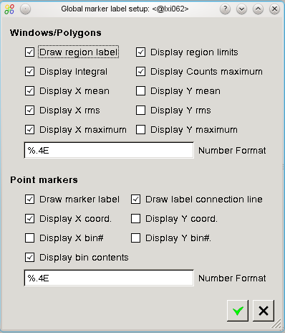
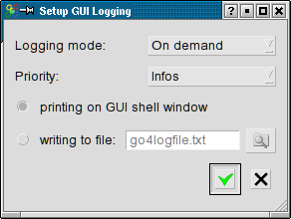
gui355/142
The Log actions of the GUI can be defined in a setup window from the settings menu. By default, the log output (e.g. condition properties, histogram information) is printed into the shell window where the GUI was started from. Additionally, a text file may be specified for output. Logging mode specifies if log output is produced On demand only (i.e. on clicking the log button  when available), or Automatic whenever the content of an editor/information window changes. Priority defines the level of output suppression: Errors, Warnings, Infos, or Debugs. Level Errors will only log in case of an error, Debugs will printout even debug information of the Go4 kernel. This reflects the priority of the TGo4Log::Message() method.

The Generate hotstart entry will save the current state of the GUI (window geometry, objects in memory and monitoring list, objects in view panel, analysis settings) to a Go4 hot start file (*.hotstart). The name of the hot start file can be defined in file dialog here. When re-starting the Go4, the hot start file may be used as command line argument, restoring the state of GUI and analysis (see chapter 4.17, page 80).
With Terminal history the buffer size for the analysis output window can be limited.

Windows menu
The Windows pull down menu shown on the right side provides items to arrange the windows and to save and clear the analysis and log windows. Cascade will arrange all windows of the Go4 workspace in a cascading manner, Tile will fill the Go4 workspace uniformly with all active windows resized as tiles. Close all will close, Minimize all will iconify all workspace windows. Selecting Full screen or keyboard shortcut F11 will expand the Go4 main window to full size, or collapse it to the previous size when selecting it a second time.
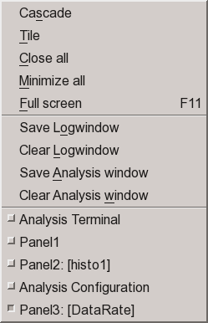
gui167
Save Logwindow and Clear Logwindow allow to save the contents of the log window to a text file, and to clear the log entries, resp. Similarly, Save Analysis window will store the text output of the analysis to file, and Clear Analysis window will erase it.
Finally the Windows menu contains a list of all windows in the Go4 workspace by their title. Selecting an entry in this list will activate the corresponding window and pop it to the front.

Load libraries to GUI
To access data from user defined classes (like parameters or events) a library including the ROOT dictionary is required. This library is produced by the make file and has the name libGo4UserAnalysis.so. It is recommended to load user libraries for non-Go4 classes (for instance, user event classes) before opening a file with a TTree, where object of these classes are stored. There are three different ways to do it.
First, any external shared library (with or without ROOT dictionary inside) can be loaded by press of the button on the main window. A file dialog then asks to specify the library to be loaded.
Second, set the environment variable GO4USERLIBRARY to a list of user libraries (separated by colons) to be loaded when the GUI starts. Typically before run the Go4 GUI the user should type in the shell:
export GO4USERLIBRARY=..../libGo4UserAnalysis.so:..../libOther.so
Third, the new possibility (since ROOT 4.00/08) for automatic load of libraries with a .rootmap file. This file contains information to automatically load all necessary libraries for user classes. All make files of the Go4 examples generate .rootmap files during compilation. To explicitly generate this file again, type make map after compilation. If this file is located in the current directory (where GUI is started) or in the user home directory, all libraries will be loaded automatically at the time when required. For more details about .rootmap files see the ROOT home page.

Launch analysis
Press the button (or Alt a n or Strg n). This will start the Launch analysis window to execute the analysis task on another host. The operation mode of the analysis task may be “As client” (default), or “As server”; this has to be specified in the left selection box on top of the Start Analysis window.
The difference of these modes is that in client mode the analysis connects as client to the starting GUI and will be finished when the Go4 GUI terminates. There can be only one GUI connected to an analysis in client mode. The starting GUI will connect automatically to the analysis client after launching it with full controller priviliges.
In contrast to this, the analysis started “as server” will be an external process independent of the starting GUI. Therefore in server mode the analysis can not run embedded into the Qt Window of the GUI. Any number of Go4 GUIs may connect to this analysis server with different priviliges, but only one GUI may be the authorized controller. Especially the starting GUI has to login to the analysis server after launching it in a separate dialog window. In addition to the established analysis server with Go4 sockets, it is also possible to launch the analysis as server with an HTTP server as connection to the GUI, and to additional web browser GUIs. This feature is selectable with the second operation mode selection box (“Go4 sockets”, or “HTTP server”).

Launch analysis task in client mode
Besides the selection of the operation mode, the popup window expects an arbitrary name for the analysis and the node name of the machine where the client should be started. Normally this is the current node (localhost) as offered by default. Furthermore there are fields for the user working directory (in this directory the analysis is started) and the analysis file (library or executable) name . Note that these values are stored to, and retrieved from the current Go4 settings file. Start the analysis with button Start or RET.
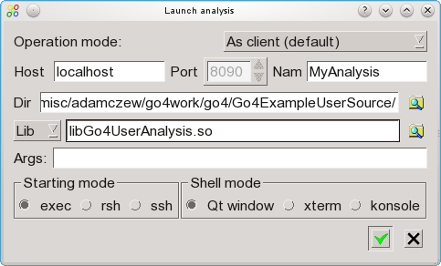

The client will be started in local process (starting mode: exec), in a remote shell (mode: rsh), or secure shell (mode: ssh). The analysis output is directed to a text window inside the GUI (“Qt window”), or to an external xterm, or to the KDE konsole (if existing), depending on the selected Shell mode. Individual configurations for starting and shell mode are stored in $GO4SYS/etc/go4.prefs file and can be adjusted there.
After initialization the client connects to the GUI. When this procedure is done, the message "Starting analysis client ...Please wait” changes to "Editing Analysis Configuration …" and the GUI is ready, popping up an analysis terminal window and the analysis configuration window. Here the analysis steps can be configured (see chapter 4.4, page 45). Then the analysis must be set up by pressing Submit (or Alt u).
After setting up the analysis it is started by (or Alt a s or Strg s). In the browser the directory of the remote Analysis appears. The next figure shows the GUI with a running analysis. On the right side is the browser with the analysis directories; on the left side the analysis terminal, and the analysis configuration window.

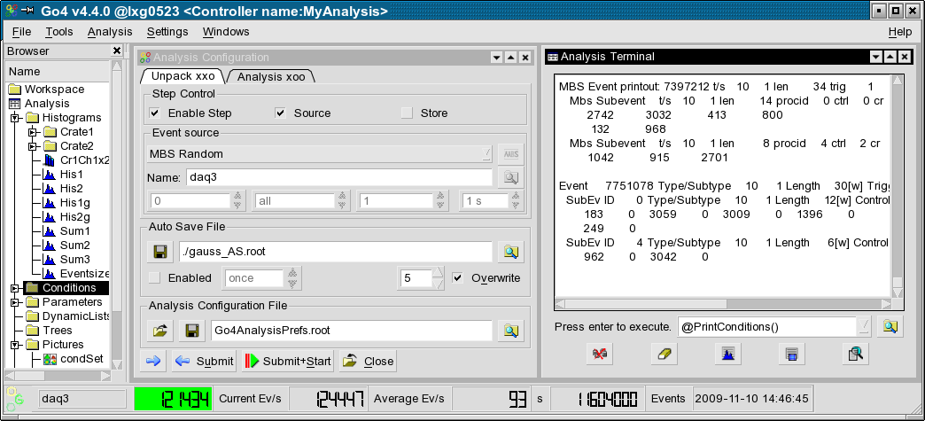
gui305

The configuration window is described in more detail in the next chapters.

Launch analysis task in server mode
To launch the analysis in server mode , the Operation mode in the start dialog window must be switched to “As server” mode. The other settings are the same as described in section 4.3.1, except for the disabled possibility to run the analysis shell in the internal Qt window of the GUI. Immediately after starting the analysis server, the Connect to server analysis dialog will pop up, expecting specifications for login of the GUI to the newly created server.

Connect to existing Go4 analysis server
After the analysis server has been started (from the start dialog, from other GUI, or from external shell command line, respectively), the Go4 GUI can connect to the server. This is done via the “Connect server” dialog that is available from the connect button in the analysis menu. If the server has been launched before from this GUI, the connect dialog will popup automatically. To establish this kind of connection, the “Connect server” dialog offers the Connection mode “Go4 sockets”.
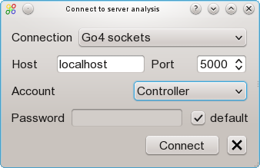
Port number must match the connection port as printed out in server terminal window. Host should specify the node name of the server machine.
Three different Accounts (roles) for login are provided: Observer, Controller, and Administrator. Each login has to be verified by a password. The Go4 default passwords go4view (observer), go4ctrl (controller), and go4super (administrator) are used when the default check box near the Password field is active.
These passwords may be changed in user analysis class by method DefineServerPasswords(const char* admin, const char* controller, const char* observer) with the arguments specifying the new password for the appropriate role. In this case, the correct password must be typed into the password field. See code examples (as comments) in Go4Example1Step and Go4ExampleAdvanced.
Only one controller or administrator may be logged in at the analysis server at the same time. If a controller (or administrator) GUI has already been attached, the next controller or administrator login will get an observer role. Observers may only view analysis objects and configuration, but may not modify them. Submit, Start and Stop, and remote macro execution is forbidden for observers, too. The controller account may modify all objects and the analysis setup and change the analysis running state, but may not shutdown the analysis server itself. Finally, only the administrator account may terminate the analysis server. After connection is established, the GUI main window title will show the role (Observer , Controller, Administrator).
After connection a controller can change and submit new the configurations. When connected as an observer, button may be used to get the object list from the analysis in the browser. One can also get the configuration, but cannot submit them.
The GUI disconnects from the analysis by , but the analysis continues to run. To really shut down the analysis one has to use button (administrator only).

No additional code should be implemented by the user to let analyses work as analysis server. All necessary jobs are done by standard go4analysis executable. It is recommended to convert older analysis code to new launch scheme – mainly remove main executable and provide several initialization routines as it done in examples. To run analysis as server from shell, one should call “go4analysis –server <name>”. The usage can be seen in any go4 example packages.

For analysis servers in ROOT macros see chapter 5, page 82

Launch analysis task as HTTP server
To launch the analysis as HTTP server mode, the Operation mode in the start dialog window must be switched to “As HTTP server”. In this case it is also required to specify a port number for the web server with the Port spinbox. Note that starting up the HTTP server might fail if this port number is already occupied on the host. In contrast to the Go4 socket analysis server, the analysis task can also run in the internal Qt window of the Go4 GUI. If an external xterm or konsole window was chosen, their output would be redirected though to the Qt analysis window. Immediately after starting the analysis HTTP server, the Connect to server analysis dialog will pop up, expecting specifications for login of the GUI to the newly created server (see chapter 4.3.5).
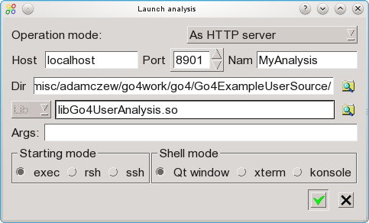

Instead of starting the analysis HTTP server from such GUI, the user may also directly call “go4analysis –http <port>” in an external shell (see section 7.1, page 87).

Connect to existing Go4 HTTP server
If go4analysis has been started as HTTP server (either from the launch dialog, or by command in external shell), it is possible to connect the Go4 GUI to such web server and perform analysis configuration and control via this connection. This can be done even if go4analysis is running in pure batch mode, i.e. without option “-server”.
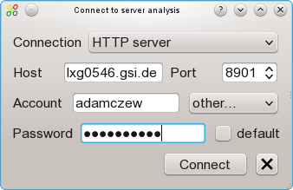
To establish this kind of connection, the “Connect server” dialog offers the Connection mode “HTTP server”. The input fields for Host name, Port number, and optional Account and Password are then dedicated for this web server access. Additionally, besides the Go4 standard roles (observer, controller, admin), any account name can be specified when choosing the “other...” entry in the Account combo box. Once connected, the objects at the http server are visible in the Go4 browser tree and can be drawn in view panels and editors, like with the native Go4 socket connection. All GUI elements for analysis configuration, rate monitoring and run control will use the http connection. In addition to the “Go4 sockets” analysis server (chapter 4.3.3), the Go4 HTTP server will also deliver the analysis text output into the embedded GUI analysis window.
To disconnect the GUI from the web server control, button can be used. Like for the Go4 analysis server, the possible shutdown of the go4analysis process by button is restricted to administrator role and depends on the web server set up. Note that full control of the web server go4analysis is possible only with ROOT versions > 5.30.00 (> 6.04.00, respectively).
Connections to any number of ROOT or go4analysis web servers may also be done by using the entry (Connect HTTP...) of the main File menu (see chapter 4.7.8 on page 54). However, only the first of these connections may get full configuration and control access via the GUI elements. Further go4analysis and ROOT web servers can be connected to the Go4 GUI just in observer mode, i.e. it is possible to browse and monitor the objects, but not to modify and control the set up.

Analysis configuration

Configuration window
The Analysis configuration window shows the last valid setup of the analysis steps. These are taken from the user analysis constructor parameters, or from the ROOT file Go4AnalysisPrefs.root (in analysis working directory), if existing.
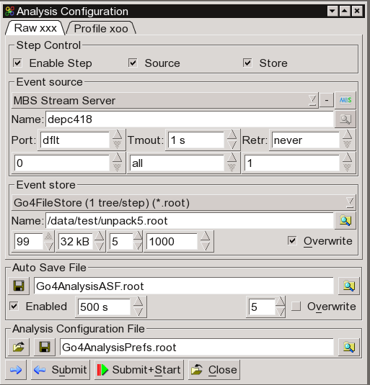
The Analysis configuration consists of the configuration parameters for each analysis step. The analysis steps are shown in different tabs of the configuration window. The values for event source, event store and working status of the analysis steps can be changed for each step separately. Depending on the chosen Event Source, relevant parameter fields will highlight for optional parameters. The MBS File, e.g., can specify an MBS tag file name (see MBS manual), and numbers for the first event, the last event and the event number step between subsequent events to be processed. Multiple input metafiles are supported by a preceding @ character (see chapter 4.4.2, page 46). The Event Source Remote Event Server needs a Port number, Event Server and Stream Server can either use the default MBS ports (“dflt”) or may specify another port number (when reading data from DABC). Additionally, for the on-line sources one can set a socket timeout Tmout in seconds and define the number of reconnection retry attempts Retr. The latter is useful if the DAQ must be restarted, so Go4 will automatically reconnect and continue once the data server is available, without submitting the settings again. For user defined sources (see chapter 4.4.3, page 46), the optional string argument Args may be evaluated in the user step factory.
The Event Store settings define the ROOT split level and branch buffer size of the ROOT tree, and the file compression level. Also the number of tree entries interval for flushing out buffers to file (tree autosave interval) can be specified in the rightmost spin box. If the Overwrite radio button is false, new events will be appended to a previously written tree of the same event store name.
Moreover, steps may be disabled completely: the first step, e.g., can be left out and the second step may read its input from a previously created output file of the first step. Note: the input of the actual first step must be specified; otherwise the analysis will not be initialized!
The auto-save file for analysis objects (histograms, conditions, parameters, dynamic list connections) is defined for all steps with the auto-save interval, the file compression level, and the Overwrite option. Selecting once for the auto-save interval will prevent saving the objects during the analysis run. However, the auto-save file will be written once at the analysis shutdown (when pressing Submit for the next settings, or Close, resp.). Auto-saving can be disabled completely by unchecking the ENABLED checkbox, i.e. the auto-save file is not even opened for reading previous objects.
Note that the  buttons at the different name fields will open a browser for the local file system to search for appropriate file names.
The new settings are activated on the analysis client by pressing the  Submit button (or Alt u). Note: you have to press Submit even if you want to apply the settings unchanged! To synchronize the configuration window with the current analysis settings, the refresh button can be used. This is usually done automatically on first connection of the analysis, but it might be useful when starting the analysis manually from a different shell, or when changing the analysis setup independently from the GUI. For convenience, the Submit+Start button will submit the new settings and start the analysis loop immediately.
The Submit button closes the previous analysis (i.e. all files and connections will be closed, all event classes except for the analysis step factories will be deleted) and initializes the analysis with the new settings. The Close button (or Alt C) will close down the analysis without initializing a new setup. The analysis process, however, will remain with all registered objects (histograms, conditions, etc.) available.
To have the changed settings available on the next analysis client startup, press the Save Button . This will write the current analysis settings to the file Go4AnalysisPrefs.root (default name for startup), or to any other ROOT file specified in the file dialog or the filename text field. Previously written configurations can be loaded using the Load button and the corresponding file dialog.
- Note 1: A changed configuration must first be submitted to the analysis before it can be saved.
- Note 2: When a new configuration is loaded, the previously active analysis is closed without saving the configuration. After loading a configuration it appears in the configuration window. To initialize the analysis with these new settings, the submit button must be pressed!

Multiple input files
There is the possibility to process multiple input files (source type MbsFile) in one analysis set-up. This can be achieved by wildcard characters in the Event Source name field, e.g. *.lmd or data???_march03.lmd or *. All files matching the wildcard expression will be read subsequently without closing the analysis; output events may be written into one event store. Additionally, one may specify the name of a metafile containing a list of inputs; the metafile name has to be preceded by an @, e.g. @gaussfiles.lml. Each line of the definition file gaussfiles.lml may contain the following format (values separated by blank spaces):

inputfile tagfile firstevent lastevent skipevents

The numbers of first and last event always refer to the running event count in the currently open event source, starting with number 1 each (not the event number inside the event header). The skip events number defines how many events shall be skipped in one file in between two processed events; this may be useful if a long term sample of a large input file shall be taken. The tag file may contain information which events shall be processed in the input file (see MBS manual).
At least the input file name must be specified; wildcards are not allowed here. Complete lines in the metafile may be commented out by a preceding “!” or “#” character.
Moreover, metafile lines preceded by an @ character are treated as ROOTCINT commands, e.g.
@ .x setup.C
@ TGo4Analysis::Instance()->ShowEvent(“Unpack”); .
These commands are executed in between change of event source, thus allowing to use different setup parameters for different list-mode files.
Note that multiple input files also work in batch mode. However, wildcard expressions must be put in parentheses (“”) if they are passed to the MainUserAnalysis or go4analysis as command line parameter. In batch mode the input file suffix is automatically expanded to *.lmd, if it was neither .lmd nor .lml. Therefore the meta file can also have suffix .lmd, i.e. @myfiles results in reading myfiles.lmd (although it is a plain text file). A better way is to use suffix .lml, because then one can omit the @.

User defined event sources
Besides the delivered Go4 event sources for the standard MBS or ROOT file input, there is the possibility to define any other event source. In the analysis configuration window, there is the selection UserSource for the analysis step Event Source type. In this case, a TGo4UserSourceParameter object is passed to the step factory of the step. The user source name, and optionally, port number and a text argument can be specified in the configuration GUI to be evaluated on analysis initialization. An example of an analyis with a user defined event source is provided in directory Go4ExampleUserSource of the Go4 distribution. Please see section 3.8, page 33 for further details how to implement a user defined event source.

Auto-save file mechanism
When auto-save is enabled (in MainUserAnalysis), all objects are saved into a ROOT file after every auto-save interval seconds time, and before termination. The auto-save file can also be written on demand by Save button in the configuration window. At startup of the analysis the following actions are done:
- The analysis is created.
- The auto-save file is read and all objects are restored from that file. Objects already existing, i.e. created in the analysis constructor, are overwritten by the objects from the auto-save file, except histograms. Existing histograms are not restored!
- Before creating objects in the processor constructor or the PreLoop() method of the analysis one should check by the proper getter method if the object has been already restored from auto-save. If not, it can be created. If it is created while already existing the existing object is deleted first, i.e. the values from auto-save are lost.
When the analysis is controlled from GUI, objects are loaded from auto-save file when the Submit button is pressed (full sequence see chapter 2.6.11, page 21)

Analysis control

Analysis terminal window
When using the Qt Window option in the launch window, the analysis terminal window of the GUI shows all analysis printouts

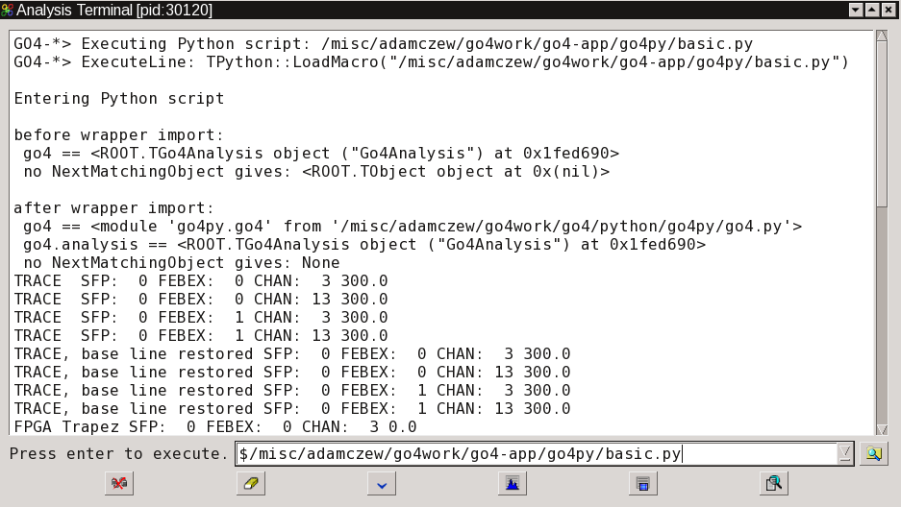
gui133

Button clears the window, button scrolls the visible text down to the end, prints all histograms info, prints all conditions info (make window wide enough for the counter bars). Button will open the event information window (see chapter 4.16, page 79).
Additionally, it is possible to kill the analysis process with the button on the hard way. This will disconnect the analysis client after a while from the GUI and analysis can be launched again. However, this is not recommended since the ROOT output files may remain in a non valid state after the kill!
Analysis terminal output can be stored by Windows►Save Analysis window menu command to text file. Analysis terminal output history is limited by 100 Kbytes. This value can be changed in Settings►Terminal history menu command. To keep full history, 0 should be set.
gui325
When the analysis task is running in an external shell (xterm, konsole), the buttons and macro execution line will appear in a special dockwindow (see figure).

Macro execution in the analysis
The analysis terminal window offers the possibility to execute ROOT interpreter commands and macros in the analysis task. Note that a history of previous commands of the session is available with the macro line combo box (mouse selection, or arrow down key). looks up for macro files (file filter *.C or *.py).
Using the go4 pointer (already set to TGo4Analysis::Instance() ), one has access to all public methods of the analysis framework from inside the macro. Note that the shortcut @ exists here for TGo4Analysis::Instance()->, e.g. @PrintHistograms(“Cr1*”) will print all histograms with names matching the wildcard expression. In macros the environment variable __GO4ANAMACRO__ is defined and may be checked. A detailed description can be found in the reference manual.
It is not necessary to load the Go4 libraries in the macro again, since these are known at runtime in the analysis anyway.
See also macro execution in GUI (see 4.19, page 81). $GO4SYS/macros directory should be added to entry Unix.*.Root.MacroPath in .rootrc setup file.

Python macros in the analysis
When beginning the command in the analysis command line with “$”, go4analysis will assume that the given file is a python macro (suffix *.py) and executes it in PyROOT environment. Please note that this feature requires that ROOT is also installed with Python features activated. The Go4 analysis object is automatically bound to Python, therefore all methods of class TGo4Analysis are accessible from a Python script with the reference go4.methodname(). Moreover, a special Python wrapper is provided that optionally embeds the bound TGo4Analysis into a native Python object go4 that may add additional features. For example, the NextMatchingObject() function has been improved in the Python wrapper with a better wildcard filtering and error handling. Further functions of the go4 Python wrapper are going to be developed.
The Go4 python wrapper framework is located at the $GO4SYS/python directory of the Go4 installation. Besides this, there are some examples available at the repository https://subversion.gsi.de/app/go4py .
In addition to the interactive GUI command line, a Python macro may also be executed from compiled analysis code when invoking function TGo4Analysis::ExecutePython() .

User defined macro command buttons
A GUI toolbar for user defined analysis macros is available from the menu Settings►Show/hide►Analysis command buttons. This toolbar offers up to nine configurable command button that allow to execute any macro command in the remote analysis by mouse click, or by pressing keyboard shortcuts Ctrl-1 to Ctrl-9, resp. Moreover, commands may be marked to be executed by a timer in the macro configuration window. In this case, the buttons will show up in green color. The corresponding commands will be frequently invoked if the timer of the macro command toolbar is activated with a given interval, as specified by the ”seconds” spin box on the right side. To activate or stop the timer, the rightmost button (“arrows” or “stop” sign) may be pressed. In such way it is e.g. possible to clear all monitored histogram contents every 10 seconds automatically, or to frequently invoke a script doing some monitoring analysis.

The macro configuration window as shown in the figure will pop up when pressing the leftmost button. For each button (C1 to C9) it allows to specify the macro command expression, an arbitrary tooltip, and the timer execution flag. All commands as discussed in sections 4.5.2 and 4.5.3 can be specified, i.e. calls of compiled Go4 framework functions, and execution of ROOT and Python macros. An empty command text will disable the button (grey color). The tooltip will appear as bubble help when pointing the mouse over a button and should tell the user a summary of the expected actions. The associated keyboard shortcut (Ctrl-1 ... Ctrl-9) is added to the user tooltip text by default. Finally, the frequent timer execution can be set for each command individually. The Reset button will clear all entries in the configuration editor, Ok button will activate the modified setup, and Cancel will discard the changes.
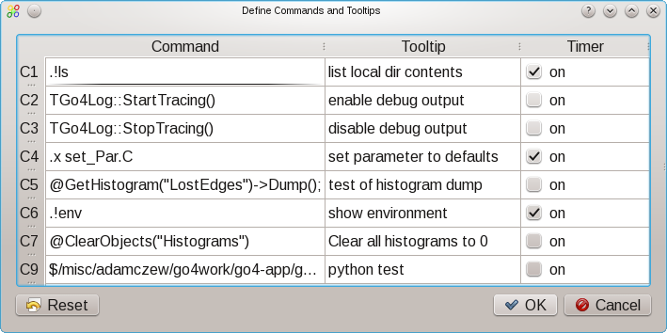

All definitions of these analysis command buttons are immediately stored in the Go4 user settings and are o available at next GUI startup.

MBS status monitor
When working with the gsi multi branch system mbs as event source, Go4 offers a monitoring tool that can request information from the status port of a running mbs system. This is available as dock window from the “Settings/ Show/hide” menu, or will appear when the mbs button is pressed in the analysis configuration window.

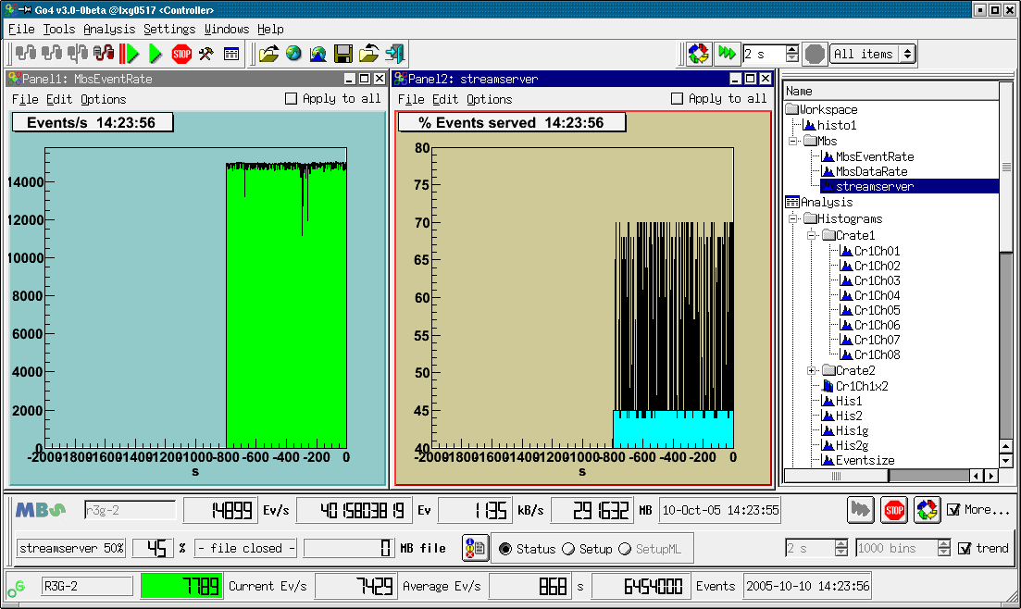
gui327b
The screenshot shows the Go4 main window with the mbs monitor tool docked in the bottom part, right above the Go4 analysis status line. The mbs monitor by default shows just one line of information, but may be extended by the lower line with more details using the More... checkbox.
The upper line displays, from left to right: The mbs logo which is animated when the mbs acquisition is running; a text line to edit the mbs host name; event rate (events/s); total events acquired; data rate (kB/s); total data acquired (Mb); time and date of last refresh. On the right there are control buttons: With the mbs status server is newly connected and the information is refreshed. It is possible to refresh the status frequently, this is switched on and off with the buttons and , respectively. The refresh time can be chosen by the “seconds” spinbox in the lower line of the mbs monitor window.
Additionally, the lower line displays (from left to right): Name of data server in use (streamserver, or eventserver) and percentage of delivered events 1/n, as it is set in the mbs by command set stream n, or set event n; percentage of real delivered events from this data server; name of the file which is currently written by the mbs, if existing, and total amount of data written to file since mbs startup. The button may be used to print the complete mbs status structure, the complete setup structure, or the multilayer setup structure, respectively, to the shell from which the gui was started. This is selected by the radiobuttons Status, Setup, and SetupML. Note that printout of multilayer setup is enabled only if a real multilayer setup exists in the observed mbs.
Besides the time selector for the monitoring frequency, the right side of the second line offers the possibility to switch on several trending histograms. This is done by the trend checkbox. The overall number of bins may be changed in the bins selector; the range of one histogram bin equals the monitoring frequency. Note that trending histograms are only written if the mbs status monitoring is turned on (i.e. no new entry in trend histogram by manual refresh using button ). Three different trending histograms are currently produced: for the event rate, the data rate, and the percentage of delivered events at the mbs data server (streamserver or eventserver). They appear in the Go4 browser in the Workspace/Mbs folder and may be observered in Go4 view panels. The screenshot shows the trending histograms for event rate and streamserver event ratio.
Note that a warning sign will appear in the upper line if connection to mbs status server fails.

The Go4 browser
After pressing the analysis starts and the rates are displayed at the bottom as shown in the screen shot below. The analysis output window and the configuration window have been closed. A view panel created by has been opened and a histogram is displayed by dragging & dropping a histogram from the browser into the canvas. Note the logging window displaying messages from the remote analysis. This log panel can be opened in the Settings menu bar. The complete logging history may be saved into a text file by the Windows►Save Logwindow menu command.

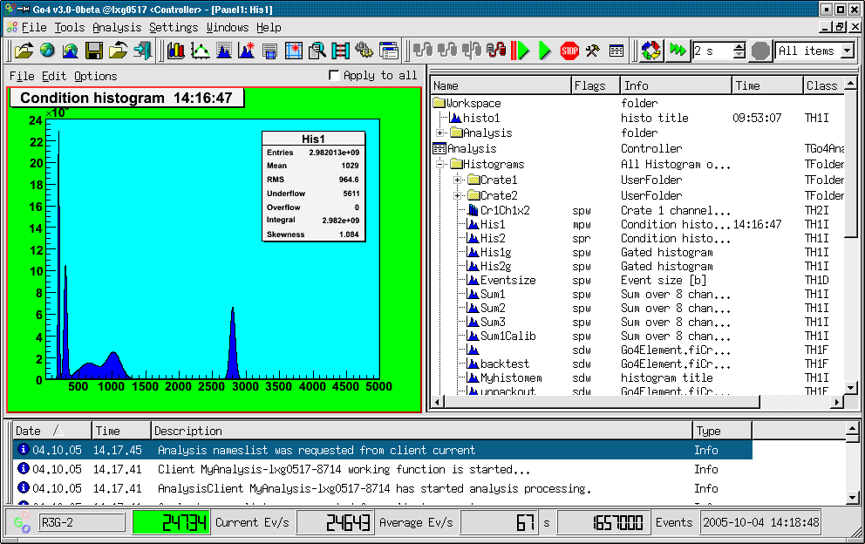
gui309

The Go4 browser on the right side shows objects from different data locations in a folder structure. Remote objects in the connected analysis task are listed under the Analysis branch. The Workspace folder contains all objects that are put into the memory of the local GUI, e.g. by creating fix copies of remote analysis objects. A root file opened from the files toolbar with the button will appear in a folder of the filename; similarly, a connection to a remote data source like the xrootd, the root webfile, or the gsi histogram server, shows up as separate browser branch.

Browser columns
Beside the “names” column showing the objects in their folder structure by symbols, the Go4 browser has configurable columns to display different kinds of properties of the displayed objects: Flags, Info, Date, Time, Class, and Size. These can be switched on and off by the menu that pops up on right mouse button click in one of these. Moreover, the order of these columns can be freely arranged in the browser by dragging and dropping their caption to a new position.
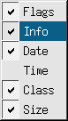
gui312
The Flags column will indicate certain properties of the object by letters:
- m - shall be monitored frequently; or s - is static until explicitely refreshed
- d - object may be deleted; or p - is protected against deletion
- r – read only, can not be reset; or w – writable, may be reset

The Info field will usually show the type of the folder, or the title of the ROOT object.
Date and Time columns show the date or time of the last object refresh to the GUI inernal cache (for remote data sources), or of the object creation (for local workspace), respectively.
Class column shows the class name, and Size will give an overall object size in bytes.
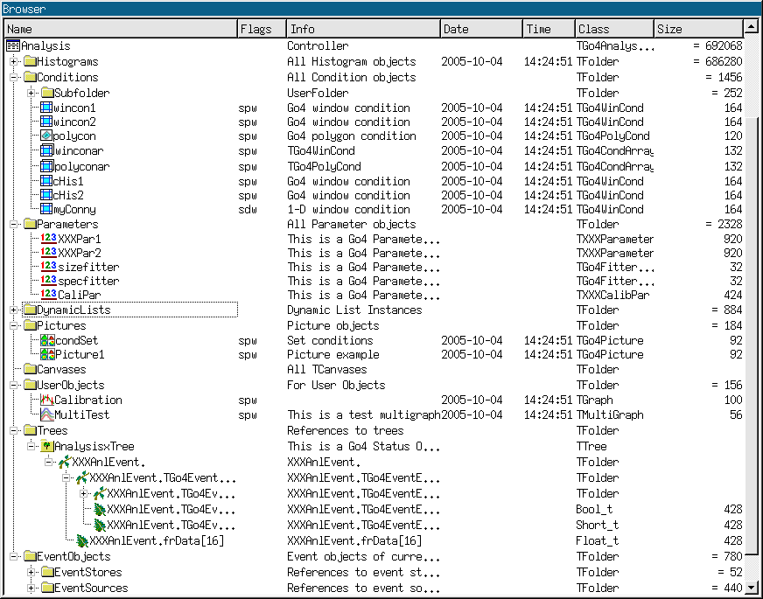 gui311

General functionality
Each item in the browser has a context menu, which can be activated by right mouse button click on that item. It is shown in the figure on the right. By means of this menu, it is possible to operate on the browsed objects. The items in the upper part of the context menu (above the line) are available for all items, whereas the items in the lower part contain special functionality to control remote data sources like the analysis.
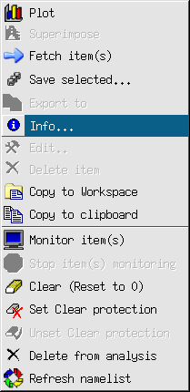
gui311
Histograms and pictures can be plotted either by double click, or by drag and drop in a view panel, or by the right mouse menu. Item Plot draws each selected histogram into an own graphical pad, Superimpose draws all selected histograms superimposed on one pad.
The browser items represent the structure of a connected data source like the remote analyis, but will only retrieve the objects on demand. This happens usually just before the objects are drawn. To explicitely get the objects into the local memory cache without drawing them, the Fetch item(s) functionality may be used. Note that the browser’s implicit fetching behaviour may be adjusted in the Settings/Preferences menu by “Fetch when drawing”, and “Fetch when copying”.
The selected objects may be saved into a ROOT file with menu item  Save selected... The Export to... functionality will offer the possibility to export root histograms to ascii or radware format.
Item Info shows some information of the object, Edit... opens the editor if available. Item Delete Item deletes the selected objects from the local memory, whereas item Delete from analysis will delete the corresponding object in the remote analysis, if possible (see chapter 4.7.9. page 55).

Analysis folder controls
The Analysis folder shows the remote folder structure, which contains all objects that were registered to the analysis client. At any time the list of the remote objects may be refreshed by the right mouse button entry Refresh nameslist. The folder Histograms e.g. contains the histograms, the folder Trees will show the structure of all registered trees, e.g. all trees created by TGo4FileStores.
The eraser item Clear (Reset to 0) clears the selected objects like histograms, conditions, graphs and so on.
Each object on the analysis has two protection modes – delete protection and clear protection. These modes indicated in Flags column of analysis browser (see below). Delete protection is set for an object when it is created and added on the analysis side. It prevents deletion of such objects from GUI. Objects created by GUI commands have no such protection and can be deleted by the Delete from analysis functionality. Clear protection prevents the user to clear the content of objects by using . This mode can be set and unset for any object via context menu commands Set clear protection and Unset clear protection , respectively.

The monitoring mode
In the Analysis a histogram, graph, or picture can be set into the monitoring mode by selecting it and pressing the monitoring entry  Monitor item(s) in the right mouse menu. This is indicated by the letter “m” in the Flags column of the browser (static objects have letter “s”). Monitoring means that the content of objects are updated continuously from the remote data source (analysis, histogram server,..) to the GUI. This allows e.g. to watch the filling process of a histogram. The monitoring property of an item may be switched off by the Stop items monitoring functionality of the context menu.
Note that only the visible objects are frequently updated, i.e. even if a browser object is in monitoring state, it will not be copied from the remote data source if is not drawn in any view panel, or displayed in an editor, respectively.
The overall monitoring action can be started with button of the Browser options dock window. Here the update frequency may be specified in seconds, too. Button will cease monitoring of all monitored objects, but will not change their monitoring property (flags). Additionally, this dock window offers a button for immediate refresh of all visible objects, and a filter function for the browser to display either all objects, or only the monitored objects, or only the currently fetched objects, respectively. The clear button may be used to clear (reset to 0) all remote objects at once (see section 4.7.9, page 55). When the Browser options tool is active, the following keyboard shortcuts can be applied:
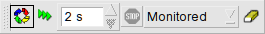
gui326
F5: Refresh display of all remote histograms
Shift-C: Clear all remote histograms remotely
Shift-M: Start monitoring timer
Shift-N: Stop monitoring timer

The workspace folder
The Workspace folder contains all objects that are put into the memory of the local GUI. This may happen either by producing a new histogram from the ROOT menus in the view panel, like a re-binning, or a projection, or from the Go4 tree viewer; or objects may be copied from elsewhere to the workspace. Item Copy to Workspace will produce a copy of the current object and put it into the workspace folder. This copy will preserve the subfolder structure of the data source; if e.g. a histogram was copied from analysis folder “Histograms/Crate1”, the copy will be placed in folder “Workspace/Analysis/Histograms/Crate1”. The Copy to clipboard, Paste from clipboard, respectively, allow a standard copy/paste functionality to any destination in the workspace. Additionally, in the workspace folder the right mouse button menu offers the Create folder and the Rename object functionality, as known from general file system browsers.

Browsing files
ROOT files containing data can be opened (buttons and of the main window file menu, respectively) as with the native ROOT TBrowser/TTreeViewer. Any ROOT file can be opened. Histograms in these files can be displayed in the Go4 view panel like local objects. A ROOT tree in a local file can be examined with the tree viewer of Go4. In contrast to the remote tree viewer mode, trees in a local file are processed by the GUI itself and do not have an effect on the remote analysis. The GUI knows if a tree viewer entry comes from a remote, or from a local TTree, so the button will either send a command to the analysis client for a dynamic histogram, or will perform a local TTree::Draw() call.
If the file contains user objects, make sure that the GUI has loaded the proper libraries to access them (see chapter 4.2, page 40).

Resetting and deleting objects
Any object in the workspace may be deleted by selecting it and using the popup menu delete item . Objects in the Analysis (histograms, conditions, parameters, …) that were created in analysis code must not be deleted, for the compiled user analysis would still try to access these objects after deletion. Therefore, deleting these objects is disabled using the delete protection property (symbol “p” in Flags browser). However, dynamic objects that had been created from the gui (histograms, conditions, dynamic list connections) are not delete protected and can be removed by the delete button.
An analysis histogram can be reset (contents and statistic values to zero) by selecting it and chosing the “ Clear” entry in the browser’s right mouse button popup menu. Resetting an analysis TGraph object will erase all points of the curve. For parameters, the method Clear() is called which may be implemented by the user.
All objects within a folder are reset at once by selecting the folder icon in the remote browser and chosing the entry of the right mouse button menu. This has the same effect as calling method ClearObjects(“Foldername”) of TGo4Analysis. It is also possible to select multiple objects in the browser and then apply the clear menu. To clear all remote objects at once, the clear button in the Browser options dockwindow can be pressed.
Note that any analysis object can be protected against clearing by a switch in the remote browser’s right mouse button context menu (See chapter 4.7.3).

ROOT web server connection
From the main window File menu entry (Connect HTTP...) it is possible to connect any ROOT web server (available for ROOT versions > 5.34.30) and view the exported objects. This also includes the web server that go4analysis process may optionally start up (see chapter 7.1 , page 87).
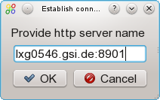

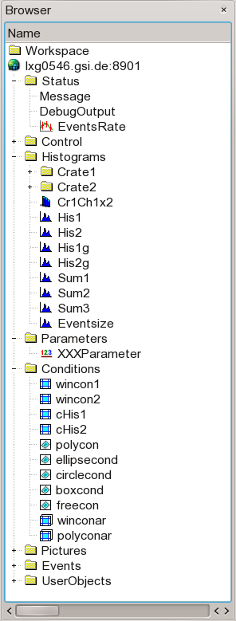
gui316/317
After selecting the button a dialog window prompts for the hostname and optional port number, as shown in the picture. Clicking OK will initiate the connection. If web server required authentication, the Go4 GUI would prompt again for username and password in separate dialog windows. After establishing the connection, the exported objects at the web server are available in the Go4 browser under a folder named nodename:port, e.g. lxg0546.gsi.de:8901.
The remote web server objects can be displayed and inspected with the Go4 GUI tools as available from the mouse context menu. Native ROOT objects, like histograms or graphs, can be displayed on Go4 view panels. If the web server is provided by a go4analysis process, also Go4 objects, like conditions and parameters, are available here. If the web server allows write access for the connected account credentials, it is also possible to modify such objects. Moreover, the first go4analysis process that is connected to the GUI by its web server can be even configured and controlled by the GUI analysis control elements (see chapter 4.4.1 on page 45). This HTTP connection mode has almost the full functionality of the regular Go4 socket connection, so it is also provided as alternative in the setup window to attach the GUI to an existing analysis server (see chapter 4.3.4 on page 43)

DABC server connection
If Go4 has been installed together with the data acquisition framework DABC, the main window File menu contains an additional entry that connects to the native command and data socket channel of any DABC process. The DABC server is identified by a connection URL of format dabc://nodename:port to be specified in a connection dialogue window. After a successful connection the object hierarchy of DABC appears in the Go4 browser under a folder named nodename:port, e.g. lxg0538:1237. This allows displaying and monitoring the ROOT objects that are known to such DABC node on the Go4 GUI.
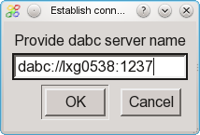

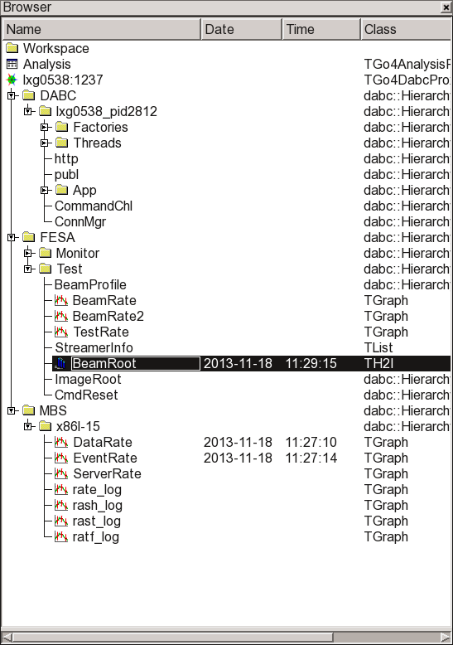
gui316/317

Histogram server connection
From the main window File menu entry one can connect to any GSI histogram server like MBS, GOOSY, LeA, or another Go4 analysis. The parameters for the histogram server, such as node name (Server), login name (Base), the socket Port number, the Password, and an optional Filter expression, are specified in a connection dialogue window. After a successful connection the histograms of the server appear in the Go4 browser in a folder named HServ_basename, if basename is the name of the histogram server base.
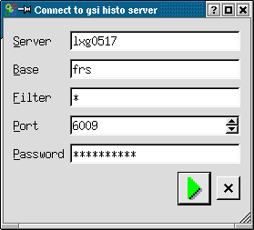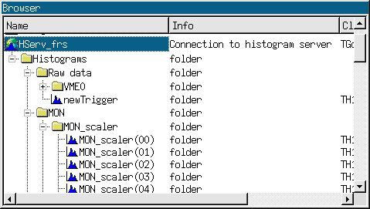
gui316/317

The Go4 tree viewer
The Go4 tree viewer is started via Settings►Show/Hide►Tree viewer menu or via RMB pull down menu.

gui140

There are two operation modes for the Go4 tree viewer: the local mode, or the remote mode. Dragging and dropping the tree leaf names from file or remote browser, the tree viewer will switch automatically into the local or remote mode, respectively.

Local mode
The tree viewer works on a tree in a file that was opened in the browser. This is like the original ROOT tree viewer, with the same logic of drag and drop. However, the Go4 tree viewer supports the resolution of the Go4 composite event information (see section 5, page 82). On pressing button , the local tree will be processed as defined by the given draw expressions in (and optional ) fields of the Go4 tree viewer. The local histogram of the given name is filled with the result. The histogram will appear in the memory tab and may be displayed in a view panel. If no name is specified, an automatic name is chosen from the given leaf names.
All classes, which are stored in the tree, should be known to GUI. User should load appropriate libraries before using local tree viewer (see chapter 4.2, page 40).

Remote mode (dynamic list histogram)
The Analysis folder shows the structure of all objects registered to analysis trees in the Trees subfolder. By drag and drop the elements of a tree can be put into fields of the Go4 tree viewer. A name and an optional drawing condition can also be defined here. The logic is the same as for the regular ROOT tree viewer. On pressing button , this information is passed to the analysis client and a new entry in the Go4 dynamic list is created. After pressing in the Analysis panel, a new histogram of the defined name appears in the histogram folder (if no name was defined in the tree viewer, a default name is used combining the variable names). Note: the histogram itself will be created no sooner than the next events after the are processed, i.e. the analysis must be running. This histogram will be filled event by event with the defined parameters of the tree. Go4 internally uses a TTree::Draw() over a number of collected events to update the histogram contents. This number, the dynamic list interval TreeDrawInterval, can be set by the analysis method SetDynListInterval(Ndyn), or can be changed in the dynamic list editor (see chapter 4.14, page 76).
If the histogram specified in the tree viewer already exists when the dynamic list entry is created, the histogram of that name will be filled by the dynamic list instead of filling a new histogram. Therefore it is possible to create a histogram with desired bin size first (see chapter 4.8.3, page 57), and then assign this histogram to a new entry of the dynamic list. This can be done easily by dragging and dropping a histogram icon from the histograms folder into the histogram textbox of the tree viewer. Again, pressing will create the dynamic list entry; the given histogram will then be filled every Ndyn events. The dynamic list tree is kept in memory, if in the analysis configuration for output Go4BackStore had been selected.
A histogram filled by the dynamic list, like any other remote histogram, can be displayed continuously in a view panel by switching on the Go4 monitoring mode (see chapter 4.7.4, page 53).

Creating a new histogram
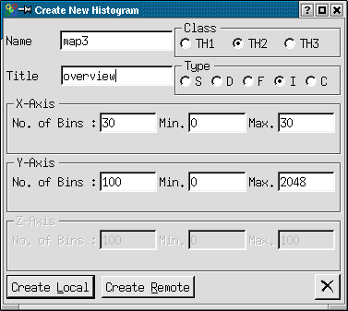
gui317
The button will popup the histogram creation window. Here the properties of the histogram to be created anew can be specified (dimensions, precision, binning, range, name, title). The histogram may be either created in the local directory (Create Local), or created in the remote analysis (Create Remote). A new local histogram will appear in the local objects panel, a remote histogram is put under the histograms folder in the Go4 folder structure. A new histogram (like any existing histogram) can be used as target for the remote or local tree viewer. This is done by specifying the histogram name in the tree viewer name field, or by dragging and dropping the histogram icon to this name field. The tree viewer will then fill the created histogram instead of creating a new histogram with arbitrary binning and range settings.

The Go4 view-panel
Pressing in the Go4 main control window opens a new Go4 view panel. A new view panel will also pop up automatically when any object in the browser is selected and the right mouse button menus or are activated. Furthermore, objects can be drawn by “drag and drop” from the Go4 Browser to an existing view panel pad and displayed there. On the left side the optional ROOT graphical editor is embedded. It is opened by
Edit►Show ROOT attributes editor. Select with left mouse an object on the canvas and the editor will change accordingly.

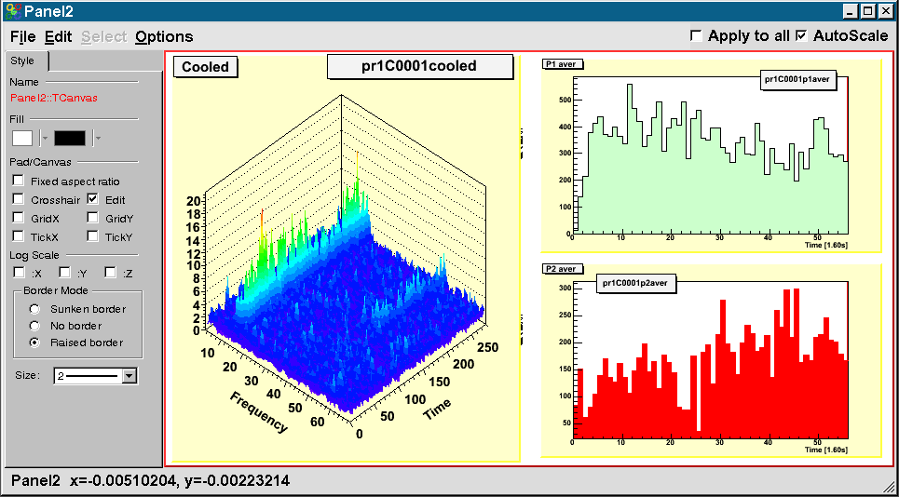
gui318

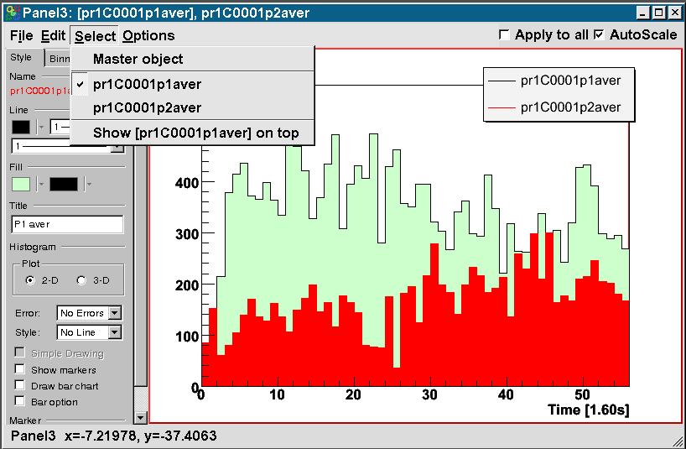gui368

An existing view panel can be divided into independent sub-pads by the division buttons in the Canvas Tools activated with the RMB on an empty region. When several histograms in the browser are selected for plotting, the view panel division will be done automatically to display all histograms in one new view panel window.
The canvas embedded in the Go4 View panel is an ordinary ROOT canvas, offering all ROOT features of the mouse button actions on the displayed objects (e.g. opening a histogram fit panel, rescaling the axes using cursor and left mouse button, ...). The currently active sub-pad (indicated by a red frame) can be selected with the left, or with the middle mouse button (ROOT style), resp. Graphic style and range settings are always applied to the sub-pad that was selected most recently, except the Apply to all option checkbox is enabled. Note that the settings are preserved for each pad, i.e. they will be recovered when switching back to the pad.
The view-panel offers the menus:

File menu
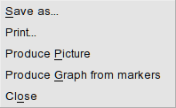
gui319
Save as.. save the content of the view-panel in different formats.
Print ... hardcopy the view-panel to $PRINTER or .ps file
Produce Picture create Go4 picture from viewpanel, put it in workspace
Produce Graph
from markers (see description below)
Close the view-panel

If the selected pad contains point markers as created with the Go4 marker panel (see Section 4.9.8, page 63), function Produce Graph from markers will create a TGraph object containing the marker x,y coordinates. The new TGraph is named “<Panelname>-Markergraph_<Number>” and is put into the Workspace folder of the Go4 browser. This is useful to choose certain points in a 2d histogram for a fit. Then one can apply the Go4 fit panel on the TGraph data later.

Edit menu
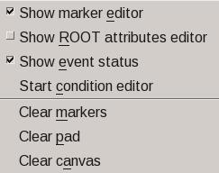
Show Marker Editor open marker panel
Show ROOT Attributes open ROOT graphics editor
Show Event Status toggle ROOT event status in bottom line
Start condition editor start condition editor if condition is in pad
Clear Markers clear all marker objects in pad
Clear Pad clear contents of current pad (and sub-pads)
Clear Canvas removes content and pad divisions

Select menu
When histograms or graphs are displayed in superimpose mode, each one may be selected here. Then attributes like color may be set for selected histogram. If the selected object is currently not on front of all superimposed objects, an additional menu entry “Show ... on top” will appear. When chosen, this entry will pop the selected object to the foreground. Note that the object first must be selected and then set to top.
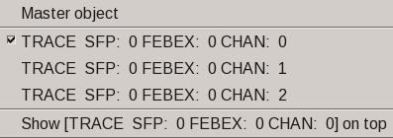

Options menu
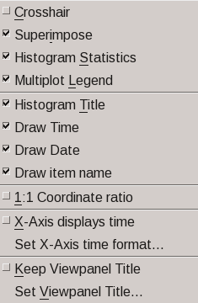
Crosshair toggle the ROOT pad crosshair mode
Super Impose toggle superimpose option
Histogram Statistics toggle display statistics box on pad
Multiplot Legend show legend for superimposed histograms
Histogram Title toggle display histogram title on pad
Draw Time display refresh time in histogram title box
Draw Date display refresh date in histogram title box
Draw item name display full path and name in histogram title box
1:1 Coordinate ratio toggle histogram aspect ratio
X-Axis displays time toggle X-axis shows data as timescale
Set X-Axis time format… define ROOT axis time format Keep View panel Title Do not overwrite title
Set View panel Title Set the title

With Settings->Panel defaults one can set defaults for these values. If the Superimpose option is selected, any new histogram that is dragged to this pad will not replace the existing histogram, but will be displayed in the same pad with the old one (as ROOT THStack). A legend box will show the graphical style and the name for each drawn curve. This legend can be toggled on or off with the Multiplot Legend option. The text of each legend entry can be changed by opening the right mouse button popup menu at the entry position and using the SetEntryLabel function (see ROOT TLegend class for documentation of further methods in this menu).

It is possible to extend the regular histogram title by information on the refresh time and date by switching on the options Draw Time, and Draw Date , respectively. Additionally, the full name of the displayed object, i.e. the complete path and item name in the Go4 browser, may be displayed in the histogram title by toggling the Draw item name option.
Usually, the title of the view panel window (showing up in the Windows menu of the main Go4 window) is taken from the object that was drawn most recently in one of the sub-pads. This behavior can be changed by options Keep View panel Title and Set View panel Title , respectively. This allows specifying a meaningful name for a view of several histograms that will not change when one histogram is exchanged by drag and drop on a sub-pad.

The Show event Status option in the edit menu will display the current mouse coordinates and histogram channel contents in the bottom line of the view panel. If the canvas is divided, this information always refers to the selected pad.

Zoom toolbox
The Zoom toolbox contains zoom and shift buttons for the x-, y and z- axes, working on the active pad (red frame). The expansion/compression factor can be set in % of the current range. The Un-zoom all button  will restore the complete range of all axes. The set limits button will pop up a scale window. Here the range can be typed in and set explicitly by axis values. Additionally, the scaling behavior of the ROOT histogram can be changed: By default (AutoScale on), the y-axis (1D histogram) or z-axis (2D histograms), respectively, is expanded to cover the full range of channel contents whenever a memory histogram is updated, or when a monitored histogram is refreshed from the analysis. With AutoScale disabled, the previous y-range (1D) or z-range (2D), respectively, is invariant over any updates. This allows to observe a magnified region of interest in a spectrum, independent of the maximum peak height. Note that the y range of a 1D histogram can be chosen freely by ROOT TAxis selection with the mouse, i.e. clicking with left mouse button on the y-axis for the first limit, and dragging the pressed mouse to the second limit of the range. The scale window is automatically connected to the selected pad and updated accordingly. Note that the AutoScale state for the current pad is also accessible as checkbox at the top of the viewpanel window. Button “a” provides auto-zoom functionality for 1/2/3-dim histogram. This automatically adjusts range selection to non-zero content of the histogram. Can be activated also with Ctrl * keys combinations.
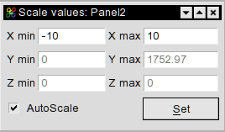
gui139
When the zoom tool panel is active, there are several useful keyboard shortcuts (see also the tooltip help of the corresponding buttons):
Ctrl-Left/Ctrl-Right: Expand/Un-expand range on x axis
Left/Right: Move Histogram left/right on x axis (only if range was expanded)
Up/Down: Expand/Un-expand range on y axis (sets autoscale off!)
Shift-Up/Shift-Down: Move Histogram up/down on y axis (only if range was expanded)
Ctrl-End/Ctrl-Home: Expand/Un-expand range on z axis (sets autoscale off!)
Shift-Home/Shift-End: Move Histogram up/down on z axis (only if range was expanded)
Ctrl-Minus: Un-zoom ranges totally
Ctrl-Plus: Show/hide range settings window
Ctrl-Star: Apply auto zoom (adjust range to show non-zero region only)

Draw options and axis scaling
Draw options and axis scaling can be set by two toolbars: One for all options available (Settings->Show/hide->Draw Options) steered by pull down menus (as described below):
gui366

and one for a subset (Settings->Show/hide->HIstDraw Options) steered by buttons only:

gui367

Both toolbars also offer buttons to change the line color , the fill color , and the marker color of the selected object, resp. Each of these buttons will open a color selection window.
The button icons of the HistDraw Options toolbar correspond to the draw option icons as shown in the pull down menus below. Additionally, buttons and will scale the Y axis linear or logarthmic,resp; buttons and scale the X axis, and buttons and the Z axis, resp. When the HistDraw Options is active, keyboard shortcuts exist for fast toggling the y axis scale:
Ctrl-Page Up: Y axis in logarithmic scale
Ctrl-Page Down: Y axis in linear scale

Buttons and set the 1d histogram line style to “scatter” and “simple line”, resp.
The Go4 draw options follow the ROOT draw options (see table on next page).

Draw options for 2-dim and 1-dim histograms and graphs:

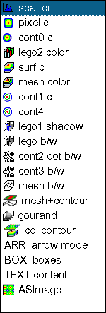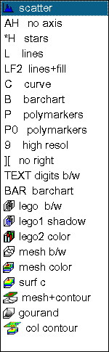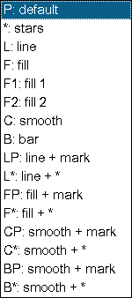
gui135/gui362/9
Details for 2-dim and 1-dim histograms:

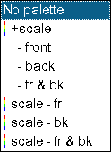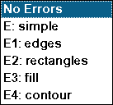
gui364/5
Coordinate system:

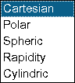 gui365

For graphs:
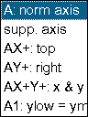 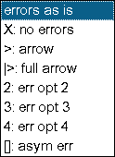 gui370/1
Go4 option | Description | ROOT
scatter | black scattered points | HIST
pixel c | colored pixels | COL
cont c | colored contour | CONT
surf c | colored surface | SURF2
pix+scale c | colored pixels and color scale bar | COLZ
cont+scale c | colored contour and color scale bar | CONTZ
Gouraud | smooth grey scale surface | SURF4
lego c | colored lego | LEGO2
lego/shadow | lego with one side colored | LEGO1
lego bw | black and white lego | LEGO3
mesh c | colored meshed surface | SURF1
mesh bw | black and white meshed surface | SURF
mesh+cont | bw meshed surface and colored contour on top | SURF3
line c | colored contour lines | CONT1
line dot bw | black dotted contour lines | CONT2
line bw | black contour lines | CONT3
boxes bw | black boxes | BOX
digits bw | channel content as numbers | TEXT
ASImage | TH2 as TASImage (fast pixel map with scale bar)
P0 (1D) | Polymarker without lines | P0
L (1D) | Line | L
C (1D) | Smooth curve | C
B (1D) | Bar chart | B
mesh+cont2 | bw meshed surface and colored contour on top | SURF5
cont4 | colored contour | CONT4
cont1+ pal | colored contour lines and color scale bar | CONT1
cont4+pal | colored contour and color scale bar | CONT4
arr (2d) | arrow plot | ARR

Color Palette tool
The color palette tool can be activated by menu Settings->Show/hide->ColorTools . It offers to
set the ROOT color palette either by index number, or by a corresponding self explaining name (for ROOT 6 and latest 5.34). The available palette index range may be restricted by the preferences in menu Settings->Panel defaults->Palette settings. Here also the default palette index can be specified.
Additionally, the pad background color can be set from all available colors by pressing the pad button  and choosing it on a color wheel pop up.

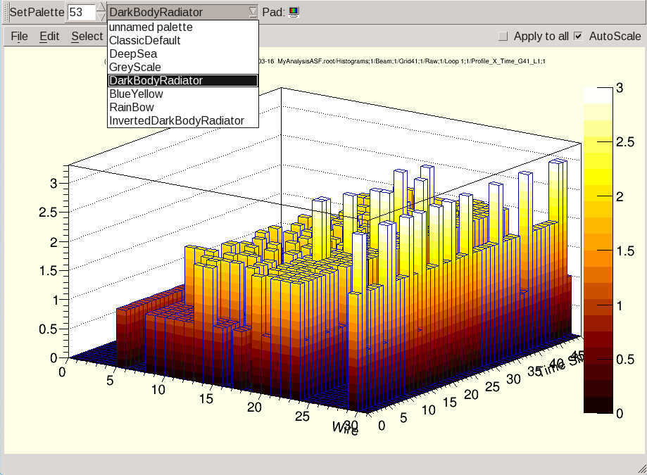

Channel and window markers
In a view panel a marker panel can be opened by Edit►Show Marker Editor menu item:

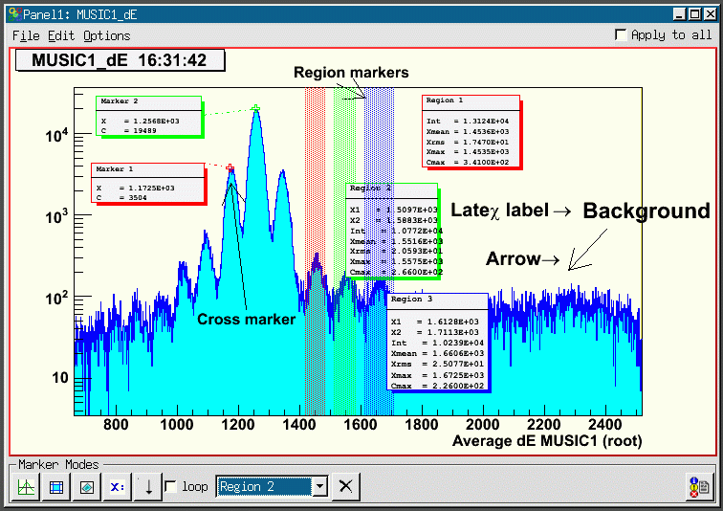
gui324
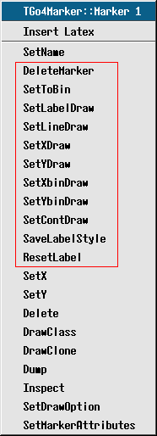
gui154
Pressing once on button and then one more time in the pad, a channel marker (cross) with a label and a connecting line is drawn. Once created, any marker can be re- positioned by chosing its name in the marker selection box and using again the button: the next pad click moves the currently active marker to the picked position. If new is chosen in the marker selection box, a new marker is created and added to the list. Note that the selected marker is always displayed on front of all other objects in the pad. Clicking on a marker or its label box with the left mouse button will also pop it frontmost.
With new selected and loop option enabled, the cursor stays after in point marker mode. Subsequent clicks in the pad create new markers. This behavior also applies for the other marker types, respectively:
draws a window marker (with two subsequent LMB clicks) and a label.
draws a polygon marker (TCutG): each click will define one point of the polygon, a double click will finish the definition of the shape.
X: places a (Latex formatted) label. Note that in ROOT Latex syntax, instead of the “\” escape character the “#” is used, so e.g “#alpha” will produce a greek α.
draws an arrow from first click to second click.
In loop mode one can switch between the five marker types.
outputs the values of the markers to the activated log output.
A selected markers can be deleted by pressing the  button near the marker selection box. Furthermore, markers may be deleted and configured with RMB on the cross or inside the window, respectively (see right TGo4Marker menu: DeleteMarker and
left TGo4WinCondView menu: DeleteRegion). The setter methods configure the layout through little windows as shown above (options 0 or 1, then apply and cancel). All elements can be moved with LMB (labels are updated). SaveLabelStyle applies current settings to all subsequent markers. With Settings►Save settings in the main Go4 window menu these settings will be stored. With Edit►Clear Markers one can remove all marker elements. To change the graphical attributes one can use the new ROOT graphical editor. It should be opened by Edit►Show ROOT attributes editor. When a graphical object is selected (LMB) the editor changes accordingly. Close the editors also through the Edit menu.
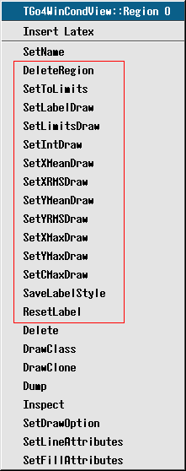
gui155
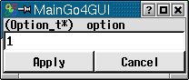
gui156

With Settings►Panel defaults►Marker labels one gets the window shown below. Here the default layout can be specified and saved.
gui354

Conditions

Conditions editing in viewpanel marker editor
A condition may be displayed in an existing viewpanel by dragging and dropping it from the browser to a destination pad containing a appropriate histogram. The full condition editor (see 4.10.2) may also draw its working condition to the viewpanel.
It is possible to edit any condition displayed in a viewpanel already by means of the marker editor in the bottom line (see figure).
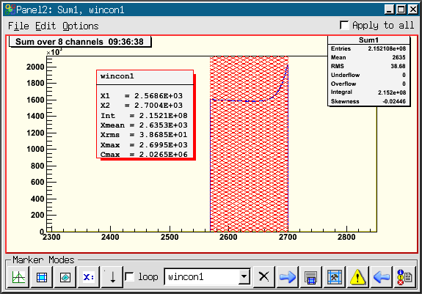
gui330
Condition wincon 1 is drawn above the histogram Sum1 that is filled only if this condition is true. As the regular markers (see 4.9.8), the condition may be selected by name in the marker selection box. In addition to the control buttons for the markers, editing a condition will enable some more buttons in the marker editor. After changing the condition by moving its boundaries, a will appear to remind you to update the condition by button on the analysis side. With the current condition state from the analysis side is refreshed in the editor window. If working on a condition from file, the refresh button will appear instead to reload the viewpanel condition.
Button opens the info window for the selected condition (see 4.15) to view current condition properties that are not displayed in the viewpanel label. For advanced editing of the condition, the full condition editor may be invoked using button .

Full condition editor
The condition editor window is popped up when one double clicks on a condition in the browser or using the edit function of the browser’s right mouse menu. It may also open by using the in the viewpanel marker editor.
In addition to the features of the marker editor, it may display and change all properties of the Go4 condition class, e.g. counters, testing properties, histogram statistics over the region, etc.
The following figures give some examples.

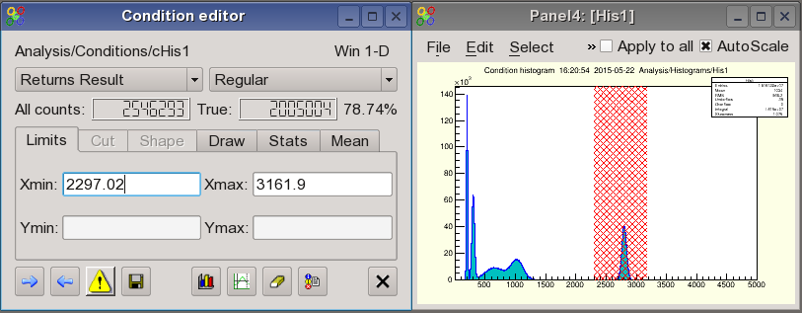
gui328
Window condition cHis1 displayed with histogram His1. The histogram has been bound to the condition by method SetHistogram() in the analysis. In this case the histogram is automatically displayed when the condition is edited.
Polygon condition polyconar is a polygon condition array from the two step example which can be displayed in a 2d view panel. When a condition array compound is edited, the index of the currently active condition can be set in the upper right spin box. The displayed values always refer to the selected array member. When selecting an entire condition array in the editor (All button or spin box index “-1”), changes will be applied to all members.

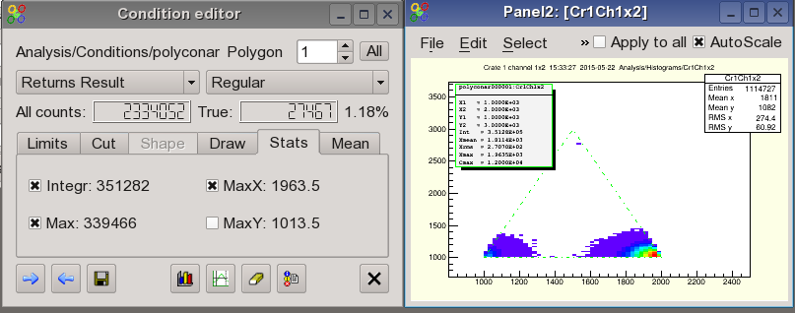
gui329
With the button the active pad of the current view-panel (selected with middle mouse button) is set as display working pad for the condition. The condition is drawn on this pad until the display button is pressed again with another active pad. If the working pad contains a histogram, it is assigned to the condition under edit and its name is shown in the editor. Note that it is possible to exchange the condition work histogram by drag and drop of a new histogram into the condition editor display pad.
After editing the condition limits graphically on the working pad, the changes will be updated automatically whenever the mouse enters the editor window. When a condition is changed in the editor (always press Enter to confirm changes), the graphical representation will be updated automatically. After changing the condition, a will appear to remind you to update the condition by on the analysis side. With the current values (e.g. counters) from the analysis side are updated in the editor window. Conditions can be set to return always true or false, respectively. The result of a condition check can be inverted. A polygon condition checks, if a point (x,y) is inside a polygon (TCutG). A window condition checks, if one or two values are inside one or two intervals, respectively.
A condition has counters for the number of all Test() calls performed, and for the number of true results. The counter values after the last refresh are displayed in the editor. With these values are reset to zero and the condition is directly updated on the analysis side.
The button allows to pick the boundaries of the condition region with the mouse. This works in the same way as in the marker editor: for window conditions, two subsequent clicks will take the click position as limits (for 2d conditions, these clicks define corner points); for polygon conditions, each click will set a corner point until the mouse double click finishes the pick mode.
Button outputs the current condition values to the GUI starting window, or into a log file if specified in the Settings menu (see 4.1). Button saves the condition in a file. If the condition editor is working on a condition in a ROOT file (via File Browser), the button will update the changes in the original file by default. This is useful to edit conditions in an existing auto save file.

Editor tabs
The condition editor offers four tabs: for the condition limits, for the display properties, for the statistics inside the selected condition range, and for the mean values, respectivly They are shown in the next screen shots:
The Limits tab contains the values of the window condition limits, or the largest extension of the polygon condition boundaries. These are updated from the graphical representation on the working pad, or can be typed in directly in case of window conditions (to apply the typed values press RETURN).
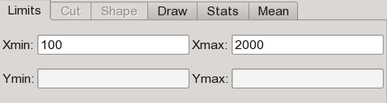
-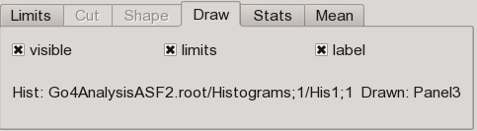
-
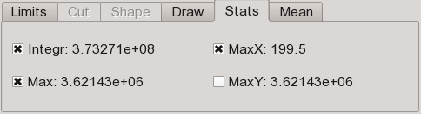
-
-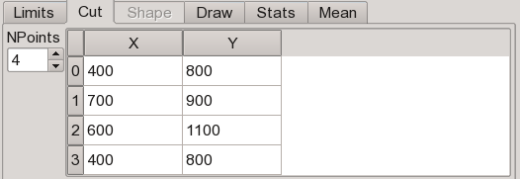
-
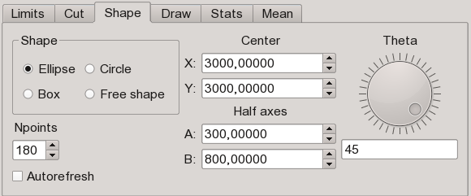
The Draw tab shows the names of the histogram and viewpad used to display the edited condition, and allows to control some draw properties. Each condition can be set as visible or not with the visible checkbox. If visible, the condition is shown on the working pad, otherwise it is hidden. This is useful when working with condition arrays. It is recommended for polygon conditions to improve editing. The visibility is a property of the condition class itself and is stored in the auto-save file. The label checkbox enables the drawing of a graphical label together with the condition (see screenshot examples). This label may contain the limits values from the Limits tab; this can be toggled using the limits checkbox. Other entries of the label may be configured in the Stats and Mean tabs.
The Stats tab shows some statistics (Integral, position and channel content of the maximum) of the current histogram inside the selected condition. In addition, the Mean tab contains mean and RMS values for x and y directions. Setting the corresponding checkboxes plots these values into the label on the working pad.
The Cut tab is only active for polygon and shaped conditions. It shows the table of x and y coordinates of the polygon (TCutG). These values may be edited here (to apply the typed values press RETURN). Moreover, the number of polygon points can be changed with the NPoints selector box. If the TCutG is edited graphically on the pad by mouse, the values in the table will be synchronized the next time the mouse enters the editor window.
The Shape tab is only active for shaped conditions. It contains parameters to modify some basic shaped conditions (see section 2.4.3) (ellipse, circle, box, free polygon). The shaped conditions are polygon conditions that may be parametrized to approximate basic forms, such as Ellipse, Circle, or rectangular Box, as selected in the Shape control frame. Any of these is defined by center coordinate (X,Y), the diameters of the symmetry half axes (A,B), and a tilt angle (Theta) in degrees between the x coordinate axis and the alf axis A. If the Autorefresh checkbox is selected, any change of these coordinates will be immediately shown in the corresponding condition display (see right side of screenshot below).
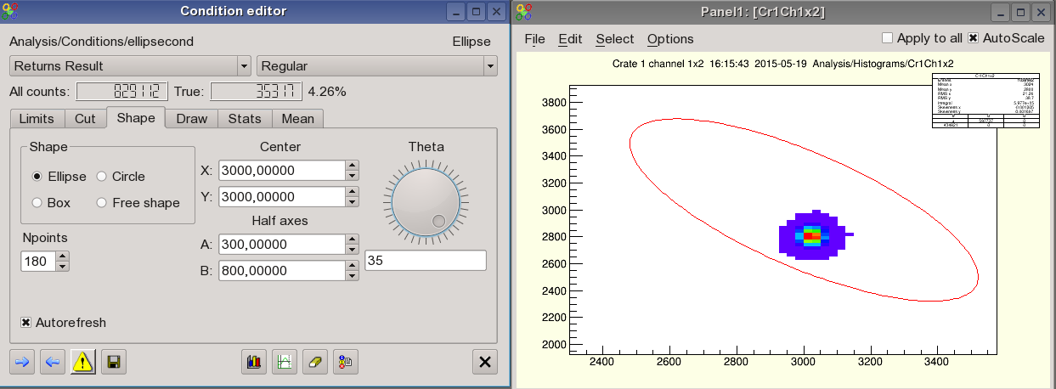
The number of polygon points to approximate the intended shape can be chosen with the Npoints spinbox element. Using a small number of points with a Circle shape also allows easily define symmetric polygons inscribed into a circle, e.g. a hexagon. For box shaped conditions, however, the number of points is always fixed to 4. It is possible to exchange the shape on the fly by switching the selection in the Shape control box. The condition editor will try to convert the polygon points into the new form, based on the center, half axes and tilt parameters. If the Free shape type is chosen, the shaped condition behaves like a regular polygon condition and may be edited in the Cut tab or with the mouse on the view panel like any TCutG. The parameters, except for the number of points, are ignored. If a free shape condition is converted back into circle, ellipse, or box shape, the condition editor will fit the parameters closest to the existing polygon points, but may change the free shape points though. As a special case, an ellipse or circular condition can be converted to free shape and then easily moved to another location on the canvas with the mouse, just by pointing over a border line, clicking the left mouse button and moving the selection as known from TCutG manipulation. Switching then back to the original shape will evaluate the new center coordinates without modifying much the other shape parameters.

Conditions bound to pictures
In the next example two conditions are bound to the upper pads of a picture (see chapter 4.11, page 72) by method AddCondition().

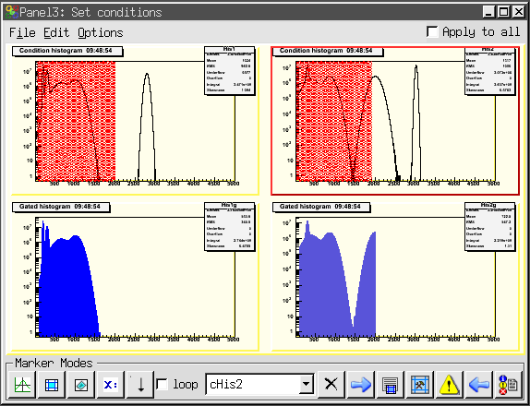
gui335

The histograms in the lower pads are filled under the condition shown in the pad above. All picture conditions will be shown simultaneuosly (if their visible property is true). Mouse click on a picture’s subpad will deliver the names of all contained conditions into the selection box of the marker editor. The selected condition may be modified and updated by means of the marker editor, or using the full editor started by button, as described above. The mechanism to bind conditions to picture pads guarantees that a condition is set always on the correct histogram.

Creating conditions
With the button of the main window “Tools” menu and toolbar, one can open a window to create a new condition in the analysis. This functionality is available as a shortcut from the dynamic list editor, too (see 4.14). The Create condition dialogue expects a condition name, the type (1-D window, 2-D window, polygon), and optional an array size. For Array size “no array”, a single condition is created, otherwise a condition array compound that contains the given number of conditions.
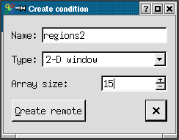
gui336
After pressing the Create remote button, the new condition will appear in the subfolder Analysis/Conditions of the Go4 browser. The name field in the create dialog may contain any subfolder path relative to this default location, e.g. Name: myconditions/region2 will create new condition region2 in folder Analysis/Conditions/myconditions. Non exisiting subfolders are created in this procedure together with the conditon.
Once created, the condition can be modified from the condition editor or from the viewpanel marker editor as described above. When the auto-save mechanism was enabled, the condition will be restored at next analysis startup. Note that it’s not possible to create a new condition without the analysis connected to the gui!

Pictures
The TGo4Picture class provides a way to set up a view in the analysis, which then can be displayed in the Go4 GUI. A picture contains:
- references to objects (via names), which should be displayed;
- division setups of pictures into sub-pictures;
- draw options and parameters like line attributes, axis ranges and so on.

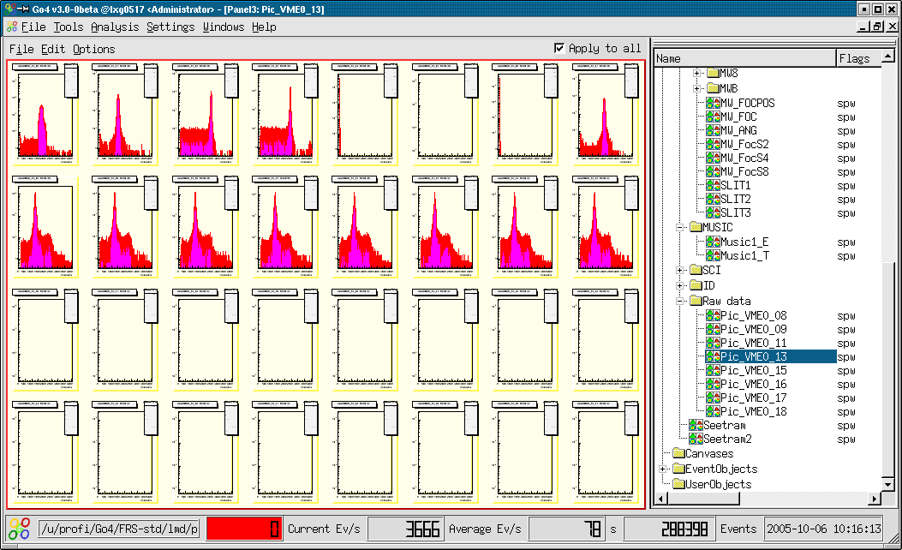
gui337
The following code creates a simple picture, which contains only one histogram:

TGo4Picture* pic = new TGo4Picture(“pic1”,”picture title”);
pic->AddH1(histo); // histo is variable of type TH1*

A picture can be divided into sub-pictures like a ROOT canvas can be divided into sub-pads. The division of a picture can be specified in the picture constructor or by method SetDivision(int ndivy, int ndivx) which creates ndixy*ndivx sub-pictures inside the picture. Sub-pictures can be accessed via method Pic(posx, posy). For each picture (and sub-picture) one can specify the following options:
Display header pic->SetDrawHeader()
X axis range pic->SetRangeX(double, double)
Y axis range pic->SetRangeY(double, double)
X log scale pic->SetLogScale(0, bool)
Y log scale pic->SetLogScale(1, bool)
Z log scale pic->SetLogScale(2, bool)
To add an object to be drawn the following methods can be used:
TH1, TH2, TH3 pic->AddH1(TH1*)
THStack pic->AddHStack(THStack*)
TGraph pic->AddGraph(TGraph*)
TGo4Condition pic->AddCondition(TGo4Condition*)
Each method requires a pointer to the correspondent object and optional draw options (if necessary). When an object has been added to a picture, the following drawing options can be set for this object (see ROOT manuals):
Line attributes pic->SetLineAtt(Color_t, Style_t, Width_t)
Fill attributes pic->SetFillAtt(Color_t, Style_t)
Marker attributes pic->SetMarkerAtt(Color_t, Size_t, Style_t)
Draw options pic->SetDrawOption(Option_t *)
TStyle attributes pic->SetStyle(TStyle*)
Axis rebining pic->SetRebinX(Int_t ngroupx), pic->SetRebinY(Int_t ngroupy)
For example, to configure a picture with four sub-pads (2 x 2), each with a different histogram, the following code can be used (first index top down, second left right):

TGo4Picture* pic = new TGo4Picture(“pic1”, ”picture title”, 2, 2);
pic->SetDrawHeader(kTRUE); // displays time, name and title of picture
pic->Pic(0,0)->AddH1(histo1);
pic->Pic(0,0)->SetRangeX(100, 200);
pic->AddH1(0, 1, histo2); // or pic->Pic(0,1)->AddH1(histo2);
pic->Pic(0,1)->SetDrawOption(“lego”);
pic->AddH1(1, 0, histo3, ”lego”);
pic->AddH1(1, 1, histo4);
AddPicture(pic); // add picture to frame work

Similarly the colors in above figure have been set up by:

Color_t his=0;
for(int i=0;i<8;i++) for(int k=0;k<8;k++){
fPict1->Pic(i,k)->SetFillAtt(his,1001);
fPict1->Pic(i,k)->SetLineAtt(his,1,1);
his+=2;
}

The TGo4Picture class supports arbitrary levels of picture divisions. This means that each sub-picture can also be divided. For instance, a picture with 3 histograms, two in top row and third in bottom row, will be created by the following code:

TGo4Picture* pic = new TGo4Picture("pic","pic title",2,1);
pic->SetDrawHeader();
pic->Pic(0,0)->SetDivision(1,2); // divide top widget on two more pads
pic->Pic(0,0)->Pic(0,0)->AddH1(histo1); // add histogram to sub-sub-pad
pic->Pic(0,0)->Pic(0,1)->AddH1(histo2); // add histogram to sub-sub-pad
pic->Pic(1,0)->AddH1(histo1, "lego2"); // add histogram to sub-pad
AddPicture(pic);

Current limitations of pictures are:
- Only histograms (TH1), graphs (TGraph) and stacks (THStack) can be add to picture or sub-picture.
- Several histograms or graphs displayed together only when pic->SetSuperimpose(true) is set.
- Conditions can be displayed only in pair with a histogram.
- A condition can be added only after a histogram has been added.
In the Go4 GUI pictures will appear in the analysis browser in the Pictures subfolder. Together with the picture all correspondent histograms will be automatically transferred. Double click on a picture draws it in a new view panel. A picture also can directly drag-and-dropped into an existing view panel.
Pictures also can be put to the monitoring list. Putting a picture to the monitoring list automatically puts all histograms of the picture to the monitoring list, too.

Fit GUI
All information of a fit like models (= fit functions) and their parameters, references to the data, and the results are stored in a fitter object (=FO). The fit panel (activated by button) is the editor of fitter objects. The fit panel is attached to a fitter object to edit it. Fitter objects are stored in two different locations:
- Fitter objects can be in the browser (file or memory). By double click the fitter object is displayed in fit panel.
- Fitter objects can be stored in a pad of a view panel (one per pad). Such fitter automatically displayed in open fit panel when pad is activated.
To create fitter for active pad, Fitter►create for pad menu item or Use pad button of fit panel should be used. The fitter object can always be copied to memory browser and than saved to the file. The data reference of a fit object is changed or set when:
- creating or copying a fitter object to a pad,
- dragging a histogram into a pad (the fitter object of the pad gets the reference to that histogram),
- dragging a histogram name into fit panel.
The next picture shows a pad in a view panel and the fit panel. The peak finder tab is shown.

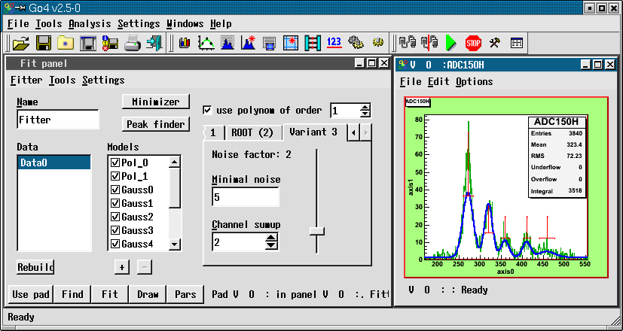
gui129

On the bottom of fit panel there are five buttons:
Use pad If fitter displayed in fit panel, it will be copied to selected pad in last active view panel. If there is no fitter in fit panel, a new fitter will be created for this pad.
Find Executes peak finder routine. All peak finder parameters should be setup first. Work only in Wizard mode.
Fit Executes fit.
Draw Draw models, backgrounds and model components as sets up in Settings sub-menu.
Pars Show all fitter parameters in a table. Parameters can be listed one by one or in lines mode, when one line corresponds to one model and contains amplitude, line position and line width.

There are three different layouts of fit panel, which can be chosen in Tools sub-menus:
Simple Contains several buttons to fit data to polynomial function, gaussian, lorentz and exponent.
Wizard Intuitive and easy-to-use tool to setup data objects and model components. Also includes peak finder setup. Suitable for most fitting tasks.
Expert Advanced tool, which gives full control over the fitter. Provides a hierarchy view of all objects inside fitter and possibility to change any relevant data fields. Supports all functionality, which may not be presented in Wizard tool.
In wizard mode there are three different peak finders available (see previous figure). Variant 2 is ROOT, Variant 1 searches peaks having specified width range above a threshold, variant 3 searches minima and maxima using a dynamic noise bandwidth. Variant 3 also allows for summing up channels to reduce the noise. Depending on the histogram characteristics, either of these may give good results. One has to play with the parameters. Changing parameters automatically launches a Find.
Found peaks are marked in the View panel pad in red. One can move their position and change their width with the mouse. Clicking on a data or model entry the right side of the panel shows related information. Models can be [de]activated clicking on the OK boxes or removed by [-]. New models can be added by [+]. After the fit the results can be seen pressing the Pars button (which changes to Back to switch the view back):

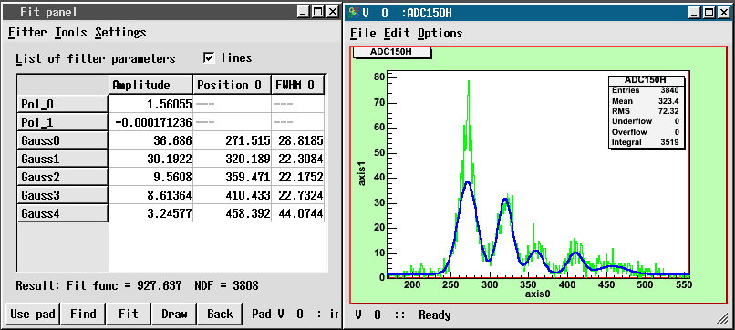
gui130

Fitter sub-menu has following items:
Create for pad create appropriate fitter for selected pad in last active preview panel
Delete delete fitter
Save to browser save fitter to Go4 memory browser
Update reference updates references on data objects from file or memory browsers
Print parameters produces parameters printout, parameters page should be active
Rollback parameters restore value of parameters, which automatically stored before last fit
Close close fit panel
Settings sub-menu contains following items:
Confirmation For each delete action (of fitter, data, model and so on) confirmation message will appear
Show primitives Show graphical primitives for model position and width and for range settings
Freeze mode Fit panel is not automatically attached to selected pad, but only by create/copy/move command from Fitter sub-menu
Save with objects Save objects, to which fitter have references, together with fitter. When such a fitter will be loaded, it will have copy of saved objects. Available only in wizard or expert mode
Use current range At any fit or peak finder action automatically uses range which is currently selected on histogram
Draw model Draw model of data
Draw background Draw background (sum of all model components, belongs to background group)
Draw components Draw all model components, which are not belong to background group
Draw on same pad Use same pad for drawing or create separate preview panel
Draw info on pad Draw on pad info box with parameters values
No integral Do not show any integral values on parameters page
Counts In lines mode on parameter page additionally shows counts number for every model component inside specified range
Integral Shows integral value for every model component inside specified range
Gauss integral Calculates and shows theoretical (based on amplitude and width parameters) integral for one-dimensional gaussian components. None of specified range conditions are taken into account.
Recalc gauss width For gauss components recalculates sigma values to full width on half maximum (FWHM)
Do not use buffers Do not use any memory buffers for fit
Only for data Use buffers only for data objects
For data and models Use buffers for all data objects and model components
Individual settings Use buffers as selected individually for each data object and model component

Detailed help on fitter and fit panel can be obtained from the main window Help►Fit tutorial.

Parameters

Parameter objects
Parameters are objects containing a user defined structure of values. These can be applied for controlling and calibrating the user analysis apart from the analysis framework configuration. All user parameters should be subclasses of TGo4Parameter. They can be created in the user analysis code and are registered to the Go4 framework by method AddParameter(TGo4Parameter* mypar). Once a parameter was registered, it appears in the Go4 Parameters folder, it is saved and can be restored from the auto-save file, and it can be edited and updated from the Go4GUI by means of the parameter editor.

Parameter editor
Double clicking a parameter icon in the browser will open the parameter editor as seen in the picture. All known members of the user parameter class and its base classes are shown here with their names, their type and their current value.

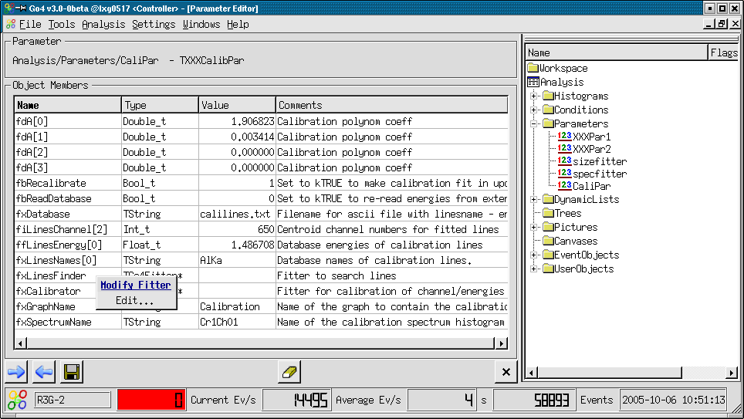
gui125

Currently supported types are:
- all basic signed and unsigned types, e.g. Double_t fdEnergy; Bool_t fbIsOK;
- the ROOT TString class to wrap text strings, e.g. TString fxMyFilename;
- pointers to TGo4Fitter objects, e.g. TGo4Fitter* fxUnpackfitter;
- arrays of the above in 1 or 2 dimensions, e.g. UInt_t fuVal[42];
Float_t ffVoltage[5][100];
- ROOT classes TArrayI and TArrayD containing arrays of integers and double values, resp.
- Comments behind member declarations (e.g. ”// my comment”) are shown in the Comments column.
Aggregations and pointers to basic types are not supported at the moment (except for aggregated fitter objects).
Arrays of data are expanded and collapsed in the table by double clicking on the array name. Additionally, the right mouse button will open a popup menu to navigate through the array without expanding it completely.
The values of the data can be edited after double clicking in the value field of the data member table. Note that any editing action has to be finished by pressing “return”, “tab”, or “cursor” before it is valid. To apply the changes, press which will update the edited parameter on the analysis side. This is done by method UpdateFrom(pointer to new) provided by the user class. This means that arbitrary functions can be executed! The changing of data members is fully controlled by the user class. Vice versa, will refresh the table shown in the editor from the current values of the analysis parameter. Note that all changes not yet applied to the analysis or saved are overwritten on refresh!
If one is working on a parameter loaded from a file, button will appear instead of , doing a refresh from the source file. Note that the original parameter in the file is not changed by the editor immediately; the root file is updated only when using the save button . Then a save dialog window will appear, that allows either overwriting the original parameter, or saving the changed object to another file.
Finally, will erase all editable fields of the table. will close the editor without modifying the analysis parameter.

Parameters containing fitters
Sometimes it might be useful to exchange a Go4 fitter object between the analysis and the GUI. A fitter, e.g., may be prepared using the FitGUI and then sent to the analysis client where it can be applied to some histograms during analysis. Vice versa, one might want to display the resulting parameters of automatic fits in the analysis on the GUI. Therefore, the Go4 parameter concept supports the TGo4Fitter class as aggregation member, i.e. a pointer to a fitter can be accessed by means of the parameter editor.
The Go4 framework already offers the parameter class TGo4FitterEnvelope that contains one fitter object. This fitter may be accessed in the analysis by method GetFitter(). In this case it is important that the fitter object itself is exchanged inside the parameter each time the parameter is updated. Thus the user should not keep the pointer to the fitter in his/her analysis class, but request the fitter from the (persistent) TGo4FitterEnvelope parameter with the getter method when the fitter should be used.
Additionally, any user defined subclass of TGo4Parameter may contain references to several fitters or even arrays of fitter references. Here it is the user responsibility how the fitters refresh their settings in the UpdateFrom() method. Moreover, one may implement getter and setter methods for the most important values of the fitters without the need to access the internal fitters directly. An example is TXXXCalibPar in the Go4ExampleAdvanced directory.
Pressing the right mouse button over the name of a fitter member will open a context menu. Selecting Edit... (or doublc clicking on the fitter) will open the Go4 FitGUI window (see chapter 4.12, page 72). A copy of that fitter is put into the local workspace of the Fit GUI to be edited or to be applied on any histogram. Selecting Get from FitPanel in the context menu, the fitter in the parameter object is replaced by a copy of the fitter that is currently active for the Fit GUI. So any fitter existing on the GUI may take the place of any fitter inside a parameter. Note that the original fitter member in the parameter will be lost after this action unless it is refreshed by from analysis again! To send the changes in the fitter back to the analysis client, like for all parameters the button must be pressed.
Note that in case of a fitter pointer array (e.g. TGo4Fitter* fxFitters[10] ), the context menu will show both the items to manipulate the array view and to edit or update the selected fitter.

Dynamic lists
The Go4 dynamic list is a mechanism to connect the event data with a histogram and a condition. The histogram is filled from certain data members of the event during the analysis. Optionally, the histogram may be filled only if a condition that is tested against other data members of the event is true. In contrast to the histograms filled from the compiled user analysis code, the dynamic list offers the possibility to define these relations on-line during the running analysis. The dynamic list and all newly created histograms and conditions may be stored in the Go4 auto-save file and are recovered on the next analysis initialization ( or Submit button in the configuration menu).
In the Go4 browser, the dynamic list folder contains all existing dynamic lists (currently only one default list). Each list shows the existing dynamic entries by name. Double clicking on a dynamic entry will open the dynamic list editor to display and change it.
To create a new dynamic entry, button of the main window tools menu will open the create new entry dialog window. Here you can define the name and the kind of the dynamic entry. There are 2 different kinds of Go4 dynamic entries: The TreeEntry and the PointerEntry (see below). After pressing “Create remote” button, the new dynamic entry will appear in the browser in analysis subfolder DynamicLists.
To delete a dynamic entry completely, select its icon in the Go4 browser and select in the right mouse button menu.

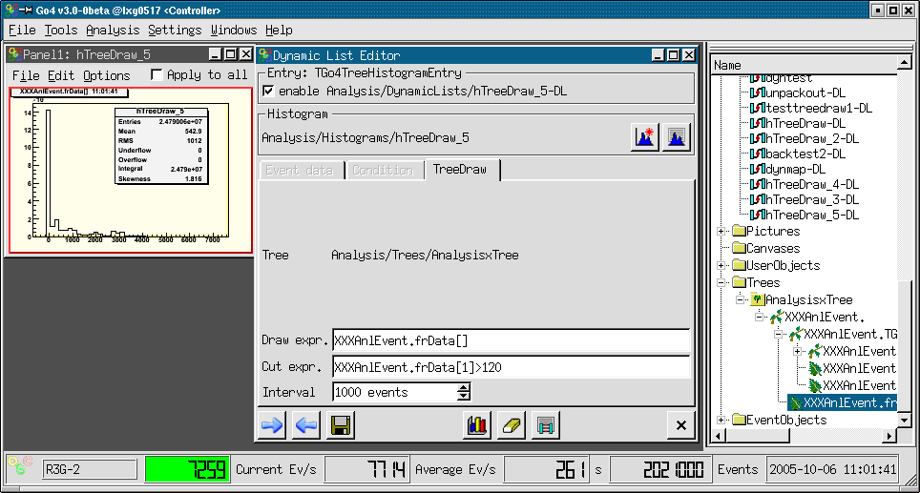
gui339

Dynamic list editor
Depending on the kind of the entry, different sub-pads of the editor are enabled: The Histogram and TreeDraw sub-pad for the TreeEntry, and the Event data and Condition sub-pad for the PointerEntry, respectively.
Any dynamic entry can be enabled or disabled by switching the enabled checkbox. A disabled entry will not be processed, but is still in the dynamic list. Note that if a dynamic entry fails on initialization (e.g. unknown object names), it is disabled automatically.
To apply the changes, press which will update/create the edited entry on the analysis side, respectively. Vice versa, will refresh the values shown in the editor from the current status of the analysis dynamic entry. Note that all changes not yet applied to the analysis are overwritten on refresh! A label will appear near the update button if the changes have not been applied to the analysis yet.
If one is working on a dynamic entry loaded from a file, button will appear instead of , doing a refresh from the source file. Note that the original dynamic entry in the file is not changed by the editor immediately; the root file is updated only when using the save button . Then a save dialog window will appear, that allows either overwriting the original parameter, or saving the changed object to another file.
will clear the target histogram in the analysis to zero counts, and will reset the events in the backstore tree (in case of tree draw entry, see below.) This allows to observe changes of the dynamic entry setups directly if the target histogram is monitored. will close the editor without modifying the entry.
The editor offers the additional feature to get some information of the histogram and condition status from the analysis. Clicking in the Histogram or in the Condition sub-frames will retrieve and display the current object status in the histogram or condition status windows, respectively (see chapter 4.15, page 79). This may be useful to check if histogram or condition settings (dimension, ranges, bin size, etc.) are suitable, without requesting these objects in the browser. Additionally, some filling and testing statistics is shown here. The GUI tool tips show brief explanations for each information line.
The button prints the names and connections of all existing dynamic entries to the analysis output window.
New histograms or conditions may be created in the analysis by the or the button, respectively. For histograms, the standard histogram creation window (see chapter 4.8.3, page 57) pops up. Use the Create Remote button here. For conditions, the “new condition” dialog is started (see chapter 4.10.5, page 69).

Entry for tree draw
Go4 uses the ROOT TTree::Draw() mechanism for the on-line evaluation of the data. This works just as described in the ROOT users Guide: A string expression defines which leafs of the tree shall be scanned by name. Additionally, the name of the output histogram must be specified; the histogram may either already exist (Create Remote from Go4 ), or it is created from the first TTree::Draw() by ROOT with automatic range and binning. Instead of a Go4 condition, this mode works with a TCut string expression to filter the histogram filling.
Note that the TTree must exist for this mechanism. Usually, the TGo4FileStore output will create and register a tree that can be used here. If no file output is needed, one can switch on the TGo4BackStore output (configuration window) which will fill a temporary TTree in memory that is cleared after each TTree::Draw() scan of the dynamic list. The TTree::Draw() is not performed for each single event, but after a number of events have been filled into the tree. This number can be specified in the user analysis by TGo4Analysis::SetDynListInterval(Int_t val) or by the Interval field.
A new tree draw entry can be created either from the Go4 tree viewer (drag of the tree name from the Analysis browser and press ), or from the Create Dynamic Entry dialog. In the latter case, the tree name, the histogram name, the draw expression and optionally a cut expression may be specified directly in the dynamic list editor after creation. This works by “drag and drop” of historams and tree leafs from the browser to the corresponding fields of the dynamic list editor. Note that the TTree name is recognized automatically from the dropped leaf.
The advantage of a tree draw entry is that it can access any level of substructures of the event if it is resolved in the TTree (depending on split level); the Go4 composite event data may be fully accessible here. It offers all functionality of the ROOT TTree::Draw(). The disadvantage is that you need to fill the event data into a tree to access it. The histograms are not filled event by event, but the tree is processed in event buffers. The buffer size should be adjusted by the user depending on the typical event rate. Since the pointers to the data and the histogram are searched by name for each Draw() call, the performance is slow compared to histogram filling from direct pointer access like in the precompiled user analysis case.

Entry for event loop
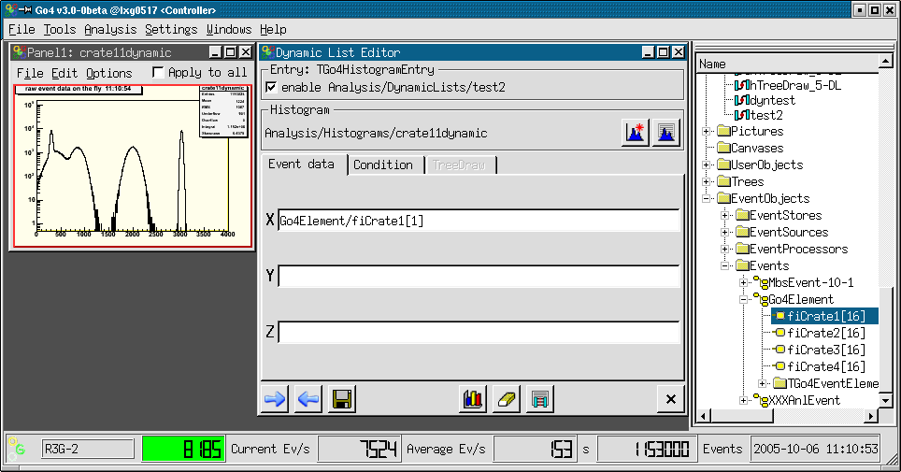

gui340
In this mode (PointerEntry), the pointers to histogram, event data and an optional Go4 condition are looked up by name once on initialization of the dynamic list. During the analysis, these pointers are used directly to test the condition and fill the histogram event-by-event. The information to locate the pointers is taken from the ROOT TClass information of the user event classes; it is not necessary to fill the event into a TTree.
For the pointer entry, at least the name of an existing histogram and one dimension of the event data must be specified. This is done in the Event data tab of the editor. Usually, for a new pointer entry the histogram should be created by (see above). The new histogram item must then be dropped from the browser to the dynamic list window.
The event data is defined by the event name and the name of the data member of the corresponding event class, separated by a slash (“/”). The Go4 browser Analysis folder offers a view of all existing TGo4EventElements in the EventObjects.Events folder. From here you may just drag and drop the Data member item to the corresponding field of the dynamic list editor. Note that data arrays are shown with their maximum size here, you need to edit the index afterwards to specify the desired array member.
Similarly, the data to test the condition can be defined in the Condition tab of the editor. The condition is usually created and registered in the compiled user analysis and is identified by name here. Polygon conditions and 2 dimensional window conditions need the event data specifications both in x and y directions. Note that the condition event data lines should be left blank if the condition shall not be tested in the dynamic entry (i.e. the histogram is filled anyway). With a new condition can be created. Button will open the editor for the specified condition.
The advantage of the pointer entry is that you do not need a TTree. Testing and filling is done for each event by pointer without any additional string compare after initialization. Therefore it is faster than the tree draw. The disadvantage is that currently only one level of substructures and only one dimensional arrays are supported (to be improved...). Implicit summing up of not specified array indices, like in the TTree::Draw(), is not possible here.

Histogram/condition information
To check the properties of a histogram or condition, general property windows exist for these objects. They support drag and drop of icons from Go4 browser. These windows will also pop up from the browser’s context menu when the button is chosen.

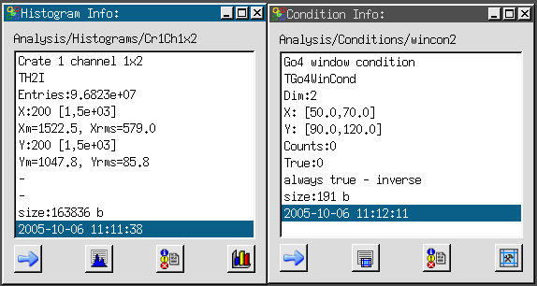
gui341

With the button or the button of the tools menu one opens the histogram or condition information window, respectively. To see the properties of a histogram or condition, drag the icon from the browser into the window. With the information is updated from analysis. With the information is output to the GUI start up window, or into a log file if specified in the log settings (see chapter , page 37). With all histograms ( all conditions) are listed in the analysis output window. starts the condition editor for a condition. displays the histogram in a view panel.

Event information
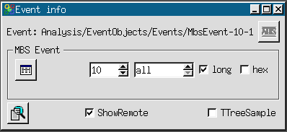
gui342
The event information tool window allows to control printout of event samples from the analysis. The button of the tools menu will open the event information window. This button is also available as a shortcut in the Qt analysis terminal. The entry of the browser’s context menu (right mouse button) over an event item will open the event information tool, too.
The name of the examined event is shown in the top text line. By default, the MBS event is chosen for printout. The event object names may be dragged and dropped to the event information window from the Go4 browser. Clicking the button will switch to the MBS event mode directly without the need to drag the MbsEvent-10-1 icon.
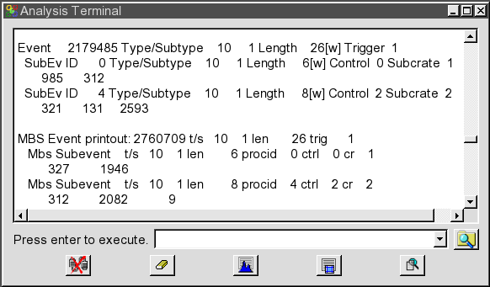
gui152b
The ShowRemote checkbox selects if the printout of the event sample is done in the remote analysis terminal, or in the terminal where the GUI was started. The TTreeSample checkbox selects if the PrintEvent() method of the event shall be called (TTreeSample off), or if the sample event shall be written to a ROOT Tree which will use the TTree::Show() method to scan and display the data (TTreeSample on). Note that for user event classes that do not implement a PrintEvent() nothing will be displayed except for the TTreeSample mode.
Each click on button will print events as shown in the upper part of the screen shot left side. The examine button will display a new printout of the currently active event (lower output on the left). Note the different format!
Additionally, for MBS events this window provides in the MBS Event sub-panel parameters for the SetPrintEvent() method. One can specify in the left field how many MBS events arriving shall be printed out in a special format. In the next field a sub-event id may be filtered (default is to display all sub-events). The hex checkbox selects to print the sub-event data either in hex or in decimal format, while the long checkbox defines if the data is seen as longwords or words. Pressing the button will resubmit these settings to the analysis thus initiating a new printout of n events. Note that the MBS Event sub-panel is independent of the settings for the regular printout of the current event. It works for the remote analysis terminal only, and it uses a different printout format than the TGo4MbsEvent::PrintEvent() or TTree::Show() methods.

Hot start
When starting the GUI several actions have to be done to get the analysis running. If these actions are always the same it would be convenient to save them in a file and execute this file when starting the GUI next time. This mechanism is called hot start. The typical actions are:
- Launch analysis client
- Submit analysis configuration
- Get analysis folders by
- Set histograms and pictures into monitoring state
- Open some view panels and display histograms or pictures
After GUI and analysis are configured, one can create a hot start file by Settings►Generate hotstart. A file selection menu pops up were one can specify a file name. The postfix should be .hotstart. The next time one can start the GUI with this filename as argument (.hotstart can be omitted). Then all actions stored in the file are executed.
With care, this file could even be edited.

User GUI
Go4 provides a possibility to execute user widgets on GUI side. There is an example of a user GUI, included in the standard Go4 distribution in directory $GO4SYS/Go4UserGUI. It can be activated by pressing button in Tools of main window.
The easiest way to create a user GUI is to copy the content of the standard example to another directory (e.g. ~/UserGUI) and compile it there (make clean, make all). The user should also specify the path to this directory in GO4USERGUI
export GO4USERGUI=~/UserGUI
The GO4USERGUI variable can also include the name of the library (default libGo4ROOTUserGui.so) which is loaded when user GUI is started. This library must include the special function StartUserGui() which loads the qt widget library (default libGo4UserGui.so) and creates the top level widget of user GUI. At the next start of the Go4 GUI pressing the specified GUI will be opened.
The user can freely modify any widgets in the example and create new ones. Changes in library names or the top widget class should be reflected in the GO4USERGUI variable and the StartUserGui() function.
There is a support of “old style” user GUI, created with older version of Go4 (up to v2.8). In that case correct path to libraries should be specified like:
export LD_LIBRARY_PATH=~/OldUserGUI/Go4Library:$LD_LIBRARY_PATH

Qt3, Qt4 and Qt5
Currently Go4 can be built with Qt3, Qt4, or Qt5. User GUIs developed with Qt3 must be converted to be used at least with a Qt4 based Go4. For general conversion rules see:
http://doc.trolltech.com/4.0/porting4.html

Macro execution in GUI

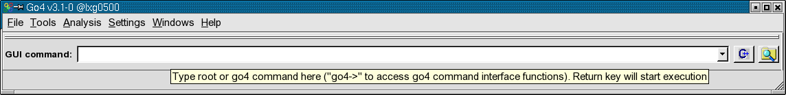
gui351
The Go4 command line toolbar can be enabled with the “Settings-Show/hide “ menu. The typed text in the command line will be executed after pressing “Return” by means of the ROOT CINT Interpreter, so all ROOT commands are available here. Moreover, the Go4 command environment is aware of the current GUI session and its objects and may access them by interface methods (see below). Like in plain ROOT, it is also possible to run complete macros by “.x” command. The button opens a browser for macros on the file system; the selected macro will be written ready to execute on the command line. With button the menu as shown in the figure below appears, showing a list of internally provided Go4 macros. The selected macro call will be copied to the command line where the empty arguments (e.g. the histogram name) can be edited before execution. Note that dragging and dropping a histogram icon from the Go4 browser to the commandline field will paste its full name there. So one can easily apply a macro to any browser histogram by dropping the browser icon inside the blank quotes (“”) of the name argument.
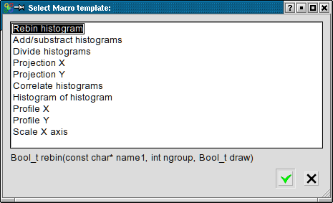
gui350
The given macros (located in the $GO4SYS/macros directory) can also be used as templates for other macros. An environment variable __GO4MACRO__ is defined and can be used to write macros to run in several environments: plain ROOT , Go4 GUI, or analysis (see 4.5.2, page 48).
The provided macros hishisto.C and corrhistos.C are written this way. The histograms to be processed are accessed through the Go4 browser or from a file, respectively.
corrhistos.C takes the bin contents of two histograms and creates a two-dimensional graph.
hishisto.C creates a histogram and makes a distribution of the bin contents of the source histogram.
Go4 provides an interface of class TGo4AbstractInterface to access the Go4 GUI browser. On the Go4 command line, or within a macro, resp, this interface can be invoked by the “go4->” pointer. Note that this is a different interface than “go4->” in the Go4 analysis macros (see chapter 5 on page 82) which invokes the TGo4Analysis instance! A further description of the available TGo4AbstractInterface methods can be found in the reference manual.
Like in the analysis terminal, there is also support for Python macros (*.py) in the GUI command line when invoked with a leading “$” character (compare section 4.5.3). Again the Python symbol go4 is not bound to TGo4Analysis object here, but to TGo4AbstractInterface, providing access to the local browser objects and GUI features.

Caution! Macros running inside the GUI can crash the GUI!
$GO4SYS/macros directory should be added to entry Unix.*.Root.MacroPath in .rootrc setup file.

Analysis Server for ROOT macros
The Go4 analysis server offers the possibility to observe and control execution of normal ROOT macros from the Go4 GUI. This allows the development of analysis code without respect of Go4 analysis framework classes (like TGo4EventProcessor, TGo4AnalysisStep and so on) still providing remote access to the running environment of a user analysis.
It is possible with minimal effort to observe histograms, produced and filled by practically any running ROOT script. The script go4Init.C initializes Go4 and starts the analysis server in background. Function go4RegisterAll() then scans the current directory for existing histograms and makes them available remotely.
Usage:
- To enable ROOT to find the go4 macros one should enter in the .rootrc a line
Unix.*.Root.MacroPath: .:$(ROOTSYS)/macros:$(GO4SYS)/Go4AnalysisClient
(Note that .rootrc may be in current directory or in $HOME.
The standard provided by ROOT is in $ROOTSYS/etc/system.rootrc)
- Run normal ROOT session.
Execute go4Init.C script by command:
root [0] .x go4Init.C
- Run user script:
root [1] .x userScript.C
- When go4Init() is executed, go4 will start the server and printout the port number for connection:
"Waiting for client connection on PORT: 5000"
- Start the Go4 GUI in and connect to the analysis server running in the CINT. See section 4.3.2 page 42 for more.

The Go4 framework can be accessed after go4Init by the global method
TGo4Analysis* go4= TGo4Analysis::Instance();
After this call, variable go4 can access any method of the analysis framework.

Methods for object registration
Any object to be seen remotely by the GUI must be registered by one of the following methods:

- go4->AddHistogram(his); // makes histogram TH1* his available in the Go4 GUI
- go4->AddAnalysisCondition(conny);// dito for TGo4Conditions
- go4->AddParameter(par); // dito for TGo4Parameters
- go4->AddPicture(pic); // dito for TGo4Pictures
- go4->AddTree(mytree); // register TTree, but do not change Tree ownership to Go4
- go4->RemoveTree(mytree); // unregister TTree: important to cleanup reference in Go4 if tree
// is removed from ROOT (closing TFile !)
- Please see Go4 Reference Manual for other available Add... methods!

The go4RegisterAll() function (from Go4Init.C) registers all histograms found in the current directory. Some more information can be found in the example macros (see below).

Methods for run control and execution
- Int_t seconds=go4->WaitForStart(); Polls until the Go4 is set into the "running" state (by Start button on GUI or SetRunning() method) with 1 second interval. Returns number of seconds from begin of wait until "running" is switched true. If negative value is returned, a ROOT interrupt has happened during wait (e.g. Ctrl-C on CINT Canvas).
- Int_t state=go4->Process(); Process one main cycle of Go4 event loop from macro. Will first execute any command from GUI, second call the Go4 main cycle to process analysis steps, user event function and dynamic list (if existing). This call is required inside any explicit loop in the macro to process go4 framework analysis actions. The GUI event rate meter is also updated by this method. Return value is <0 if running state is stopped, otherwise 0.
- go4->SetRunning(Bool_t on); Switch Go4 running state from inside a macro. Useful to react on analysis conditions
- Bool_t on=go4->IsRunning(); Check the running state of the Go4. Maybe obsolete since this is done implicitly in methods WaitForStart() and Process(). However, macro loop may be controlled from GUI independent of Go4 main loop processing.

Examples:
The following examples can be found in $GO4SYS/macros directory. It is recommended to copy these macros to a user directory with write access, before executing them.
- hsimple.C This is a standard ROOT example from $ROOTSYS/tutorials. The only modification is to call
go4RegisterAll() after creating histograms.
To run this example, start a regular ROOT session, init the Go4 server and execute script:
root [0] .x go4Init.C
root [1] .x hsimple.C
- hsimplego4.C A variation of hsimple example. This macro will wait until the Go4 start button is pressed and then run the random filling in infinite loop (mind your disk space, since a TNtuple is filled into a file here!) Registered objects may be monitored. The loop can be started and stopped at any time from the Go4 GUI. Please try the remote tree draw on the TNtuple from the Go4 GUI and view the newly created histograms. Try to launch the TBrowser before executing the macro and inspect the content of the "Go4" folders locally...
- treedrawgo4.C Macro works on tree in a file. As before, first execute .x go4Init.C:
root [0] .x go4Init.C
root [1] .x treedrawgo4.C("filename")
The "filename" specifies a ROOT file "filename.root" that contains a TTree. Note: first tree found in file will be used.
This macro contains 2 examples on trees:
- Direct TTree::Draw() expressions are executed; after finishing, a message is sent to the Go4 GUI and the output histograms may be viewed here.
- After registration of the TTree, the go4->Process() will be executed in a loop. Please try the remote tree draw on the TTree from the GUI and view the result histograms. Loop may be controlled by the Start/Stop buttons as in example hsimplego4.C.

Control of remote analysis macro from Go4 GUI
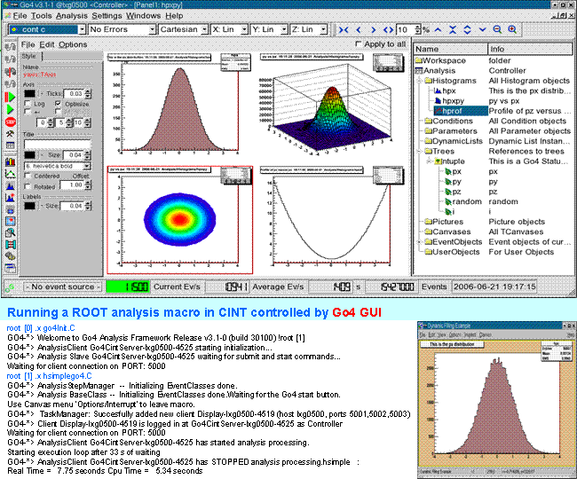
gui359

Control of remote Go4 analysis from a ROOT session
Besides the full featured Qt GUI, the Go4 analysis may be controlled and observed by a regular ROOT CINT session, using the native ROOT GUI for display.
The following screenshot shows at the bottom a go4 CINT analysis server task. Here example hsimplego4.C is running (see 5.3). This process is connected with the ROOT session in the upper part of the picture, which uses the regular ROOT GUI to browse and display the analysis objects. This is just like it would be possible with the usual Go4 GUI. Actually, a multithreaded Go4 master task is running in the background of the upper ROOT session, while a Go4 slave task is working on the analysis in the lower root session. This analysis process may not only be a root session with Go4 analysis server, but may as well be a compiled Go4 analysis client executable (MainUserAnalysis).

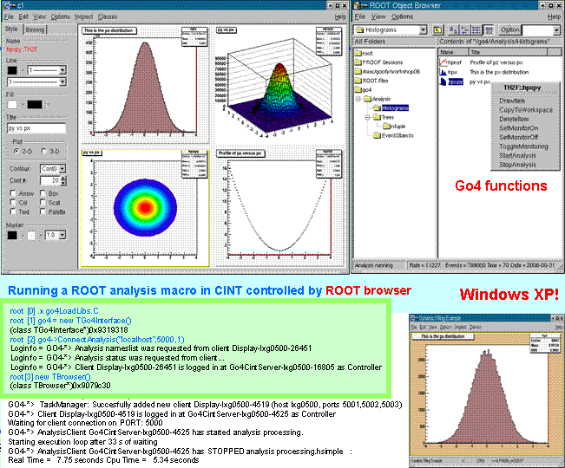gui360

Initialization
The controlling Go4 master process is realized in the ROOT session by the TGo4Interface class. After starting a regular ROOT and loading the Go4 libraries, the call
root [0] new TGo4Interface
will instantiate the master task framework. Explicit loading of libraries is not necessary if the corresponding ROOT mapfile mechanism is used. Once initialized, the variable go4 is defined as a pointer to the interface instance and may use all methods of class TGo4Interface. Note that in the analysis server session as described in section 5, variable go4 refers to the class TGo4Analysis instead!

Connecting the analysis
To connect to an existing analysis server,use
root [1] go4->ConnectAnalysis("localhost",5000,0, "XXXview");
Arguments are: hostname of the server, the port number, the login account (0=observer, 1=controller, 2=administrator), and the password. If password is left out, the default password of this account is used.
Alternatively, an analysis client may be started from this session using
root [1] go4->LaunchAnalysis("test","/u/user1/go4",
"MainUserAnalysis","lxi003");
With arguments: arbitrary name (“test”), path to the analysis executable, name of the analysis executable, and node where analysis process shall be started.
The above methods correspond to the Connect analysis and Start analysis dialogues of the Go4 GUI (section 4.3).

Controlling the analysis by command
Once the connection to the analysis process is established, it can be controlled by several methods:
- go4-> SubmitAnalysisConfig(); Submit the analysis configuration. This corresponds to the Submit button of the Go4 GUI. Usually, the configuration is retrieved from analysis after connection. It may be modified by several methods of the TGo4Interface before submit, or it may be submitted unchanged. A submit is required in any case before analysis can be started. Note that this command is not allowed when logged in as observer.
- go4-> StartAnalysis(); Start the analysis run. This corresponds to the Start button of the Go4 GUI. Note that this is not allowed when logged in as observer.
- go4-> StopAnalysis(); Stop the analysis run. This corresponds to the Stop button of the Go4 GUI. Note that this is not allowed when logged in as observer.
- go4-> StartMonitoring(Int_t period=10); Start monitoring all objects that are set to monitoring state and drawn. The update period can be specified in seconds.
- go4-> StopMonitoring(); Stop monitoring all objects. Will not reset the monitoring property of the objects.
- go4->DisconnectAnalysis(); Remove connection to remote analysis process.
For a complete reference of available methods, please see the header file $GO4SYS/include/TGo4Interface.h.

TBrowser extensions
In addition to the analysis control by TGo4Interface calls, the regular ROOT browser will offer some extensions after the connection has been established. Start the browser with:
root [2] TBrowser br; .
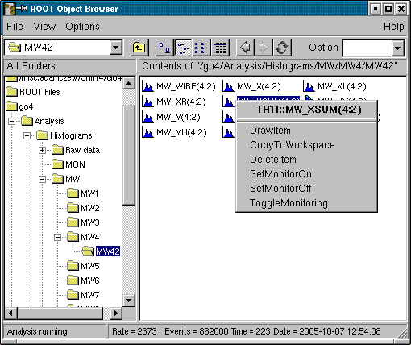
gui343
If connected to the analysis, there is a Go4 folder among the regular ROOT folders. This will browse the structure of the remote analysis with subfolders and all objects. Both histograms and Go4 pictures may be drawn to a new canvas by double clicking on the item. Go4 conditions will be drawn on double-click only together with the histogram that was bound to it. The ROOT right mouse button menu has entries added for the remote Go4 objects:
- Draw Item - will draw it if possible, just like double-click
- Copy to Workspace - Produce fix copy to the Workspace folder in local memory. Just like in the regular Go4 GUI.
- Delete Item - remove object from analysis if possible
- Set Monitor On/Set Monitor Off - Switch the monitoring property of the selected object
- Toggle monitoring – Start and stop monitoring in general. A dialog will appear to request the monitoring periods in seconds. For zero period, monitoring will be stopped. This corresponds to TGo4Interface methods StartMonitoring() and StopMonitoring().

The status line at the TBrowser bottom will show the analysis rate meter, and eventually some messages retrieved from the analysis. Additionally, the status messages are printed out to the CINT terminal.

Go4 analysis with http web server

Startup of go4analysis with webserver
If Go4 has been installed with newer ROOT versions (>5.34.30 / >6.04.00), the ROOT libRHTTP.so library allows controlling the Go4 analysis through a web server. This functionality is then available in go4analysis runtime executable and can be activated via additional command line parameter "-http PORTNUM", e.g.:
go4analysis –stream r2d2.gsi.de –http 8090

will read DAQ data from MBS stream server on node r2d2.gsi.de and will open web server on localhost with port 8090. From the Go4 GUI, it is also possible to launch the analysis directly with a web server (see chapter 4.3.4 on page 43).
Alternatively, if Go4 has been installed together with DAQ framework DABC (i.e. environment DABCSYS is set during compilation and points to DABC installation, version >= 2.6.0), additional plug-ins are generated that allow to connect via a special tcp/io socket to a separate DABC process that offers a web server. This DABC “master process” can collect data from several different applications (e.g. MBS, Go4, FESA) and export their objects to be monitored to one common server. Such connection to DABC is initiated by command line parameter “-dabc master HOST:PORTNUM”, e.g.:

go4analysis –stream r2d2 –dabc master lxg0517:8100

Here PORTNUM defines the DABC socket port, not the HTTP webserver port of DABC. This port number is set in the DABC configuration separately.

The Go4 web browser GUI
Both web servers (standalone go4analysis, or DABC master process) offer a similar JavaScript- based display to any web browser. The Go4 web server, in addition, has elements dedicated to control of Go4 objects and offers the most important functionalities of the regular Go4 Qt GUI. The screenshot below shows the browser view of standard example Go4Example2Step:

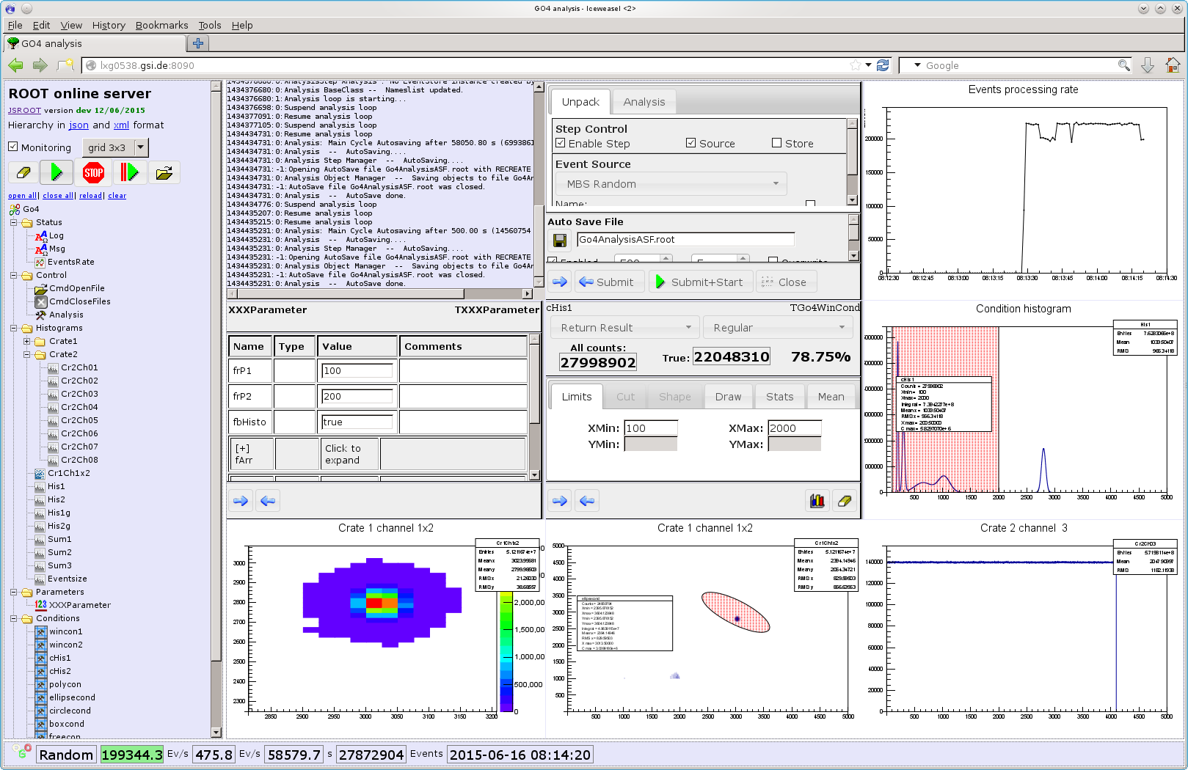

The object hierarchy view
The left browser frame reflects the Go4 objects hierarchy, like it is done in the native Go4 GUI browser. Clicking on an object icon will draw it on the next free view pad in the display frame on the right side. The display frame may be divided in different ways as described in section 7.2.2 . When the Monitoring checkbox is selected, the displayed objects are frequently refreshed every 3 seconds.
Besides the default draw mode when an icon is clicked, most objects offer various display options that are available in a popup menu when the icon is selected with the right mouse button. For instance, the picture on the left shows the popup menu of a 2 dimensional histogram with following typical entries:
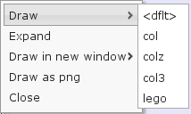
- Draw : with submenu for supported TH2 draw options (col, colz, col3, lego)
- Expand : reveal the substructure of any ROOT object in the hierarchy tree view. Any icon in the substructure can be selected and may offer additional inspection methods. Pointing at a class member icon with the mouse will show the sourcecode commentary description, if existing.
- Draw in new window : Display selected object in a separate browser tab or window instead of the display frame. This entry offers the same submenu as the Draw field.
- Draw as png : Retrieve object as graphical png image instead of interactively drawn JSROOT object. The image will be shown in a new browser tab/window.
- Close : close popup menu, no drawing.

In addition to the Go4 objects registered by the user, the hierarchy frame contains Status and Control folders with elements to monitor and to control the Go4 runtime environment, such as rate meters, commands, and log messages text. For example, EventRate measures the processed data events per second.. When the rate meter icon in the object tree is clicked, the next free view pad will show a visual representation, i.e. a time trending histogram. If Monitoring is also checked, the rate meter value will be continuously refreshed.
Besides this event rate trending, the current and average rates, running time and the number of analyzed events are displayed in a status field at the bottom of the browser. Like in the Go4 Qt GUI also the analysis running state is visualized by the animated Go4 logo and the event rate background color (green or red). Note that this background color will turn to dark grey if the web server is temporarily unavailable. The current event source name is also shown on the left side. This display is refreshed independent of the Monitoring checkbox.

The Log icon if clicked will printout all Go4 log messages into a scrollable text field. Similarly, Msg icon will show even more debug related messages. Again with option “Monitoring” enabled, these message texts will be refreshed automatically.
The most important Go4 commands are available as main buttons on top of the hierarchy:
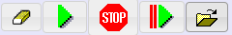
Clicking on a button will invoke this command in the analysis process, such as:
- clear all histogram contents,
- start analysis processing,
- stop analysis processing,
- resubmit current settings and start analysis processing,
- open a remote ROOT file to browse objectes (ROOT versions > 5.34.30/ 6.04.00 only)
These commands are exported via the Control folder of the hierarchy, but partially hidden in the list view. Additional commands of the web server, e.g. CmdCloseFiles, may appear in this folder and can be invoked by clicking the list view icon.

This overview lists all control widgets of the Objects Hierarchy frame:
Monitoring checkbox: if checked, all displayed objects are frequently refreshed every 3 seconds.
Viewmode combobox: defines matrix of pads in the view frame, e.g. 3 means 3x3 pads
open all: unfolds the complete object list
close all: compress the complete object list
reload: reload web page
clear all: clear the view frame and set up division as defined by Division spinbox

The display frame

The division of the display frame into pads and the grouping display mode can be set up with combobox menu on top of the objects hierarchy frame:
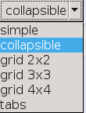
- simple : just one object in the display frame
- collapsible: several objects, one drawn below the other, each view is collapsible/expandable by clicking its top border
- grid 2x2, 3x3, 4x4: display frame is subdivided in such number of pads, each pad contains one object
- tabs: several objects, each one gets own tab field in the display frame

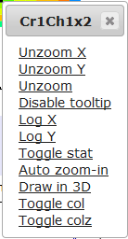

The histogram display in the view pad can be changed by a pop-up menu that appears when clicking the right mouse button over it (see picture on right side). The menu entries are self-explanatory and offer functions for zooming and scaling the axis ranges, setting the most used draw options, and toggling the histogram statistics box. Axis ranges can also be changed when holding the left mouse button over a histogram and defining a square region by dragging the mouse.

The web browser analysis configuration web editor
Selecting the Control/Analysis icon in the object hierarchy view will show the analysis configuration editor in the next view pad. This makes it possible to inspect and change the analysis set-up via the web browser.

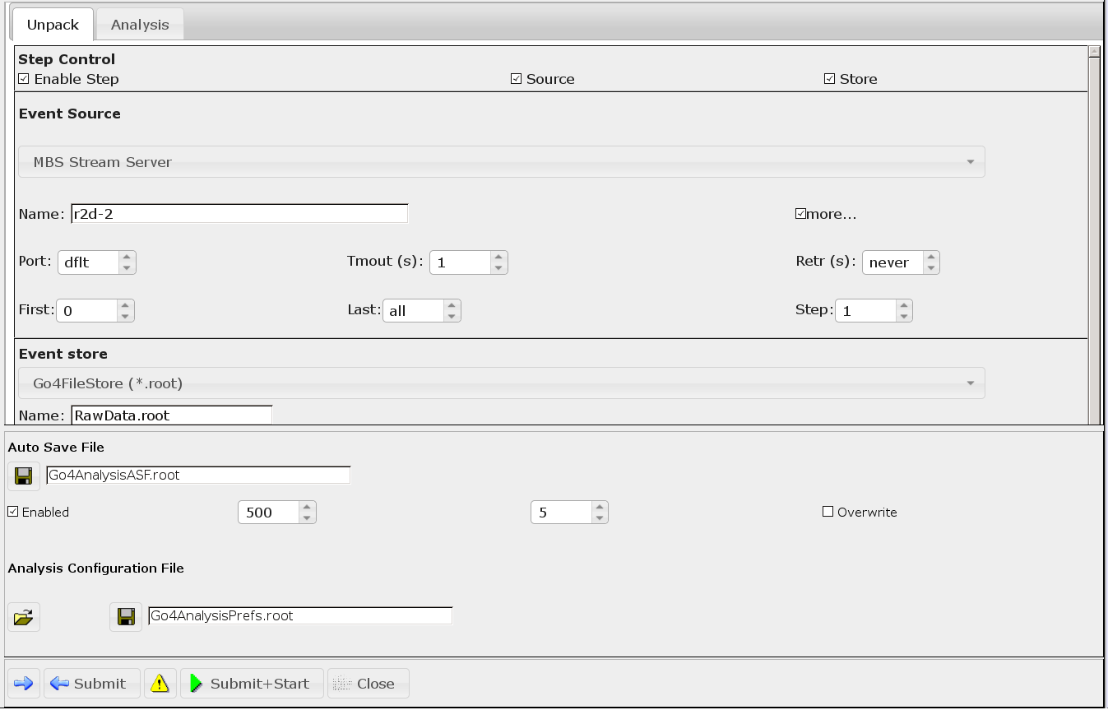

The GUI elements of the web configuration editor and the functionality are mostly identical to the analysis configuration window of the Go4 Qt GUI (see section 4.4.1).

Displaying and editing conditions
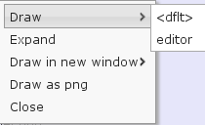
The Go4 condition objects appear as icons in the Conditions folder of the hierarchy tree. Like in the Go4 Qt GUI, conditions can be modified with a condition editor, or displayed on a view pad together with the assigned histogram. If no histogram is assigned to the condition, clicking the condition icon will open the condition editor in the next view pad by default. Otherwise condition and assigned histogram are drawn in the view pad. The right mouse button pop-up menu, as shown on the left side, allows selecting the editor draw mode apart from this defaults <dflt>. Moreover, by drag and drop of a condition icon to any existing histogram view pad the condition is drawn together with the histogram. This re-implements the known behavior of the regular Go4 Qt GUI.

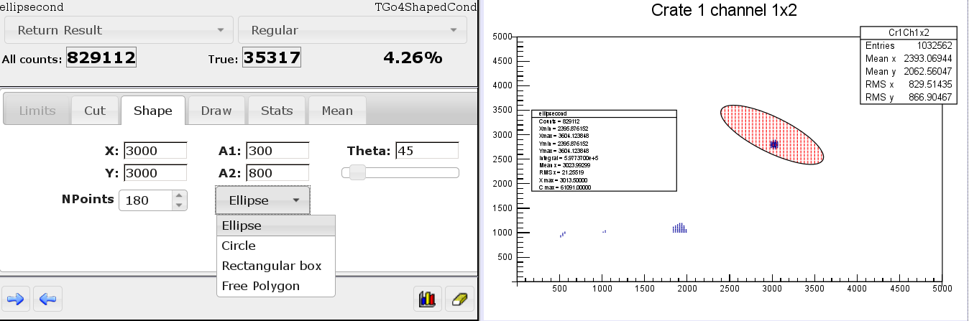

An example of the Go4 web browser condition editor and the display of an elliptical shaped 2 dimensional condition are shown in the picture above. Design and functionality of the web client editor resembles as close as possible the well established Go4 Qt GUI (see section 4.10).

The web browser parameter editor
The Go4 parameter objects appear as icons under the Parameter folder in the hierarchy tree. Clicking a parameter icon will open the web GUI parameter editor in the next view pad.

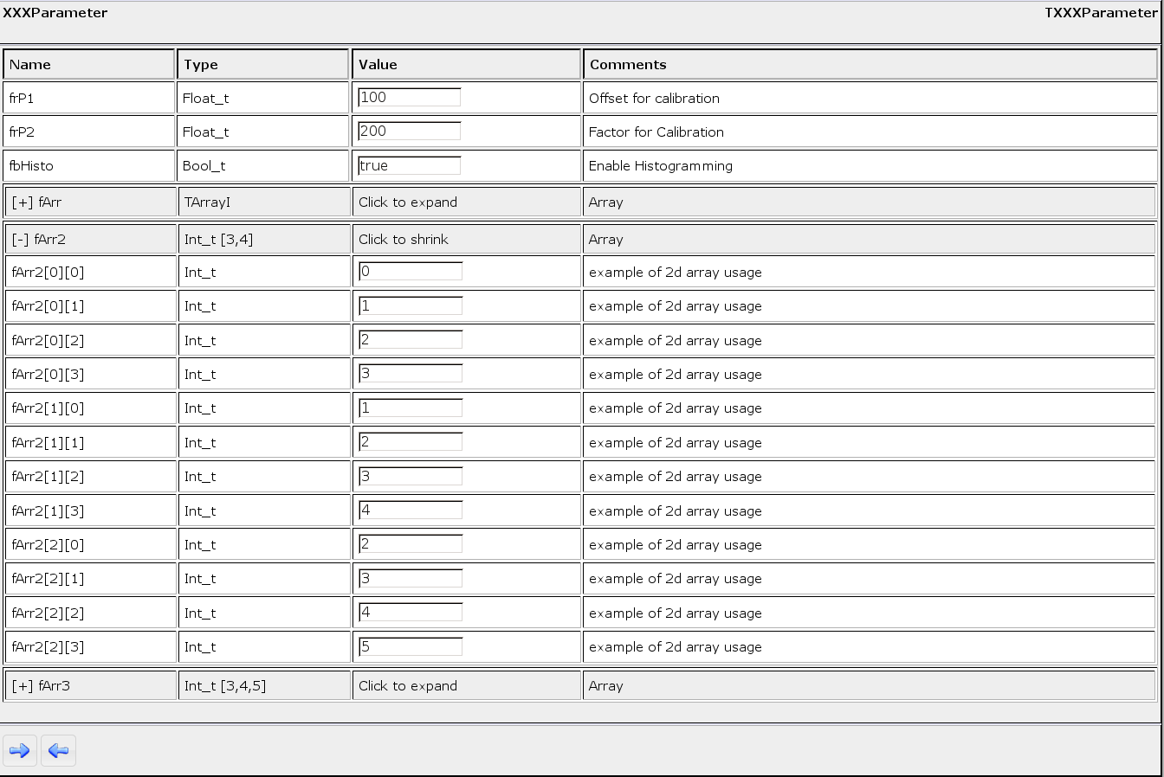

Functionality and operation of the web parameter editor are mostly the same as for the Qt GUI parameter editor (see section 4.13.2). In addition to this, also editing of 3 dimensional arrays are supported in the web GUI. Any array in the parameter class is expanded or shrink by clicking on its heading line. This allows changing each single array entry. The right mouse button pop-up menus of the Qt GUI for arrays and Go4 fitter members, however, are not supported in the web GUI.

The web browser analysis terminal
Selecting the Control/Terminal icon in the object hierarchy view will show the analysis terminal with macro command line in the next view pad. The functionality is almost the same as for the Qt GUI analysis window (see section 4.5.1). The top text view will display the analysis output, the command line may execute ROOT and optionally Python macros, and the buttons provide the actions clear, scroll down, print histograms, and print conditions, respectively

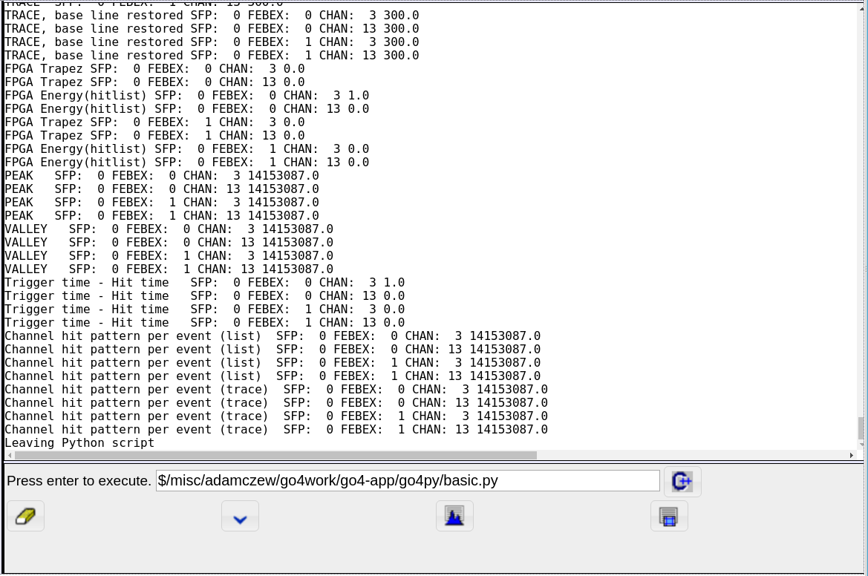

The Go4 Composite Event Classes

Introduction
The Go4 framework applies the concept of the ”event” structure (or class) that represents a set of data values belonging to the same processing cycle of the analysis loop. As explained before in this document, such event classes are used both for the input, and for the output data of each analysis step. Which data belongs to each event cycle is firstly defined by the data acquisition system that reads out and stores such values together. Mostly an event may correspond to a certain “trigger” situation of the experiment. Here it represents e.g. the record of all physical interactions in the detector after the reaction between a beam particle and a target. But it could as well be just a container for data acquired within a given time interval. At later Go4 analysis steps, the event representation may be redefined by skipping, cutting out, or combining input events.
An experimental set up often consists of DAQ or detector components and subcomponents. These can be many of the same kind, or many various ones. Each kind of subcomponent may acquire data of the same structure. The subcomponents must be bundled into components which finally are aggregated to the complete event data representation. The depth of the subcomponent hierarchy is principally not limited here.
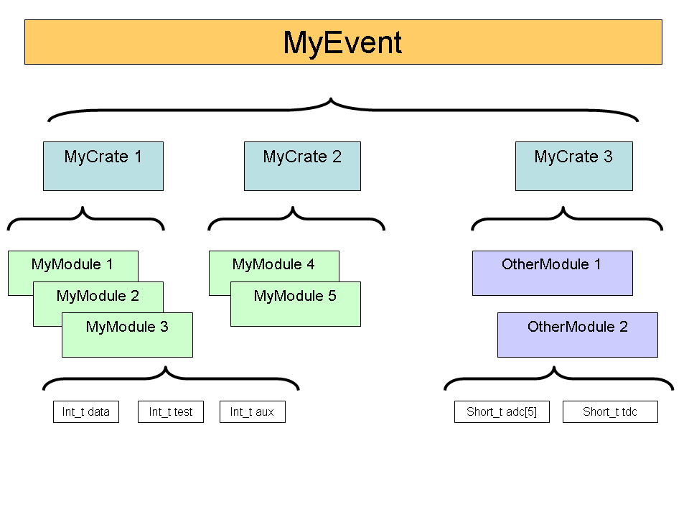
A typical example is shown in this simplified object diagram. The complete event structure MyEvent consists of three subcomponents MyCrate1, MyCrate2, and MyCrate3 which represent a certain DAQ crate hardware. Each of these crates contains a number of MyModule or OtherModule subcomponents. These provide primitive variables data, aux, adc[5], etc. which hold the actual data read out by such module. Hence this example is reflecting the partitioning of the DAQ hardware. For advanced event structures with detector hits, or physics data, it is also very likely though that a similar substructuring occurs.
To define a Go4 event class for this situation, the user could of course just aggregate similar subcomponent objects by means of collection classes, like std::vector, or TObjArray. Storage of such “composite” class with ROOT I/O into TGo4FileStore - Trees should be no problem. However, when using the ROOT or Go4Treeviewer tool, the representation of the subcomponent data would not show up as separate leaves, even in full tree split mode 99. Thus the usage of a quick TTree::Draw() analysis would be impossible for this approach. Moreover, it would not be possible to identify each single subcomponent by name and apply e.g. partial i/o when reading back the data, or search for the component in the full input event.
Because of this, the Go4 framework provides the TGo4CompositeEvent class with generic functionality to aggregate any level of subcomponents with TGo4EventElement objects. When written into the TGo4FileStore with splitlevel 99, the primitive data members of each subcomponent will appear as a separate leaf in the ROOT Tree. Moreover, any subcomponent can be retrieved from the top event object by name, or by id number. The TGo4CompositeEvent implementation uses a TObjArray for the collection of subcomponents, but redefines the ROOT branch i/o for each subcomponent.

Application Programmers Interface
Using the composite event in own Go4 analysis code is based on inheritance from the two interface classes TGo4CompositeEvent and TGo4EventElement.
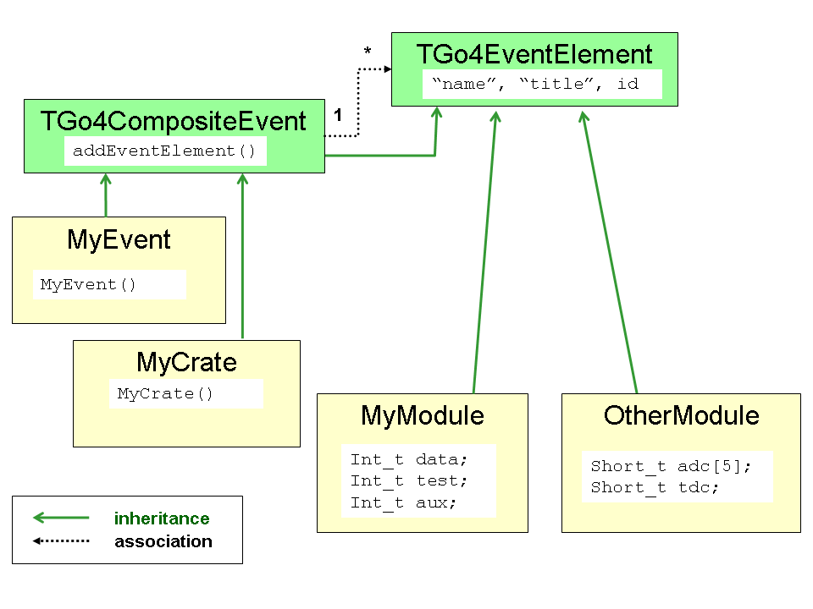
Elementary subcomponent classes should inherit from TGo4EventElement . These classes are elementary bricks of the data structure which contain members of all data-types that the ROOT system supports in its IO split mechanism. In order to create an elementary object, one should follow the TGo4EventElement general interface, and according to this interface the data object should have as parameter of its constructor
- a name (const char*)
- a title (const char*)
- a unique identifier (Int_t)
The name will be used to generate the corresponding TBranchElement branch names in the ROOT TTree layout. The identifier should be unique for each user class.

Data-container classes should inherit from TGo4CompositeEvent. This applies for all classes which will aggregate subcomponents of TGo4EventElement implementation. Because the TGo4CompositeEvent is also a subclass of TGo4EventElement, it is possible to aggregate composites of subcomposites with theoretically unlimited depth. To add a subcomponent to a composite event collection, the interface method
- TGo4CompositeEvent::addEventElement(TGo4EventElement * evt)
is to be used when the composite object is created.
To access any subcomponent within a top composite event, there are two methods provided:
- TGo4CompositeEvent::getEventElement(const char* name) will retrieve pointer to event element by name. Note that this function is invoked full recursively, i.e. the component name is searched in all subcomponent composites.
- TGo4CompositeEvent::getEventElement(Int_t ix) will retrieve pointer to event element by index number in the collection of this composite event. Such method is not recursive, but restricted to the current composite event object.
A simplified UML class diagram of the component example described above is shown in the figure.

Green solid arrows indicate inheritance (arrow points to the base class); dashed black arrows show aggregation association between composite event and event element (one composite event “1” may contain many event element objects “*”). It is obvious that TGo4CompositeEvent is a subclass of TGo4EventElement, thus allowing to recursively aggregate subcomponents of composite events.
To implement event object structure of the example situation, classes MyEvent and MyCrate are derived from TGo4CompositeEvent. Classes MyModule and OtherModule, containing primitive data variables, are simply derived from TGo4EventElement. The actual set up of the composite object may be done in the constructors of the composite classes. Constructor MyEvent() will instantiate the contained MyCrate objects with unique names and id numbers, and put them to the subcomponent collection by means of the addEventElement() interface. The MyCrate() constructor of each crate will do similarly for the MyModule, or OtherModule components. A general object configuration may be read from such constructors to tell by id number which subcomponent should be created when the Go4 event classes are initialized.

Example
An example usage of a TGo4CompositeEvent can be found in $GO4SYS/Go4ExampleAdvanced. The composite structure is here very similar to the case as discussed above: The input event of the first step TXXXUnpackEvent is a TGo4CompositeEvent with subcomponents of class TXXXCrate. Each TXXXCrate is also a TGo4CompositeEvent, containing a configurable number of TXXXModule objects. The latter is a simple TGo4EventElement with a structure of elementary variables fiData, fiTest, and fiAux:

class TXXXModule : public TGo4EventElement
{
public:
TXXXModule():TGo4EventElement(), fiData(0) {;}
TXXXModule(const char* name, Short_t id):
TGo4EventElement(name,name,id), fiData(0) {;}
virtual ~TXXXModule() {;}

void Clear(Option_t *t="")
{
fiData=0;
fiTest=0;
fiAux=0;
}

Int_t GetData(){return fiData;}
void SetData(Int_t dat){fiData=dat;}

Int_t GetTest(){return fiTest;}
void SetTest(Int_t dat){fiTest=dat;}

Int_t GetAux(){return fiAux;}
void SetAux(Int_t dat){fiAux=dat;}

/* in this example, each module represents single channel of data.*/
Int_t fiData;

/* module may have test data channel.*/
Int_t fiTest;

/* module may have aux data channel.*/
Int_t fiAux;

ClassDef(TXXXModule,1)

};

The constructor of TXXXModule will pass the name and id number arguments to the TGo4EventElement constructor, thus allowing for composite identification.
The classes TXXXCrate and TXXXUnpackEvent just derive from TGo4CompositeEvent, but do not add any other data members here:

class TXXXCrate : public TGo4CompositeEvent {
public:
TXXXCrate():TGo4CompositeEvent(){;}
TXXXCrate(const char* name, Short_t id);
virtual ~TXXXCrate() {;}

ClassDef(TXXXCrate,1)
};
class TXXXUnpackEvent : public TGo4CompositeEvent {
public:
TXXXUnpackEvent():TGo4CompositeEvent(){;}
TXXXUnpackEvent(const char* name) ;
virtual ~TXXXUnpackEvent() {;}

ClassDef(TXXXUnpackEvent,1)

Hence they are mere data containers to organize the structuring of the TXXXModules. Note that virtual method Clear() needs not to be implemented in this case, since Clear() of base class TGo4CompositeEvent will invoke all Clear() methods of the composite components.
The set-up of components is done in the constructors of TXXXUnpackEvent and TXXXCrate, resp.:

TXXXCrate::TXXXCrate(const char* name,Short_t id) :
TGo4CompositeEvent(name,name,id)
{
if(id <0 || id>XXX_NUM_CRATES)
{
printf("TXXXCrate id %d outside range!\n",id);
}
else
{
TString modname;
for(UInt_t ix=0; ix<Config_Crates[id]; ++ix)
{
modname.Form("XXXCrate%d_XXXModule%d",id,ix);
addEventElement(new TXXXModule(modname.Data(),ix));
}
}

}

//***********************************************************
TXXXUnpackEvent::TXXXUnpackEvent(const char* name) :
TGo4CompositeEvent(name,name,0)
{
TString modname;
for(UInt_t ix=0; ix<XXX_NUM_CRATES; ++ix)
{
if(Config_Crates[ix]==0) continue; // skip empty crates
modname.Form("XXXCrate%d",ix);
addEventElement(new TXXXCrate(modname.Data(),ix));
}
}

Here the static array Config_Crates[] is used to define the set up of crates and modules. In this example it can be changed at compilation time by means of some definitions in TXXXUnpackEvent.h:

#define XXX_NUM_MODULES 16
#define XXX_NUM_CRATES 4

// nr of modules in Crate 0 1 2 3
// | | | |
#define NR_MODULES {0, 16, 16, 2}

Definition NR_MODULES will initialize the array Config_Crates[] in TXXXUnpackEvent.cxx, thus defining the actual configuration:

static UInt_t Config_Crates[XXX_NUM_CRATES] = NR_MODULES;

When writing such event to a ROOT tree with TGo4FileStore enabled, the composite event substructures can be inspected with a ROOT or Go4 treeviewer tool.

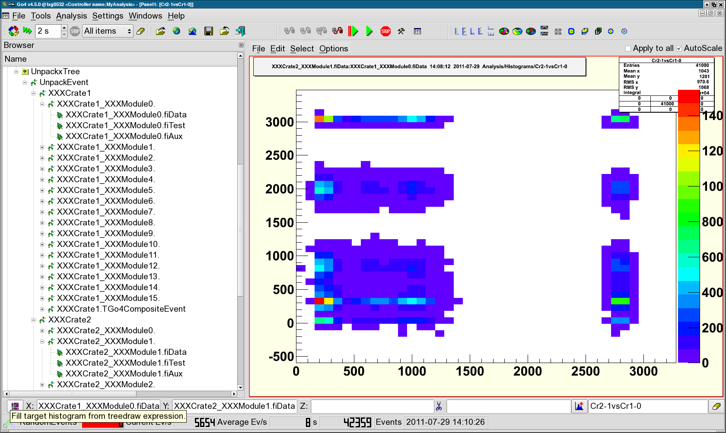

This screenshot picture shows the browser view of a tree produced by the above example. Here Go4 filled a dynamic list histogram from the fiData members of different subcomponents. The hierarchical representation of the composite event leaves in the Go4 treeviewer can be used to easily navigate between different subcomponents. Note that the GUI menu “Settings/Preferences/” provides a mode “Hide TGo4EventElement” to hide all TGo4EventElement leaves in the Go4 treeview. This is useful, since every subcomponent has leaves with members derived from the base class.

Icon Table

 |  | File pad: open local ROOT file on disk
 |  | File pad: open remote ROOT file (TNetFile, TWebFile, TRFIOFile)
 |  | Save content of memory to ROOT file
 |  | File pad: close selected ROOT file
 |  | File pad: close all ROOT files
 |  | Export selected objects of memory browser into another format (ASCII, radware, ROOT)
 |  | Stop running analysis, shutdown analysis and terminate GUI
 |  | Open view panel
 |  | Open fitter window
 |  | Open histogram properties window (there: list properties in analysis window)
 |  | Open histogram creator window
 |  | Open condition properties window (there: list properties in analysis window)
 |  | Open condition editor
 |  | Open event inspector window
 |  | Open dynamic list editor
 |  | List dynamic list in analysis window
 |  | Open parameter editor
 |  | Open browser to (un)load libraries; show list of loaded libraries
 |  | Open user GUI
 |  | Open analysis launch window
 |  | Stop and shut down analysis client, disconnect analysis server
 |  | Stop and shut down analysis server
 |  | Start analysis. Monitor pad: start updating all objects in list, or only displayed ones.
 |  | Stop analysis
 |  | Open analysis configuration window (can be closed/opened any time); browser popup menu: edit selected
 |  | Open analysis output window (can be closed/opened any time)
 |  | Open file browser
 |  | Open color editor
 |  | Expand/shrink histogram in selected pad in X.
 |  | Expand/shrink histogram in selected pad in Y
 | Expand/shrink histogram in selected pad in Z.
 |  | Move expanded histogram in selected pad in X direction
 |  | Move expanded histogram in selected pad in Y direction
 |  | Move expanded histogram in selected in pad Z direction
 |  | Set fill color
 |  | Set line color
 |  | Set marker color
 |  | Scale Y axis linear/logarithmic
 |  | Scale Z axis linear/logarithmic
 |  | Scale X axis linear/logarithmic
 |  | Draw 1d histogram/line style
 |  | Reset display in selected pad to histogram limits
 |  | Open window to set display limits (applies to selected pad, or all pads if this option is enabled in view panel)
 |  | Execute Tree draw.
 |  | Kill analysis
 |  | Clear button in browser pads clears objects in analysis, in condition editor clears counters.
 |  | Enable clear function for objects
 |  | Disable clear function for objects ( does not clear these objects)
 |  | Analysis pad: copy selected object(s) to monitor
 |  | Remove selected object(s)
 |  | Move selected object(s) to memory (from analysis, monitor, or histogram server); or copy object from analysis to editors (conditions or parameters)
 |  | Copy object in editor to analysis (conditions or parameters)
 |  | Analysis pad: update folders from analysis. Memory pad: update all objects from analysis and redraw.
 |  | Browser icons for window condition (arrays). Window mode in marker editor
 |  | Browser icons for polygon condition (arrays). Polygon mode in marker editor
 |  | Browser icon for TCanvas
 |  | Browser icon for TGraph
 |  | Browser icon for Go4 pictures.
 |  | Brower icon for TH3 histograms
 |  | Browser icon for TH2 histograms
 |  | Browser icon for TH1 histograms. Button: draw selected objects (one per pad).
 |  | Draw selected objects (all in one pad, superimpose)
 |  | Save selected object in memory to ROOT file
 |  | Refresh memory list (needed to see new histograms created e.g. by ROOT in the GUI). In condition editor: refresh values from view panel.
 |  | Browser popup menu: open information window for selected histogram or condition
 |  | Editors: shows up if object in editor differs from object in analysis (file). Use for update.
 |  | Condition editor: connect to a picture with conditions (gets list of conditions from it)
 |  | Condition editor: update graphics from values in editor.
 |  | Output values of condition editor, info window, or markers according settings in the log action.
 |  | Close window without further action
 |  | Browser icon for dynamic list entries
 |  | Insert arrow in marker editor
 |  | Pick next mouse click in pad to get values into condition editor or marker editor
 |  | Browser icon for a tree
 |  | Browser icon for a branch
 |  | Browser icon for leafs

Table of Menu and Toolbar Keyboard Shortcuts
Note that the Alt-x keys work on windows whereas the Ctrl (Strg)-x keys work directly. Sometimes the same function is available in both, i.e. Alt-a-n or Strg-n. In these cases the last character is identical.

Ctrl-O | Alt-F-O | File menu: Open local file
Ctrl-R | Alt-F-R | File menu: Open Remote file (TNetFile, TWebFile, TRFIOFile)
Ctrl-Y | Alt-F-Y | File menu: Save all objects of memorY browser to ROOT file
- | Alt-F-H | File menu: Connect to Histogram server
Ctrl-Q | Alt-F-Q | File menu: Close (Quit) all files
Ctrl-X | Alt-F-X | File menu: EXit Go4
Ctrl-V | Alt-T-V | Tools menu: Open new View panel
Ctrl-F | Alt-T-F | Tools menu: Fitpanel
- | Alt-T-H | Tools menu: Histogram properties window
Ctrl-I | Alt-T-I | Tools menu: HIstogram creation tool
- | Alt-T-O | Tools menu: COndition properties window
 | Alt-T-C | Tools menu: Condition creation tool
- | Alt-T-E | Tools menu: Event printout and inspection tool
Ctrl-D | Alt-T-D | Tools menu: General Dynamic list editor
Ctrl-B | Alt-T-B | Tools menu: Load liBrary dialog
Ctrl-U | Alt-T-U | Tools menu: User GUI
Ctrl-N | Alt-A-N | Analysis menu: LauNch analysis process
Ctrl-C | Alt-A-C | Analysis menu: Connect to running analysis server
Ctrl-M | Alt-A-M | Analysis menu: Disconnect (reMove) analysis
Ctrl-T | Alt-A-T | Analysis menu: SubmiT settings and start analysis run
Ctrl-S | Alt-A-S | Analysis menu: Start analysis run
Ctrl-H | Alt-A-H | Analysis menu: Stop (Halt) analysis run
Ctrl-G | Alt-A-G | Analysis menu: Show/hide analysis confiGuration window
Ctrl-W | Alt-A-W | Analysis menu: Show/hide analysis output terminal Window
- | Alt-S-O | Settings menu: shOw/hide...
- | Alt-S-F | Settings menu: Fonts...
- | Alt-S-Y | Settings menu: StYles...
- | Alt-S-L | Settings menu: Log actions
- | Alt-S-H | Settings menu: Generate Hotstart
- | Alt-S-T | Settings menu: Analysis Terminal history length
- | Alt-S-S | Settings menu: Save Settings
- | Alt-W-S | Windows menu: CaScade
- | Alt-W-T | Windows menu: Tile
- | Alt-W-C | Windows menu: Close all windows
- | Alt-W-M | Windows menu: Minimize all
- | Alt-W-O | Windows menu: Save LOg window to text file
- | Alt-W-L | Windows menu: Clear Log window
- | Alt-W-A | Windows menu: Save Analysis window to text file
- | Alt-W-W | Windows menu: Clear analysis Window
F11 | Alt-W-F | Windows menu: Toggle Full screen mode
F1 | Alt-H-I | Help menu: Read Go4 Introduction manual
- | Alt-H-R | Help menu: Read Go4 framework Reference manual
- | Alt-H-F | Help menu: Read Go4 Fitpackage manual
 | Alt-H-G | Help menu: Read Go4 GUI macro command reference
F2 | Alt-H-Q | Help menu: About Qt
F3 | Alt-H-O | Help menu: About ROOT
F4 | Alt-H-G | Help menu: About Go4
Alt-U | - | Analysis configuration window : SUbmit analysis settings
- | Alt-I-S | View panel file menu: Save as...
- | Alt-I-P | View panel file menu: Print...
- | Alt-I-O | View panel file menu: ClOse View panel
- | Alt-E-E | View panel edit menu: Show/hide marker Editor
- | Alt-E-R | View panel edit menu: Show/hide ROOT attributes editor (TGedEditor)
- | Alt-E-C | View panel edit menu: Start Condition editor and work on pad conditions (in pictures)
 | Alt-E-E | View panel edit menu: Show/hide object Event status line
- | Alt-E-1 | View panel edit menu: Change to 1:1 coordinates ratio
- | Alt-E-D | View panel edit menu: Change to Default pad margins
- | Alt-E-M | View panel edit menu: Clear Markers
- | Alt-E-P | View panel edit menu: Clear Pad
- | Alt-E-A | View panel edit menu: Clear CAnvas
-
- | Alt-O-C | View panel options menu: Toggle Crosshair mode
- | Alt-O-S | View panel options menu: Show/hide histogram Statistics box
- | Alt-O-T | View panel options menu: Show/hide histogram Title box
- | Alt-O-L | View panel options menu: Show/hide multiplot Legend
- | Alt-O-K | View panel options menu: Keep view panel title
- | Alt-O-V | View panel options menu: Set View panel title...
- | Alt-O-I | View panel options menu: Toggle SuperImpose mode
- | Alt-O-X | View panel options menu: Toggle X-axis time display mode
F6 |  | Toggle visibility of browser dock window
F7 |  | Toggle visibility of logging dock window
F8 |  | Toggle visibility of MBS monitor dock window
F9 |  | Toggle visibility of DABC monitor dock window (only if installed with DABC/DIM)
Ctrl-Left: |  | Zoom tools: Expand range on x axis
Ctrl-Right: |  | Zoom tools: Un-expand range on x axis
Left |  | Zoom tools: Move Histogram left on x axis (if range is expanded)
Right |  | Zoom tools: Move Histogram right on x axis (if range is expanded)
Down: |  | Zoom tools: Expand range on y axis (toggles autoscale off)
Up: |  | Zoom tools: Un-expand range on y axis (toggles autoscale off)
Shift-Up |  | Zoom tools: Move Histogram up on y axis (if range is expanded)
Shift-Down |  | Zoom tools: Move Histogram down on y axis (if range was expanded)
Ctrl-End |  | Zoom tools: Expand range on z axis (toggles autoscale off!)
Ctrl-Home |  | Zoom tools: Un-expand range on z axis (toggles autoscale off!)
Shift-Home |  | Zoom tools: Move Histogram up on z axis (if range was expanded)
Shift-End |  | Zoom tools: Move Histogram down on z axis (if range was expanded)
Ctrl-Minus |  | Zoom tools: Un-zoom ranges totally
Ctrl-Plus |  | Zoom tools: Show/hide range settings window
Ctrl-Star: |  | Zoom tools: Apply auto zoom (adjust range to show non-zero region only)
F5 |  | Browser options: refresh all displayed objects
Shift-C: |  | Browser options: Clear all remote histograms remotely
Shift-M: |  | Browser options: Monitoring on (start timer)
Shift-N: |  | Browser options: No monitoring (stop timer)

Event Classes Diagrams
The following UML scheme gives an overview of the event base classes and typical implementations:

The TGo4MbsEvent is filled from the TGo4MbsSource (both provided by Go4). The TUserEventProcessor, which had been defined to match the user’s experiment, takes the raw data from GSI format 10,1 and unpacks them into the TUserEvent object. Both TGo4MbsEvent and TUserEvent objects can be stored into (different) TGo4FileStore instances. Later these can be read again event-by-event using the TGo4FileSource.

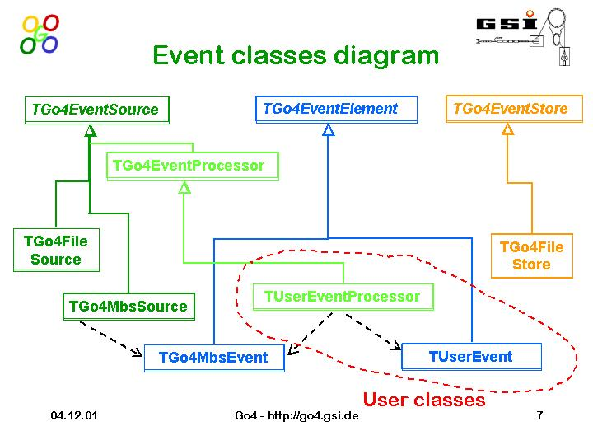

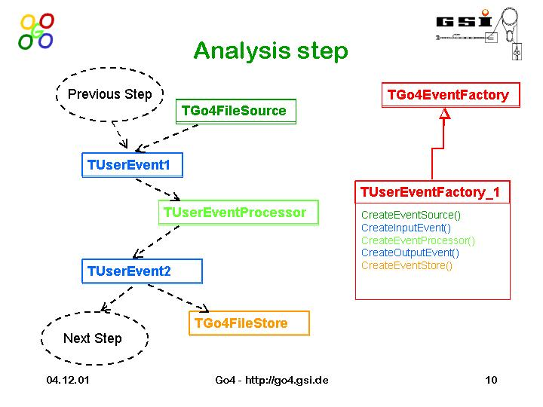
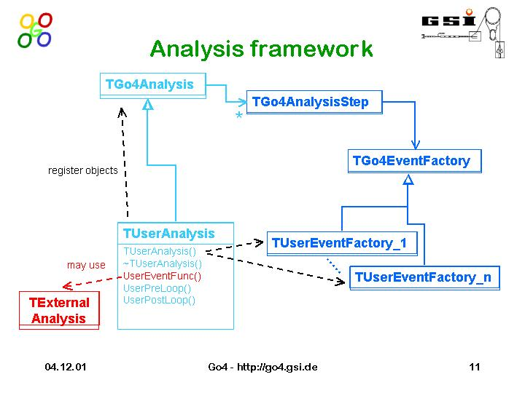

Release Notes

New features in Go4 v5.2 (January 17)
- Support of ROOT v6
  - Fix problem with ROOT6 - it requires exact location of Go4 include files when running GUI or analysis. Especially important when doing "make install"
- Web client and http server
  - When running go4analysis, one could specify alternative (newer) JSROOT version like go4analysis -random -jsroot http://jsroot.gsi.de/latest/
- Analysis framework:
  - Changed default test lmd file names of examples to $GO4SYS/data/test.lmd instead /GSI/lea/gauss.lmd. New method TGo4Analysis::GetDefaultTestFileName() that delivers the actual pat to this file in the current installation.
- QtRoot interface::
  - Handle mouse wheel events in QtRoot interface, used in ROOT zooming.
  - Modified qtroot interface and gui viewpanel to take into account optional Qt5 high dpi scaling factors set by QT_SCALE_FACTOR environment variable (Qt> 5.6.x only).
- Go4 GUI:
  - Added HighDPI Scale factor to Preferences. Can be adjusted via Settings/Preferences Menu. Requires GUI Restart. Qt Version > 5.6 only!
  - Added panel defaults properties for object draw line width, fill color, and style. Useful for 4K monitors, where default line width (=1) is too tiny..
  - New toolbar for Analysis Command Buttons: Provides nine buttons C1...C9 that can be freely configured by the user with commands to be executed in the analysis process interpreter. Supports ROOT, go4 and Python macros. Default shortcuts Ctrl-1 ... Ctrl-9 allow fast keyboard interaction. Additionally, an execution timer with adjustable period allows any user defined command that is checked in the configuration to be executed frequently.
  - Viewpanel: new feature - double click on histogram pad does unzoom of axes. For subpads, still another viewpanel with the subpad is opened
  - Viewpanel: improved display of 1:1 coordinate ration for 2d histograms. Aspect ratio of the selected pad will be automatically re-adjusted when resizing the viewpanel. Besides, the histogram borders will be expanded to use maximum margins of the pad..
  - Viewpanel: Added panel defaults property to supress background colors of pads and frames when exporting the canvas with the Viewpanel "File/SaveAs.." Menu to various image and print formats. This mode can be set by main window menu "Settings/PanelDefaults/White canvas for saved images".
  - Viewpanel: bugfix - in Go4 v5.1.0 statistic and label boxes could disappear or be scrambled when mouse was moved over them. This was an unwanted side-effect of the previous TGraph/polygon condition crash bugfix.
  - Improvement in main window status message: Ratemeter will clear message when updating, no message display timeout anymore. Solves problem of GUI messages still visible behind ratemeter counters.
  - Hotstart script: . Preserve frame position, do not reset frame with every update.
  - Parameter Editor: bugfix - format string precision for Float_t, Double_t, and Double32_t was reduced to defaults. Now it supports full range of data type and exponential formatting.
  - Bugfix - when creating hotstart, TLatex object was added to picture specials twice, which leads to crash when such picture need to be deleted.
- Python scripting:
  - Restructured the whole Go4 python module: moved things that are not interesting for a user, i.e., implementation details (ExpMem is in expmem.py) and helper modules (e.g. facade.py) into the go4py.internals namespace/subfolder. Added nicer error message if go4init is imported outside Go4..

New features in Go4 v5.1 (March 16)
- Web client and http server:
  - One can register Start/Stop/Clear commands in any place of THttpServer hierarchy. Such commands are recognized by the GUI and used when pressing Start/Stop analysis buttons or Clear analysis objects button
  - Web GUI: Implemented analysis terminal window with macro command line (requires ROOT>=5.34.34). This also covers the python scripting support.
- Go4 GUI:
  - TGo4Style Color Tool: Added selection menu to provide new ROOT6 named palettes. New entry "Settings/Panel defaults/Palette settings" to specify minimum and maximum valid ROOT palette indices for spinbox, and default palette index.
  - Added shaped condition class to "Create new condition" tool.
  - Analysis terminal window: added button to scroll down to end of output text.
  - Provided "1:1 Coordinate ratio" display for histograms as pad option for TGo4Picture. So this property can be saved and recovered with hotstart script, or predefined in analysis code by method TGo4Picture::SetXYRatioOne(bool). Moved corresponding entry in viewpanel from Edit to Options menu, can be toggled now.
  - Bug fix in monitoring of polygon conditions: moving condition object with mouse during monitoring refresh could cause severe memory corruptions and a crashing GUI, due to temporary static arrays in ROOT painters not treated correctly when redrawing the objects.
- Analysis framework:
  - Allow to use graphics in analysis. With "-gr" or "-graphics" option one enable ROOT graphics. User can create and update canvas or any other TG... object.
- Python scripting:
  - Support Python Scripting in analysis, either by GUI Analysis terminal command line or in compiled code: A leading '$' in command line will execute python script of given name, occasonally TGo4Analysis object is bound as go4 symbol. New methods ExecuteLine and ExecutePython in TGo4Analysis and TGo4EventProcessor to invoke regular interpreter commands and python scripts,resp, from compiled code. File search dialog of Analysis terminal in GUI will provide also file filters for *.py macros. Thanks to Sven Augustin, MPI Heidelberg, for this idea and code support.
  - Support Python Scripting in GUI command line (TGo4AbstractInterface binding). File search dialog of GUI commandline tool will provide also file filters for *.py macros.

New features in Go4 v5.0 (June 15)
- Support of ROOT v6
  - To provide full support of ROOT6 one dictionary per go4 library will be created. Exclude dictionary generation for GUI classes while no libraries with Qt classes exists.
  - Support -std=c++11, which is now used in ROOT6.
  - Activate graphics editor (TGedEditor) when called via context menu. Was not working due to recent ROOT changes.
  - ROOT v5 ís also still fully supported
- Support of Qt5
  - Use QMdiArea instead of obsolete QWorkspace, solves several small problems in window management.
  - Workarounds in qtroot interface for Qt5: to avoid known bug with non compressed X mouse events (https://bugreports.qt.io/browse/QTBUG-40889), introduced 100ms time limit for processing mouse move events in QRootCanvas. This improves canvas interaction performance significantly.
  - GUI Settings/Preferences: Added configurable window resize/move mode ("rubberband" outline or full repaint). Reduces window flickering with current Qt5.x versions due to non compressed X-events
  - Qt 4 is also still fully supported.
- Web client and http server:
  - Introduce go4.js with generic go4-related JavaScript code
  - Provide JavaScript-based condition, parameter, and analysis configuration editors in web-browser. To change values via HTTP server in analysis, UpdateFromUrl() method is implemented for condition and parameter classes, and in new class TGo4AnalysisWebStatus which is interface for reconfiguring analysis set up.
  - Provide several shortcuts in web interface for commands like: "Start", "Stop", "Clear", "Resubmit"
  - In web-browser allow to explore parameter and events objects, registered in the analysis. Hide unsupported types.
  - Add support of fastcgi. Now go4 can deliver its data to standard web server (like Apache or lighttpd). This allows to control access rights and security with usual methods, provides by web-servers.
- Go4 GUI:
  - By default all objects appear in gui with monitor flag. Only monitoring should be started to get any histogram/graph monitored
  - Improve handling of superimposed graphs and histograms: support time axis, correctly set colors, adjust size of legends box.
  - When file is opened in Go4, sub-directory will be read only after actively clicked. Allow read large ROOT files.
  - Store main window geometry and toolboxes settings in hotstart (only >Qt4). Makes it possible to reproduce exactly view of the main panel.
  - Support access to ROOT-based http server from go4 GUI. Just when staring go4, specify: [shell] go4 http://localhost:8080
  - GUI can connect to go4analysis with either HTTP server or Go4 sockets with "Connect to server" button. HTTP server provides same functionality as Go4 sockets connection and besides shows remote terminal output in the analysis window. Access to web server (controller/observer roles) can be controlled by htdigest accounts and password.
  - GUI can start go4analysis as HTTP server with “Launch Analysis” button. This provides now an alternative mode to the established “Go4 sockets” analysis server.
  - Support setting the ROOT Tree auto save interval in analysis configuration window for TGo4FileStore output. Defines how often tree is flushed to file during analysis.
  - When taking ROOT objects from DABC-based application, also request and unpack list of streamer infos. This allow to browse and display objects with different class version..
  - Bugfix concerning autoscale in multipad viewpanel.
- Analysis framework and API:
  - In batch mode do not account events in non-running mode, reduce cpu load with sleep in non-running mode.
  - Added new condition type TGo4ShapedCond. This is subclass of TGo4Polycond with properties to create ellipse/circle/box-shaped polygon region from center/radius/tilt parameters. Supported by new registration methods MakeEllipseCond, MakeCircleCond, MakeBoxCond in TGo4Analysis and TGo4EventProcessor. Condition editor in qt4 GUI has a tab to manipulate these conditions interactively. Thanks to Sven Augustin, MPI Heidelberg, for this idea.
  - In go4-config script provide --cflags, --libs and --glibs option. This should allow to build libraries and executables, which are using go4 libraries.
  - Use MSG_NOSIGNAL option when send/recv data via socket (only for Unix). Allows to correctly terminate analysis when socket corrupted or broken.
  - Introduce UserPreLoop() and UserPostLoop() methods in TGo4EventProcessor. One can use such methods without creation of specialized analysis class.
  - Implement TGo4Analysis::GetInputFileName() - returns currently processed file name. Automatically reset TGo4Analysis::IsNewInputFile() at the end of event processing.
- Go4 examples:
  - Introduce Go4ExampleDabc, which shows usages of DABC functionality in Go4. Example shows how one can regularly submit commands to running MBS.
  - Changed some histogram definitions in Go4ExampleUserSource, added angular distribution. Now covers different scenarios of multiple scattering simulation SCATT2014.

New features in Go4 v4.6 (November 13)
- Analysis runtime environment:
  - New printout option for go4analysis: "go4analysis -print bhead fhead" will print lmd buffer and/or file headers together with the event headers. Additionally, most recent time string from buffer header is printed together with event header
  - Allow to specify port number for any MBS source (beside file) in form name:port like calling "go4analysis -stream node:6543". Useful for virtual desktops (vnc) where ports around 6000 are blocked. Same can be done in gui.
  - Add retry counter for some MBS sources - let reconnect server if it was down for some time. Useful for online analysis when server can be switched off/on very often for short time. Implemented in MBS source class, can be configured in go4analysis, qt3/at4 gui, hotstart.
  - Allow to specify several files in row as argument of command "go4analysis -file ..." It is very useful in the case when wildcard characters are used. Shell automatically expands all wildcards itself and therefore previous go4 versions get errors. Now following command is valid: "go4analysis -file *.lmd". Make debug output of the analysis more clear when processing many files.
  - Add -rate argument to the go4analysis executable. Enables output of current rate in batch mode.
  - Added support for x-axis time display in TGraph and TH1. New Items in Viewpanel Options menu: "X-Axis displays time" and "Set xaxis time format"
- Analysis framework and API:
  - Add ExecuteScript() method to analysis and event processor. Simplifies usage of macros in user code.
  - Add in MakeParameter method possibility to execute setup macro In GetParameter method one could optionally specify class name, which will be verified
  - Allow to use TArrayI and TArrayD in the TGo4Parameter and parameter editor. Now parameter elements of such classes can be edited and store in script
  - Introduced event processor API methods SetKeepInputEvent() and SetKeepOutputEvent() to provide "1 to n" and "n to 1" event building functionality. To be used if input event contains several output event data sets, or vice versa if several input events must be processed to gain one output event. Each time these methods are called in event processor, the next analysis cycle will skip all previous, or all subsequent analysis steps, resp, and will reprocess the input, or continue filling the output event data, resp.
- Go4 GUI:
  - Provide in preference menu possibility to set "draw once" flag. Means every histogram can only be drawn once when double-clicked in the browser.
  - Implement auto-zoom functionality for 1/2/3-dim histogram (qt3/qt4). Automatically adjust range selection to non-zero content of the histogram. Can be actiavted also with Ctrl * keys combinations. Thanks to Michael Traxler for nice idea.
  - Added some keyboard shortcuts for histogram display manipulation:
      - Ctrl-Left/Ctrl-Right: Expand/Unexpand range on x axis
      - Left/Right: Move Histogram left/right on x axis (only if range was expanded)
      - Up/Down: Expand/Unexpand range on y axis (toggles autoscale off)
      - Shift-Up/Shift-Down: Move Histogram up/down on y axis (only if range was expanded)
      - Ctrl-End/Ctrl-Home: Expand/Unexpand range on z axis (toggles autoscale off)
      - Shift-Home/Shift-End: Move Histogram up/down on z axis (only if range was expanded)
      - Ctrl-Minus: Unzoom ranges totally
      - Ctrl-Plus: Show/hide range settings window
      - Ctrl-Page Up: Y axis in logarithmic scale
      - Ctrl-Page Down: Y axis in linear scale
      - F5: Refresh display of all remote Histograms
      - Shift-C: Clear all remote Histograms remotely
      - Shift-M: Start monitoring timer
      - Shift-N: Stop monitoring timer
Note: All these shortcuts do work only if the corresponding toolboxes (zoom tools, browser options, short histogram draw options) are active!

  - Added shortcut F1 to display the Go4 Introduction Manual as Help.
  - Added shortcuts F6, F7, F8 to toggle visibility of browser, logger, and mbs monitor dock windows (F9 for DABC monitor if compiled with DIM)
  - GUI analysis status ratemeter: Tooltip of runtime seconds this time as hour:minute:seconds representation.
  - Graphical Markers and Conditions: Added possibility to define a "printf style" format string in for the float number display in marker/condition label box (default is %.4E). When selecting the marker/the condition display on TPad via mouse button, the ROOT context menu provides method SetNumFormat(const char*) to change the settings of current marker. Context menu function SaveLabelStyle() will set current format as default for all markers/conditions. MainWindow menu "Settings/Panel Defaults/MarkerLabels..." also has new field to set this format string. These defaults can be saved to go4 settings.
  - Add full-screen mode for main window (F11). Both for qt3 and qt4
  - Add possibility to change default position of stat box (only for qt4 gui)
  - Add support of composite events in dynamic list editor (qt3/qt4)
- Introduced several functionalities from DABC framework classes:
  - To get different DABC functionality to go4, one need to compile go4 with "make withdabc=1" flag. One should use newest dabc version (>= 2.6.0) from repository.
  - Provide a http server within go4analysis: Just add "-http 8090" arguments to start web server, which can deliver all go4 objects to a web browser. This provides go4 analysis view in web browser similar to the go4 GUI. Commands like start/stop analysis and clear histograms are available via the web interface.
  - Possibility to optionally connect go4 analysis with a DABC “master node”, which can export go4 data via http server. By this data from many go4 analyses can be aggregated in the same server.
  - Optionally open direct communication channel from go4 GUI to a DABC node to access objects. Idea is to have similar look and fill like web-based interface, but with native ROOT graphics in Go4 GUI.
  - In GUI Analysis Launch Panel one can specify arguments to start http server or to connect with master DABC application.
  - Support of connection to dabc in gui and hotstart (qt4)
- Hotstart and GUI scripts:
  - Provide configurable timeout in hotstart script for time when analysis configuration is submitted. It can be longer as default 20 sec, which now can be changed.
  - Add possibility to refresh names list after analysis configuration. Can be used if shortly after analysis start new histograms are created, which should be shown in the gui. For that one need to add following lines to the hotstart: go4->Wait(10); go4->RefreshNamesList(); First wait defines how long one need to guarantee, that analysis starts.
  - Provide in gui script possibility to request item name, drawn in the panel. Method name is go4->GetDrawnItemName(panel, cnt = 0). Can be useful in some gui scripts. Done for qt3/qt4.
  - Added macro fft.C for fast fourier transform of histograms into gui command line.
- Adjustments for ROOT 5.99 development version.
- Many small code bugfixes and adjustments for most recent OS and root versions.

New features in Go4 v4.5 (July 11)
.
- Implement Ctrl-C handler for go4analysis executable. This will close analysis properly. If go4analysis runs under gui control: After first Ctrl-C analysis will try normally finish event loop and exit. After second Ctrl-C it tries immediately store autosave file and exit. All consequent Ctrl-C will just terminate analysis.
- Implement -print argument for go4analysis program. This allows to print any kind of event on the terminal - even without actual user analysis. For instance: go4analysis -stream r4-4 -number 10 –print will print 10 events from MBS stream server r4-4. Print also works with user source.
- Significant changes in event classes. Reincarnation of TGo4CompositeEvent.It is now can be used again as output/input of any step. Many errors are fixed.
- Add possibility to hide TGo4EventElement members from tree viewer and even viewer. This makes look of data structures, especially in composite events, much more clean. Default is off, can be changed via Settings->Preferences menu. Implemented for both qt3 and qt4 version.
- Add TGo4CompositeEvent structure to example Go4ExampleAdvanced.
- Default implementations for TGo4Parameter methods are provided. Now Clear(), PrintParameter() and UpdateFrom() methods have meaningful functionality and can be used as is in user derived classes.Thus, it is possible to declare user parameter class without any additional methods.See Go4ExampleSimple and Go4Example1Step.
- Add support of arbitrary objects in TGo4Picture::AddSpecialObject, show real picture size in the browser
- Add possibility to specify wildcard in TGo4EventSource class - allow to treat many subsequent root files, improve wildcard treatment in TGo4MbsFile, provide wildcard functionality for Windows.
- Added possibility that output event of first analysis step can be declared as MbsEvent and just save the incoming mbs event into ROOT tree without copying the data: added method TGo4MbsEvent::AssignReference() allows to use TGo4MbsEvent as a "reference" to another TGo4MbsEvent; added constructor TGo4MbsEvent(const char*) to use it with standard factory
- Add to TGo4Analysis static methods IsBatchMode(), IsClientMode(), IsServerMode(), returning running mode of the analysis. Variable is set in go4analysis program and therefore methods can be used already in user analysis constructor
- Adjusted to new version of gSTORE RFIO/ lmd event input (RFIO v6.0)
- Implement TGo4FileStore::SetMaxTreeSize method to let configure size of created tree. Add -maxtreesize argument to go4analysis to change value in batch.
- Add possibility to display/monitor TLatex object from analysis (qt3/qt4).
- Keep and restore panel name in hotstart file.
- Allow to configure default draw options for classes like TH1/2/3, TGraph
- Provide meaningful implementation for TGo4Analysis::SendObjectToGUI method. Now user can send any registered object (histogram, graph, condition) to gui, where it will be automatically updated. If object displayed, viewpanel will be updated. This allows do histogram monitoring without activating monitoring mode.
- Optional polygon condition in projection macros
- Use 64-bit integer for analysis loop count. Display correctly number of processed events in gui.
- Add possibility to select font in analysis window. Sometimes it is useful to set fixed-size font there to see better formatted output from analysis.
- Use gStyle->GetStatFormat() for formatting of fitter parameters output.Add possibility to configure this format from GUI via Settings/Panel defaults/Printf menu.
- Autosave file performance: for complex directory structures, it took sometimes minutes just to open it during analysis start.Normally analysis reads histograms in the beginning (when autosave enabled) and file was opened in "update" mode. When closing such file, ROOT writes complete directory structure back to the file, which may takes minutes. Therefore, for reading autosave will be opened in "read", when writing "recreate" will be used.
- Windows version: Adjust to Microsoft Visual Studio 2010. Support UserGUI in Win32, solve windows export/import problems. Fix error with user source example under Windows.
- Support of MacOS X (Darwin). Still experimental.

New features in Go4 v4.4 (November 09)
- Add clear histogram and conditions button in gui
- System configuration tested once and stored in $GO4SYS/build/Makefile.gener file. This simplifies compilation of user analysis and excludes misconfiguration.
- Makefile logic improved to be able work with system-wide installed ROOT version - ROOTSYS no longer required to be set. Instead root-config script should be always available via PATH variable.
- ROOT/Qt/Go4 library paths directly specified in all go4 executables (go4, user analysis). This speeds up start time and allows to run gui and analysis without any login scripts. To disable this compilation option, during compilation call "make rpath=false"
- Introduce standard go4analysis executable, which can be used to launch any user analysis, loading it from the user (typically libGo4UserAnalysis) library. Minimum changes required - user should implement CreateUserAnalysis() function. ExampleSimple, Example1Step, Example2Step adjusted to this scheme.
- Introduced go4-config utility, which provide possibility to use go4 without setting environment variables like GO4SYS or LD_LIBRARY_PATH. The only requirement is that go4-config should be accessible via PATH variable or should be placed in one of the standard locations.
- New install capability in makefile. One can compile complete go4 with command "make prefix=/usr/local", where prefix variable defines installation directory. After compilation completed, "make install" command will copy binaries in bin/, libraries in lib/, includes in /include/go4 and other additional staff in share/go4/ subdirectories. After installation it is enough just provide PATH variable to bin/ subdirectory to be able fully use go4 GUI and compile user analysis. To use such installation in old makefiles, GO4SYS variable should be defined and point to share/go4/ subdirectory. Or one can slightly modify old makefile, specifying there GO4SYS=$(shell go4-config --go4sys) - see standard examples.
- go4 gui can be started with "-observer", "-controller", "-admin" arguments, followed by optional hostname [localhost], port number [5000] and access password [none] which defines running analysis server. This simplify gui handling when running analysis from other shell. Especially useful when running analysis with go4analysis executable like: “go4analysis -server -stream mbshost"
- From gui one can launch analysis without shell, just with simple exec command. This solves problem, when ssh requires running DNS even when launching analysis on the same node. This also allows to launch analysis from windows gui.
- Logic how analysis started from the gui is completely changed. Instead of two intermediate shell scripts analysis executable called directly. All shell/terminal/initialization settings for such command collected in etc/go4.prefs file. User allowed to create its own go4.prefs file in current directory to redefine some settings. With conditional syntax one can define host/OS specific configuration how is analysis started. This approach allows run go4 analysis on the nodes with completely different OS/software settings. Old scheme (via AnalysisStart.sh scripts) can be activated by setting export GO4OLDLAUNCH=yes variable before gui start.
- Allow to run analysis, compiled into library, from the gui. Example simple, 1step and 2step shows how it can be done. From this point on it is no longer necessary to have MainUserAnalysis executable at all.
- Signal handler is used to normally stop analysis by Ctrl-C pressing from the user - stop processing, close connections, save autosave file.
- Support TGraphPolar in draw options selection.
- Make default location for setting account wide, one should define GO4SETTINGS=LOCAL to store/use gui settings from current directory.
- Simplify event source handling in user code. It is no longer required that event class 'knows' all its possible sources - only source itself decides which event class and how it fill. Cleanup all sources class in go4 and examples. Old code will work as is.
- go4analysis executable search user library for new classes and create user analysis instance, using predefined signatures: (const char*) or (int, char**). Constructor signature (int, char**) like for main() function allows to deliver arbitrary arguments to user code (see Example2Step). If standard signature not found, any non-default constructor will be tried - most old examples and codes should work. Alternatively, one can define CreateUserAnalisys(const char*) function to create analysis instance.
- Improve saveparam.C and savecond.C macros - better readable code. SavePrimitive() methods are used, implemented for parameter and condition classes. New saveall.C macro to store all conditions and parameters in single macro file.
- Fix error with connecting DABC/MBS servers second time
- Fix error (introduced in v4.3.0) with using autosave files - object was not found correctly there
- Set green/red color in analysis status monitor widget
- In qt3 version exclude all gui libraries, integrating code in executable (similar to qt4)
- Suppress symbolic links in user gui library to avoid compilation problem on DOS partitions, where links are not supported
- Workaround for TCutG API changes in ROOT 5.25.1 and further

New features in Go4 v4.3 (June 09)
- Remove Q3Support classes completely - now Qt4 based GUI is pure Qt4 application. This solves many side effects like crash by style changing or blinking during resize of main window. From this version on Qt4 GUI is default.
- rootmap files are generated per library - this simplifies make procedure significantly, old user makefiles are still working
- Go4 makefile now can better recognize standard installed Qt version without QTDIR set. 'make WITHQT=3' or 'make WITHQT=4' forces usage of specified Qt version.
- Fix problem with drawing of THStack from canvas or file.
- Add proxy for THStack to be able browse into THStack and draw single histograms from it
- Better autoscale of THStack class
- Ensure that drawing of histogram first time done only once, in case of 2D histograms doubles the performance
- When running GUI, one can specify one or several root files, which will be loaded automatically
- BUGFIX: GUI was hanging when non-existing hotstart file was specified.
- New MakeTH1, MakeTH2, MakeWinCond, MakePolyCond, MakeParameter methods in TGo4EventProcessor class are implemented. They provide easy way to produce analysis objects or take them from the autosave file. See analysis examples how these methods can be used.
- Examples only have Makefile, no Module.mk any more.
- Make "COL" as default option for 2-D histogram, improves significantly speed for large histograms, one can always goes back to scatter plot
- Analysis, running inside GUI, runs without DISPLAY variable set (ssh -x). If any graphics required in analysis, one should run it in separate xterm/konsole application, where ssh -X is done.
- After Go4 built, one can call "make clean-bin" to remove all object and dependency files, but executables and libraries will remain. Useful for installation. Now one can compile (but not run) Go4 without Go4SYS set.
- Histogram title position is now preserved and restored when histogram is updated.
- Solve problem with flickering widgets in Qt4 GUI.
- Make Go4ExampleSimple really simple - no more complex parameters or initialization. Main executable is now more flexible when specifying command line arguments.
- When new view panel is created, it should always fit into current main window - before one can get view panel which two time larger.
- Go4 event loop optimization - simple analysis with GUI runs 10-20% faster than before.
- Configuration of Qt4 GUI is stored by default in current directory in go4.conf file. One can do "export GO4SETTINGS=ACCOUNT" to store GUI settings in account-wide location.
- Replace "disable" by "enable" check boxes in analysis configuration - makes configuration more intuitive. Shortcut of each step configuration can be seen together with step name on the top of analysis configuration panel.
- Provide better log output when Go4 open/change/closes lmd/root files in analysis. End of ROOT file no longer results in ERROR exception, but in End of File exception.
- Automatic stop after specified number of events. For all MBS event sources an event count can be set in configuration panel after which the analysis is stopped and can be continued for the next number of events. The current values for files specify start and end event number as found in the event data. Often this event number starts not from 0 and is even rather unknown. In addition it does not allow for stepping through a file. Note that an event function can stop the loop by throwing TGo4EventEndException(this) (TGo4EventEndException.h must be included).
- For multiple plots he canvas division is taken from the values given in the canvas widget. If these values do not fit, take defaults as now.
- Tree browser: Several enhancements make usage much better: After dragging an item into the tree viewer field, focus is set into that field, because most probably one has to modify the index. A RET in that field triggers the browser. Dragging a field and RET accumulates over all indices. TABs move to next input field. Histograms can be cleared in workspace.
- BUGFIX: Adding histograms to an superimpose enabled canvas changed colour only once to red, all following black. Selecting histograms and superimpose in new plot showed different colours as expected. Fixed.

New features in Go4 v4.2 (April 09)
- Merge Go4 version 3 with Go4 version 4 together - now same package can be compiled either with Qt 3.3 or Qt 4.4.x. Version of Qt can be selected by setting proper QTDIR path. If QTDIR is not set, default version will be used (if any)
- Replace html documents by pdf, use external pdf viewer for them.
- Reduce usage of qt3support classes in Qt4 part of GUI.
- Add in Go4Example2Step example of TGo4Fitter usage
- Few more options can be set in TGo4Picture: SetStatsAttr, SetAxisTitleFontSize, SetAxisLabelFontSize, SetTitleAttr;

New features in Go4 v4.1 (October 08)
- New toolwindow DABC Monitor: For new GSI DAQ framework Data Acquisition Backbone Core. Allows to inspect all info services registered to any DIM server. Any DABC ratemeter service running on DABC or MBS nodes may be monitored and filled into trending and statistic histograms. This tool is build optionally if environment $DIMDIR is set and DIM is installed there.
- Added Support of Solaris with CC 5.x (without RFIO). Fixed different warnings from Solaris CC compiler.
- Viewpanel menu: "File/Produce Graph From Markers" will generate new TGraph in local workspace containing the points of all Go4markers set in the current pad. May be used to fit function to manually selected positions.
- Bugfixes:
  - Viewpanel canvas was not working with Qt >= 4.4.x (empty widget with grey background) because Qt workspace may change X-window id at runtime. Improved Go4QtRoot interface classes to reset winId dynamically on resize. Modified rendering of TQRootCanvas to avoid unnecessary Qt double buffering.
  - Viewpanel embedded TGedEditor was sometimes not displayed at startup. Improved Go4QtRoot interface to avoid extra Resize() in TQRootWindow::paintEvent which may lose coordinates of primary editor tab.
  - "Settings/Style" menu would crash GUI sometimes due to unresolved problems in QtApplication::setStyle when called at application runtime. Workaround: menu will select style for Go4 settings, style is no sooner activated than on next startup.
  - "Settings/Fonts..." menu would crash GUI sometimes due to unresolved problems in QtApplication::setFont when called at application runtime. Workaround: menu will select font for Go4 settings, font is no sooner activated than on next startup.
  - QGo4Settings is not working correctly anymore with Qt>4.4 due to modifications in QSettings API and Qt settings location. Now general settings must always be kept at $HOME/.config/GSI/.go4.conf and can not vary for different directories in the same account. However, the main window toolbar setup may still be saved locally (at $PWD/.config/GSI/go4toolsrc, default), or account specific (at $HOME/.config/GSI/go4toolsrc ). This is selected as before by setting environment variable GO4SETTINGS="ACCOUNT".
  - Mbs API: streamserver connection timeout was not working correctly (leads to hangup of analysis control when no data is delivered from streamserver).
  - Mbs API: several errors at reading of *.lmd files with new event format 100,1 (DABC)
  - MbsAPI , for f_stccomm.c file. Fixes problem with connecting 64 bit machine to MBS events/stream/trasnport server. False usage of select() function.
  - TreeViewer swapped x/y/z coordinates, convention is TTree::Draw("z:y:x"))
  - Viewpanel: "Produce Picture" did not save all draw options to picture
  - Viewpanel: Mismatch between Go4 viewpanel range (full visible range) and ROOT user range (referring to low edges of bins) could cause slight shift of x axis range on canvas refresh
- Maintenance:
  - Modifications in makefiles - now only in one place in Makefile.config one should specify platform - Linux, Solaris or Win32. Other small changes in makefiles
  - Adjustments for modifications in ROOT signal-slot mechanism syntax (ROOT >=5.19/02); this caused viewpanel crash.

New features in Go4 v4.0 (February 08)
- Ported the Go4 GUI for Qt Version 4. This includes the main Go4GUI, the Go4UserGUI example, and the GSI qtroot interface with the Go4 extensions. Notes:
  - Go4 v4 REQUIRES Qt3support libraries of Qt4 installation (should be the configure default).
  - Go4 v4 needs to disable the XInitThreads() in ROOT TGClient initialization to avoid conflicts between ROOT X11 graphics and Qt4. This is only possible for new ROOT versions that support to switch the X11.XInitThread resource by environment settings (thanks to Fons Rademakers!).
=> Go4 v4 REQUIRES ROOT VERSION > 5.19/01
  - Go4 v4 will not work anymore with Qt Versions 3.x. To use Go4 with Qt3, please install Go4 versions 3.03.0x which will still be supported in parallel.
- Mbs event library: Added new event types for future GSI data acquisition framework DABC.
- Viewpanel: Correct work of marker class in case of superimposed histograms. Now newly created marker will be assigned to currently selected histogram.
- FitPanel: in Wizard and Expert mode there is now possibility to clone existing model component. Especially usefull in case of TGo4FitModelFunction and TGo4FitModelFormula classes, which require a number of different settings.
- Bugfixes:
  - TGo4Browser: Arrays fVisibleColumns and fIndexes has 1 item less than required.
  - QRootApplication: in constructor numc argument must be delivered as reference.
  - TGo4MBSViewer: status record must be cleared in constructor.
  - Fit package concerning parameters handling when some parameters are fixed
  - MbsAPI , for f_stccomm.c file. Fixes problem with connecting 64 bit machine to MBS events/stream/trasnport server. False usage of select() function.
- Maintenance:
- Small adjustments for the new ROOT (5.17.05) browser.
- Two ROOT libraries (libTree and libGpad) added to Go4 rootmap file that user Go4 analysis library can be loaded in CINT session.
- ThreadManager workaround for ROOT bug in TThread::Delete() (ROOT bug report 31085): for some compilers, Go4 GUI crashed when shutting down or disconnecting analysis.

New features in Go4 v3.3 (May 07)
- Viewpanel
- Marker editor: A point- or region marker and its label will pop to the pad foreground when it is selected with left mouse button. Additionally, selection of a marker in the combo box of the editor will let it appear frontmost.
- In superimpose mode selected histogram can be moved on the top of complete histogram stack via new menu command "Select/show histo on top".
- Draw options enhanced: support for TGraph draw modes and TGraphErrors error style. Reorganization of draw options for TH1/TH2. New draw options tool for line, marker, and fill colours of histograms and graphs.
- Menu "Select" to chose active object from superimposed histograms and graphs.
- Autoscale checkbox as shortcut on top of each viewpanel
- Improvement in speed of view panel redraw (up to factor of 2).
- Fitpanel improvement: keep y-scaling when fitting on x subrange of histogram
- New Zoom toolbar: added buttons for scaling z-axis of 2d histograms.
- New icons for zoom toolbar and draw options toolbar.
- New additional draw options toolbar to select commonly used drawing options by buttons (lin/log, line, histo, some 2d styles). The new toolbar is displayed via the RMB options pull down menu.
- New example macro scalex.C to scale x-axis of histogram with linear calibration function
- Settings menu: "Show event status" selectable as default pad option.
Settings menu: "Statistics Box..." dialog to define default pad options for histogram statistics.
- TGo4Picture: new method AddSpecialObject() to add any ROOT graphical object (text labels, markers) to the picture
- Improvement in TGo4MbsFile for partial read of lmd file: Corrected mismatch between first event index and real event number (before: index=event number-1).
- TGo4MbsFile: now can also read list-mode data of old event formats type 4,1 and 4,2. Event will be converted implicitly into format 10,1 for further processing: User unpack processor gets TGo4MbsEvent with one TGo4MbsSubevent that contains all event data.
- GUI command interface TGo4AbstractInterface. Added methods:
- GetViewPanelName() - returns view panel name
- SetViewPanelName() - changes view panel name
- RedrawPanel() - updates view panel view
- RedrawItem() - updates all views of specified items
- FindViewPanel() - searches for view panel of specified name
- GetActiveViewPanel() - returns currently active view panel
- Maintenance:
- Some Makefile and build skript improvements
- Added missing includes for <math.h>, required by some compilers
- Due to changes in ROOT in many Go4 files includes like TROOT.h, TMath.h, TList.h are missing. Sometimes user should also include these files in user code.
- In latest ROOT TBuffer class becomes abstract, therefore one cannot use it directly in the code. Instead, TBufferFile class must be used.
- Adjustment of Makefile because of changes in default libraries for ROOT >= 5.13/04 (separated libSpectrum.so)
- Adjusted Go4ThreadManager package due to changes in TTimer copy constructor for ROOT versions > 5.12.00
- Some bug fixes concerning compilation against old ROOT versions 4.08
- Bug fix
- for changes in ROOT>v5.14 pad cleanup: Viewpanel with go4 markers on subpads crashed when closed or cleared.
- 1-d histogram drawing. Due to some features of ROOT histogram painter several draw options (lin, barchart and others) not working after TH1::SetSumw2() is called - in there Sumw2 array sum of squares of weights is accumulated. Modification in Go4 code were done to avoid Sumw2 arrays when it not necessary.
- in Go4Socket library (missing include) because of changes in ROOT version 5.14-00
- Problems with view panel scaling functionality when build with gcc4.0.x compiler (FC5); fixed.

New features in Go4 v3.2 (July 06)
- Analsis framework: TGo4EventElement now implements default method Fill() that calls virtual function TGo4EventSource::BuildEvent(). As a consequence, for a simple analysis the user only has to implement BuildEvent() method in his processor class. There is no need to develop a user output event class. Even if a user output event class shall be used, methods Fill() and Init() are not necessarily needed for a standard analysis. Go4ExampleSimple and Go4Example1Step were changed accordingly.
- Analysis framework: TGo4EventProcessor now implements BuildEvent() and can be used in steps which are only used as handle for event input (branched steps).
- Macro usage: Analysis defines __GO4ANAMACRO__ on startup to be used in any Go4 analysis script to check the current environment. In GUI, __GO4MACRO__ is defined and can be checked analogously. In analysis, pointer go4 is already set to TGo4Analysis::Instance(), in GUI to TGo4AbstractInterface::Instance(), i.e. all methods can be referenced by go4->. (see 4.5.2, page 48, and 4.19, page 81)
- Parameter editor offers popup menu GetFromFitPanel for embedded fitters to update fitter settings from the current fit editor. Useful for calibration parameters that should be fitted interactively to spectra (see Go4Example2Step).
- Rebin in GUI. Now when histogram will be rebinned via right-mouse menu or via ROOT graphical editor, rebinning will be kept when histogram will be updated next time from analysis. Many views of the same histogram with different binning are possible. Binning also kept in hot-start file. TGo4Picture has new SetRebinX(), SetRebinY() methods to configure rebinning of displayed histogram.
- All Go4 macros put into new subfolder $GO4SYS/macros. This directory should be added to entry Unix.*.Root.MacroPath in .rootrc setup file.
New macros: savecond.C and saveparam.C to create macros to set conditions and parameters to their current values (see 2.4.2, page 12).
- Bugfixes:
  - Access to RFIO root files from Go4 GUI browser was not possible (at GSI), since internal functions of libRFIO.so were shadowed by functions of GSI event lib with same names. Solved by separating Go4 event library package into different modules for analysis and GUI task.
  - Analysis server executed UserPostLoop() each time a GUI client was disconnected. Disabled.
  - Several changes concerning the cleanup mechanism in GUI object manager
  - AnalysisClient in CINT mode showed thread deadlock for ROOT versions> 5.02-00
  - Start client dialog selects correct analysis directory when choosing the analysis executable

New features in Go4 v3.1 (May 06)
- New script command line widget for GUI: Allows execution of ROOT commands or macros within Go4 GUI task. Moreover, Go4 hotstart scripts may be invoked here at any time. The widget offers a file dialog to search for *.C and *.hotstart files. It also has a selector dialog of preloaded commodity functions for histogram manipulation (rebinning, addition, projection, etc.). These function template calls may be completed with existing histogram names by dragging histogram items from the browser and dropping them on the empty command argument. The history of the command line may be saved to the current Go4 settings file .go4/go4localrc and is then restored on next startup. (See 4.19, page 81).
- New GUI command interface class TGo4AbstractInterface. It can be accessed by handle "go4->" in GUI command line. This makes it possible to interact with Go4 GUI views and browser objects in a ROOT/Go4 script. Additionally, all remote analysis control commands are available here, like in the hot start scripts. Method reference of TGo4AbstractInterface is available in the Go4 help viewer (type "help" in GUI command line, or use Help►GUI commandline menu of Go4 main window). Example scripts using this interface are at $GO4SYS/Go4GUI/scripts (definitions of the preloaded command line histogram functions). Note: have been moved to $GO4SYS/macros in V3.2.
- New general marker label settings dialog. In main window menu Settings►Panel Defaults►Marker labels.., a checkbox dialog offers to switch all label properties of the region and point markers (visibility and information displayed in the label). These settings have effect on all new markers of the view panel marker editor. They are saved in the go4 preferences file .go4/go4localrc. (see 4.9.8, page 63)
- Plain ROOT canvases in files are better displayed.
- New settings feature Settings►Preferences►Fetch when saving. If enabled, the save browser / save memory button of the file toolbar will refresh all browser item objects from analysis before saving. Thus the ROOT file will contain a snapshot of all analysis objects. Otherwise, only the already fetched objects are saved.
- Zoom tools "set scale" dialog upgraded to non modal MDI widget. This will appear always on top of workspace widgets and refers to currently selected view panel pad. Changes include some bug fixes concerning the range settings of 2d histograms, and the auto-scale property.
- MBS monitor tool: If monitoring switched on, calculation of rates is now done in Go4, averaged over update time. Parameters of MBS monitor are stored in Go4 settings file.
- TGo4Interface: new method ExecuteLine to remotely do CINT call from Go4 master process in the remote slave process
- View panel superimpose mode improvements:
  - is not changed anymore after superimposed draw of FitPanel results, i.e. fitter data histogram can now be replaced just by drag and drop on the view panel
  - existing axis labels of first histogram are kept
- FitPanel settings are saved/restored in go4 settings file
- Fit GUI: Enhanced draw styles for TGraph
- Bugfixes:
  - Workaround for ROOT crash in histogram rebin editor: Selecting a histogram in view panel for rebin with the ROOT attributes editor leads to segmentation violation when original histogram was replaced or deleted.
  - Crash in Go4 markers/conditions when histogram in view panel was replaced by drag and drop.
  - Update of histogram in GUI failed when histogram dimensions (ranges) were changed in analysis
  - Position and size of histogram statistic label may now be saved in Go4 picture objects. Thus these properties can be restored on Go4 hot start.
  - Crash on closing last non-minimized window in view panel
  - Problem with empty TGraph as data source in Fitter
  - Crash when FitPanel histogram under work was replaced or deleted in view panel. FitPanel did not react automatically on changes, happening with histograms (or graphs), displayed on view panel. Therefore, when superimpose mode was switched off, fitted histogram disappeared from view panel (and also deleted), while fitter still has pointer on that histogram. Now FitPanel slot in object manager registered also against all histogram, used in fitting. If histogram is deleted, FitPanel will be automatically refreshed.
  - Histogram title could not be switched off in superimpose mode in view panel
- Improvements in make files
- Adjustments of includes due to changes in new ROOT version 5.10

New features in Go4 v3.0 (November 05)
- Redesign of the GUI with new internal object manager. Decoupling of controlling functionality from the Qt graphics layer. Effects many of the following features.
- New Go4 browser. Instead of several tabs for remote analysis, local memory, monitoring list, now one browser with sub-branches for different data sources, such as remote analysis, histogram servers, root files, is used. Supports local memory workspace folder with copy and paste by drag and drop, clipboard, and renaming. All controls available via right mouse button context menu. Switchable columns for object properties. Filter for monitored, fetched, and all objects.
- New view panel. Improved marker editor with lightweight condition editor. Additional options to display date and time of refresh, and full object path. Can display same object with different draw styles and ranges simultaneously. May store current setup as Go4 picture.
- New condition editor: More compact layout, shares functionality with view panel marker editor.
- Improved parameter editor: May display user parameter structure without loading the user analysis library into the GUI. Suppresses display of unknown components.
- New dynamic list editor: More compact layout. Automatic resolving of event name and data member name when dragging and dropping from analysis event structure, in case of pointer entry. Dito for tree name and draw expression in case of tree entry.
- New dockwindow for analysis terminal. If analysis is started in external shell, functionality of analysis output window (macro execution, etc.) shrinks to dockwindow.
- Improved dialogs for analysis startup and connection.
- Decoupling of libraries from GUI. GUI does not require all analysis libraries anymore due to changes in command pattern and dependency rearrangements. Will speed up GUI startup time and may reduce memory consumption.
- Status monitor for remote MBS node. New dockwindow offering connection to the mbs status port. Frequently update of daq rates and status possible. Trending histograms in browser workspace. Full printout of mbs status and setup structures possible.
- Go4 analysis status bar improved. Animated Go4 logo shows true running state of analysis, independent of current event rate. Current event source of first active step displayed per name in text field.
- Remote control of Go4 analysis from regular ROOT session. Command interface to connect and control analysis process from CINT. Inspecting and retrieving Go4 objects with extended root TBrowser possible.

New features in Go4 v2.10 (June 05)

- Go4TaskHandler redesign: Decouple client and server tasks from master and slave role. This implies that analysis can run in the network both as server or client task (as in previous Go4 versions). Vice versa, gui can run either as client or as server (previous behavior). Additionally, TGo4AnalysisClient class now inherits TGo4Slave (previously TGo4ClientTask), and TGo4Display inherits TGo4Master (previously TGo4ServerTask). One analysis server can be connected by many Go4 GUIs (one controller/administrator GUI, and several observer GUIs).
- Go4TaskHandler redesign: Password for login of master client to slave server with accounts for administrator, controller, and observer roles. Additionally, some Go4 commands are forbidden if master is logged in with a low priority account (observer e.g. may not reconfigure analysis, but only request objects for display). Default passwords may be changed in MainUserAnalysis code (see chapter 4.3.2 page 42).
- Go4GUI prepared to run with analysis server: Command go4 -client will start the GUI master task in client mode. In this case, the Launch analysis dialogue requests for login account, password, node and connection port of the analysis server. Moreover, a client GUI may first launch a new analysis server in an xterm and connect to it afterwards (see chapter 4.3.2 page 42).
- Example of analysis server in package Go4Example2Step: MainUserAnalysis may be started from command line with option –server as third argument (first arguments like batch, see Error: Reference source not found,page Error: Reference source not found), thus starting the analysis as server. Processing starts immediately (no submit from GUI necessary). Command line parameters of this example will set additional boolean arguments (servermode, autorun) of TGo4AnalysisClient constructor appropriately (see chapter 4.3.2 page 42).
- ROOT macro execution with Go4 analysis server: A Go4 environment and analysis server can be started from any ROOT session in the background (.x go4Init.C). Go4 GUIs may connect to this server and request data from running analysis macros, or control macro via Start/Stop buttons. New methods TGo4Analysis::WaitForStart() to poll for the Go4 environment running state, and TGo4Analysis::Process() to invoke the Go4 analysis loop explicitely from ROOT macro (checks also for STOP). Example macros hsimple.C, hsimplego4.C and treedrawgo4.C. See chapter 5 page 82.
- Analysis: UserPreLoop() and UserPostLoop() are only executed once when analysis running state is changing. In previous versions, each press on Start, or Stop button, respectively, would execute the corresponding method another time. Bugfix: postloop was called twice if analysis client was terminated in running state.
- Bugfix: MbsAPI/f_evt.c (close of streamserver).
- Bugfix: Labels for conditions and markers were not drawn correctly in logscale anymore for ROOT v>4.03/02.
- Bugfix: Adjusted reallocation behaviour in TGo4Socket and TGo4Buffer to changed definition of TBuffer::kIsOwner flag for ROOT versions>4.03/02
- Fixed several small memory leaks.

New features in Go4 v2.9 (February 05)

- Keyboard shortcuts for many functions (see table chapter 10, page 100).
- Settings for Go4 GUI are now saved in the current directory by default in $PWD/.go4/go4localrc and $PWD/.go4/go4toolsrc, respectively. So different settings for the same login account are possible now. If the current directory does not contain a Go4 settings file on Go4 GUI startup, it will be created using the global account preferences at $HOME/.qt. Settings behavior can be changed using environment variable GO4SETTINGS. If this is set, the GUI preferences are used from directory $GO4SETTINGS. If GO4SETTINGS contains keyword ACCOUNT, the Go4 settings at $HOME/.qt are used (like in previous Go4 versions).
- New context sensitive menus (right mouse button popup) for all GUI browsers.
- ROOT object editor TGedEditor will show up in view panel side frame instead of top-level X-window. To implement this, the Go4 QtRoot interface has a new widget TQRootWindow which embeds a ROOT TGCompositeFrame into a QWidget.
- Superimposed drawn histograms, THStack objects and TMultiGraph will show a TLegend box in view panel. The legend box can be switched on or off by view panel menu.
- View panel marker editor: Added polygon shaped regions (TCutG).
- File browser: Added "Open remote file" functionality to read objects from TNetFile/XRootd (ROOT:), TWebFile (http:), and tape library (rfio:).
- Analysis browser: Objects may be protected against Clear() (histogram reset to 0), and against deletion in the analysis. Browser shows protection state in 3rd column as "C" and "D" symbols, respectively. Objects created from analysis code are always protected against deletion, objects created from GUI may be deleted from GUI again. Protection against clear may be changed using the browser's right mouse button menu. The protection state is persistent in the auto save file.
- Analysis: Histograms associated with Go4 picture objects will not appear anymore in the analysis Pictures folder, but only in the Histograms folder.
- Analysis macro: New analysis macro MainUserAnalysisMacro.C in directory Go4ExampleSimple. It needs a .rootmap file for automatically loading all necessary libraries. This file is created by the new files Makefile and Module.mk from the example. One can copy both files from the example, or modify existing files if they contain application specific changes. Look for map- expressions!
- New Method TGo4Analysis::Print() to print the current setup of the analysis and the steps.
- Multiple input file (metafile) for TGo4MbsFile may contain lines with CINT commands preceded by an "@" character. Commands, e.g. ROOT macro execution like ".x setup.C", are performed in between change of event source.
- Metafiles should have suffix .lml. Then they are recognized without @. The main programs in the examples have been modified not to add a .lmd to a .lml file name (update your main program accordingly!).
- TGo4FileSource: Partial IO functionality - name of the input event defines name of the tree branch to be read. Additionally, improved read performance for full event.
- New Example Go4ExampleMesh to show how to setup an analysis with non-subsequent analysis steps. May use partial input from tree branch.
- Reorganisation of Go4 make files and installation. Reduced number of Go4 libraries. Removed unnecessary ROOT dictionary information from libraries. Go4 may be installed without libASImage.so if this is not supported on the system.
- Implemented .rootmap mechanism to auto-load required Go4 libraries in macros.
- Bugfix: Preview panel options menu apply to all did not work for histogram statistics property.
- Bugfix: Double click in Go4 GUI browsers was not always working, because of conflict with drag and drop mode.
- Bugfix: When Submit was called without stopping the analysis before, references set in UserPreLoop() were not updated. Now UserPreLoop() is called also in this case. Additionally, UserPostLoop() is not called when analysis stops after initialization has failed.
- Bug fixes: A set of use cases has been set up to test the GUI functionality. Several bugs have been found and fixed performing these use cases. The test procedure has improved the stability of the GUI. It will be extended and used for all future Go4 updates.

New features in Go4 v2.8 (September 04)

- Marker editor in view panel allows for marking channels or windows. Labels and arrows can be created. All marker elements can be saved and restored.
- New ROOT graphical editor can be called from view panel. The editor dynamically adjusts to the graphical object selected by LMB.
- View panel window title: can optionally be set by user and may be kept constant. If a TGo4Picture is displayed, the picture name defines the view panel title.
- Condition editor: the cursor mode has been removed because the functionality is now provided by the markers
- Condition, markers and labels: Implemented correct ROOT streamer (bug fix), i.e. saving and loading these objects to and from ROOT files is possible with fully recovered functionality and graphical properties. Support of pad display in linear and log scale (bug fix). Additional controls in RMB menu of ROOT (set ranges, location, save default properties, reset). Default label setup stored with Go4 GUI settings.
- Polygon condition: Implemented statistics functions for work histogram under the cut (integral, mean, rms, etc.). Enabled InsertPoint and RemovePoint functions in RMB menu (bug fix).
- Fit GUI: Selection between sigma and FWHM (default) by Settings►Recalculate gauss width. Fit results may be printed to terminal or Go4 log file output.
- 1D drawing: ROOT "L" (line) "C" (curve) "B" (bar chart) "P0" (poly-marker) line styles supported.
- Histograms: re-binning, projections, and profiles supported (standard ROOT methods with RMB). Automatic “synchronize with memory” on pad click to get newly created histograms.
- Histogram client: monitoring implemented (auto-update). Drag and drop support. Display error message when server connection is not available (bug fix). Store server specification in Go4 settings.
- File store: Storing objects into a ROOT file a title is prompted. This title can be seen in the Go4 browser and the ROOT browser.
- UserObjects folder: With AddObject(...) histograms, parameters and conditions can be put into folders of the
UserObjects folder. They can be located there by the standard Get methods, e.g. GetHistogram(). Editors work also with objects in these folders. Note: object names must be unique!
- Log window: Empty messages are now suppressed (bug fix).
- QtRoot interface: bug fix concerning initialization order of X11 system (ROOT init now before Qt init). Lead to crash of the main GUI on newer Linux systems when using Qt versions > 3.1 (FEDORA2, SuSe9.1)
- Thread manager: bug fix: adjusted default exception handling to work with newer libpthread.so that uses one process for all threads (e.g. FEDORA2). This lead to a crash when Go4 threads were canceled (shutdown of the go4 GUI).
- Analysis Framework: bug fix: analysis without analysis step (UserEventFunc() only) again possible.
- Client startup script: full PATH and LD_LIBRARY_PATH of the Go4 GUI environment is passed to the analysis process.

New features in Go4 v2.7 (June 04)
- Keyboard shortcuts (Alt-1 to Alt-5) to select browser tabs (File, Monitor, Remote, Memory, Histogram client). Items are selectable with arrow keys (left-right to unfold and shrink subfolders). Return key acts as double click.
- MBS event classes improvements: Method TGo4MbsSubEvent::IsFilled() checks if the sub-event was filled in the previous event built. Iterator TGo4MbsEvent::NextSubEvent() by default delivers newly filled sub-events only, suppressing existing sub-events in list of non used ids. Sub-event data field re-uses the memory allocated by libgsievent instead of copying it to own buffers. New method TGo4MbsEvent::SetPrintEvent() to set verbose mode for the next n events. Format changes in TGo4MbsEvent::PrintEvent().
- Performance improvements of analysis framework in step manager, dynamic list and MBS event classes.
- New EventInfo toolwindow to control printout of an event sample in remote or local terminal. Optionally the user implemented PrintEvent() method, or the ROOT TTree::Show() output may be used. May control the arguments of TGo4MbsEvent::SetPrintEvent(). Supports drag and drop for event names from remote browser.
- Display total memory consumption of histograms and conditions at the end of PrintHistograms() and PrintConditions() execution, respectively.
- TCanvas support in file browser improved: Histograms saved inside a TCanvas in a ROOT file will appear in memory browser whenever this canvas is displayed
- Analysis Terminal window: Limitation of text history buffer to 100 Kb by default, may be changed in settings menu. Disabled text wrapping in output for scrollbars.
- Scale values dialog window extended by zmin and zmax fields. Allows setting minimum and maximum thresholds for channel contents of 2d histograms when auto scale is off.
- Conservation of TLateX textfields when changing draw style or histogram statistics boxes visibility
- File browser open file dialog allows multiple file selection
- Analysis configuration window: remember path to previous selected file in event source, auto-save, and preferences dialogs. Some layout cleanups.
- Superimpose of histograms with same name from different files possible if overwrite mode is deselected in memory browser. Histograms will be copied to memory browser with cycle numbers added to names.
- Bugfix: Superimpose THStack does not crash anymore when deleting histograms
- Bugfix: Crash after closing and re-opening view panel for same histogram with different sub-pad divisions
- Bugfix: Analysis did stop when an analysis step without event processor is disabled
- Bugfix: histogram bound to condition was not fetched from analysis when double clicking on remote condition icon
- Bugfix: Double click on histogram in divided view panel did pop up this histogram magnified in a new view panel, but did not initialize view panel colours and crosshair settings correctly.

New features in Go4 v2.6 (May 04)
- New Go4 Hotstart: The current setup of the GUI (analysis name and settings, view panel geometry, objects in memory and monitor browser, displayed objects in pads) may be saved to a hot start script file (postfix ".hotstart") from the Settings►Generate hotstart menu. The script name may be passed as argument on next Go4 GUI startup (e.g. "go4 mysetup"), which will launch the analysis and restore the settings (e.g. from file "mysetup.hotstart").
- New TGo4ExportManager class transforms and saves ROOT objects into other formats. Currently supported: plain ASCII (*.hdat, *.gdat) and Radware/gf3 (*.spe). An export filter is available in the GUI memory browser to save selected objects.
- Redesign of Go4 Auto-save mechanism. Subfolders are mapped as TDirectory in TFile now, thus improving performance for large number of objects. Auto-save file is closed after each write, avoiding invalid file states in case of analysis crash. Dynamic list entries are saved as independent objects.
- Example macro Go4Example2Step/convertfile.C converts all histograms and graphs from ROOT file into ASCII files, conserving the subfolder hierarchy.
- New TGo4StepFactory class can be used as standard step factory to simplify the setup of analysis steps for small analyses. New example package Go4Example1Step shows the usage.
- The TGo4Analysis class can now be used as standard analysis class. New example package Go4ExampleSimple shows the usage.
- New view panel has size of previously active view panel. Default view panel starting size is stored in settings and recovered on next Go4 startup.
- View panel: Switch on/off histogram title display in options menu.
- View panel: Switch on/off crosshair for each pad in options menu. Default crosshair mode can be selected in main window settings menu and is saved and restored by Go4 settings. Crosshair mode button in condition editor has been removed.
- View panel: Default background color can be selected in main window settings menu and is saved/restored by Go4 settings.
- TCanvas objects in analysis task may be send and displayed on GUI. Works both for memory and monitoring list.
- Support of TMultiGraph objects in analysis and GUI (display, memory and monitoring list update).
- New draw option TASImage for 2 dim histograms in Go4GUI. May improve rendering speed for large maps when updating and resizing the canvas. Offers own palette editor in right mouse button popup menu.
- Parameter editor: Added column to display the source code comments for each parameter class member as description.
- Condition editor: General editor has button to create a new condition. New condition is defined in a dialog window and is put into general editor. May be sent to analysis for registration, or saved into a file then. All types of new conditions (window, polygon, array of these with variable size) are supported.
- Object editors (condition, parameter, dynamic list) may save and load objects from/to ROOT files.
- Status messages of object editors appear in bottom status line of Go4 main window.
- Support of dynamic list entries in file browse: Editor opens on double click.
- Histogram and Condition info windows: Object size now takes into account real data size on heap.
- New analysis toolbar button for "re-submit and start" shortcut. Useful when file shall be re-read from the beginning after changing something in the setup.
- Auto-save may be disabled completely from analysis configuration GUI.
- New mode for TGo4MbsFile (*.lmd) wildcard/metafile input: Auto-save file may change its name whenever input file is changed. Name is automatically derived from input filename. Old behavior (one auto-save summing up all inputs) is still possible. This can be switched with method TGo4Analysis::SetAutoSaveFileChange(bool ).
- End of .lmd file input gives informational message instead of error message.
- Bug fix: avoid log-file crash when Go4 is started in directory without write access.
- Bug fix in Go4 Mainwindow exit dialog. Exit via window "x" icon works properly now, too.
- Some adjustments to work with ROOT versions > 4.00 in Go4Fit and qtroot packages

New features in Go4 v2.5 (December 03)
- Histograms may be bound to conditions by method TGo4Conditions::SetHistogram(). The bound histogram will be fetched automatically in GUI whenever condition is edited.
- TGo4Picture can contain conditions together with histogram objects.
- General condition editor in addition to the condition specific editors. Supports drag and drop of condition icons and conditions linked to TGo4Pictures.
- Warning label for unsaved changes in condition editor, and in dynamic list editor.
- Condition editor cursor tab can make copies of the current cursor marker. For printouts with multiple markers.
- Analysis log window in GUI displays date and time of last refresh.
- New histogram status window, and condition status window in GUI.
- Redesign of GUI object management: Added drag and drop support of TGraph, TGo4Picture from all browsers. Bug fix and improvements in histogram superimpose mode.
- Monitoring list supports TGraph, TGo4Picture, and THStack.
- Logfile mechanism for GUI actions. Log output configurable in Settings menu. Logging output on demand from condition editor, histogram and condition status windows.
- View pane can turn on or off histogram statistics box.
- View panel supports fix/auto scale modes for TH1, THStack, and TGraph objects.
- View panel resize speed improved (redraw only at the end of resize action). View panel does not start in full screen mode anymore.
- Analysis terminal: New buttons for clearing the terminal, PrintHistograms, PrintConditions. Command line has shortcut “@” for “TGo4Analysis::Instance()->”. “KillAnalysis” button buffered with confirmation dialog window.
- “Quit Go4” button buffered with confirmation dialog window.
- Dynamic list editor can change the global dynamic list interval for analysis.
- Reorganization of GUI icons.
- Performance improvements in TTimers of Go4 kernel: Removed Turn On/Off statements.
- New method TGo4Analysis::NextMatchingObject() for search in analysis objects with wildcard expression.
- Analysis: PrintHistograms(), PrintConditions() supports wildcard expressions for output list selection.
- New methods: TGo4Analysis::StoreParameter, StoreCondition, StoreFitter, StoreFolder to write these objects into event store of an analysis step. Event number will be appended to object keys for parameter logging.
- Consistency checks of analysis steps can be disabled by new method TGo4Analysis::SetStepChecking(bool). For setting up of non serial type analysis steps with own user management.
- TGo4MbsEvent::PrintEvent() extended to display headers and also data field contents of sub-events.
- New methods: TGo4MbsEvent::GetMbsBufferHeader(), TGo4MbsSource::GetBufferHeader() to access the buffer headers of list-mode files. Implemented example in Go4Example2Step.
- Go4 GSI histogram server also exports TGraph objects as histograms (if possible).
- Implementation of TGo4Condition::Paint() to display Go4 conditions in regular ROOT environment. Conditions may be drawn on TPad which already contains a histogram. New classes for condition painters and condition views.
- Reorganization of the distribution make files.

New features in Go4 v2.4 (August 03)
- New Package Go4Log to handle all messages and log file. This replaces the old package Go4Trace. Static method TGo4Log::Message(char*, ...) can be called everywhere to display text on terminal and optionally write to log file. Modified Go4 message prompt.
- Header information of MBS list-mode data files accessible by new methods s_filhe* TGo4MbsSource::GetInfoHeader() and s_filhe* TGo4MbsEvent::GetMbsSourceHeader().
- Event source class TGo4MbsRandom to deliver random spectra into MBS events without connection to MBS node or reading list-mode file. Matches event structure of standard example Go4Example2Step.
- TGo4Picture objects can be used in the monitoring list.
- Changes in Analysis configuration window: Number of events, start/stop/skip events may be specified; tag file name and optional socket timeout. File browser for event source files. Auto-save interval now refers to time (seconds) instead number of events. Modified layout.
- Dynamic list editor with button to PrintAll dynamic list entries on analysis terminal.
- Improved postscript print dialog in View-panel menu.
- Histogram client API supports conversion into Radware format.
- Go4 histogram server supports float histograms.
- Execution of ROOT interpreter commands / macros in the analysis task possible by command line in analysis terminal window.
- Re-design of condition editor:
  - Display all conditions of array in different colors or hide them optionally. Visibility in editor is property of TGo4Condition and stored in auto-save file.
  - Working view-panel pad and reference histogram of condition may be changed at any time.
  - Clear counters button applies clearing to analysis condition immediately and refreshes editor from analysis.
  - Statistics inside window condition limits (integral, maximum, mean, rms, etc) are calculated; these values are displayed in editor and may be drawn in labels on working pad. Methods to calculate statistical quantities belong to TGo4WindowCondition class and may be used in analysis, too.
  - Cursor panel with crosshair mode and optional marker to pick values from displayed histogram. Cursor may be set by mouse click, by moving the graphical marker object, or by defining cursor position in the text fields. Cursor values may be drawn in label on working pad
  - Extension of polygon condition /TCutG is calculated and shown like the borders of the window condition.
  - Improved creation of new TCutG functionality. Assignment to current polygon condition may be cancelled. Handles pads with multiple TCutGs.
- Added class TXXCalibPar to Go4Example2Step. Shows a procedure how to calibrate spectra using the Go4 fitter in connection with the parameter mechanism and an ASCII file “database” of line energies.
- Make full screen default for new view panels.
- When updating objects in Memory folder, a redraw is done automatically.
- When monitor updates a View-panel, the pads are updated without blocking the GUI (not yet for picture)
- Button besides zoom buttons to enter display limits by values
- Drag pictures from Analysis pad to View-panel (only empty view panel, or is inserted in pad)
- Some buttons on the browser pads have been rearranged to be consistent. On Memory browser pad the icons for "update local objects" and "synchronize with directory" have been exchanged to be consistent with Analysis pad.

New features in Go4 v2.3 (May 03)
- TGraph objects can be registered and displayed correctly. Reset of TGraph (clear all points) by “eraser” button from GUI possible.
- Reset/clear complete folders by selecting them in remote browser and “eraser” button. New method ClearObjects(“Histograms”) to reset all objects of named folder, e.g. all histograms at once.
- “Print” button to printout histogram and condition lists with statistics in analysis terminal. These buttons are located in the dynamic list editor.
- Parameter classes may contain TGo4Fitter* references or arrays of these. Fit GUI can be used to edit fitter from within parameter editor. Framework provides new class TGo4FitterEnvelope as example parameter. Example put into TXXXAnalysis.
- User defined event source is possible. New class TGo4UserSourceParameter to be checked in analysis step factory for any kind of input. Example package Go4ExampleUserSource shows usage.
- New class TGo4Picture to define layout of canvas with histograms. Pictures are registered in Go4 Pictures folder and stored in auto-save file like histograms; they can be displayed in any view-panel. Example added in TXXXAnalysis.
- Possibility to register complete TCanvas objects in Go4 Canvases folder to be saved within auto-save file. Switch TGo4Analysis into ROOT batch mode to suppress drawing actions in analysis client while canvas is set up.
- Go4 GUI can display and compare objects from different files in the same view panel now.

New features in Go4 v2.2 (April 03)
- Possibility to select rsh or ssh and analysis output in Xterm or GUI window.
- Wildcard in input lmd file names.
- Input file name beginning with @ is interpreted as text file containing lmd file names.
- An auto-save file can be written on demand (button in configuration menu).
- Parameter editor. User parameter objects (subclasses of TGo4Parameter) registered in the analysis can be edited in the GUI by double click in the browser. Currently supported members are the primary data types and arrays of these.
- New environment variable GO4USERLIBRARY can be set to a colon separated list of ROOT user libraries which are loaded automatically in the GUI. This is needed for editing parameter objects.
- Dynamic lists. A dynamic list editor can be used to create/specify dynamic entries. A dynamic entry consists of a histogram (can be created new) and a member of an event object which shall be histogrammed. Optionally a condition can be added. The condition also can be created new. The event structure is expanded in the browser. Drag&drop is provided to select members.
- The condition editor has been improved. Arrays are now handled properly. TCutGs for polygon conditions can be created new.
- TGraph objects are supported like histograms.
- In the Go4 view panel, the ROOT "event status" (cursor position) can be displayed.
- The new fit GUI is available. It includes three different peak finders, a simple fitter, a wizard, and full access to all fitter components. Fitters can be stored/retrieved to/from files or memory.
- User Makefile: the user executable need to be linked against the make file variable $(GO4LIBS) only, as defined in the Makefile.config of the framework (see Makefile of example Go4Example2Step).

Editorial
Layout used in this document:

Text Times New Roman, 10 pt
Verbatim text Courier new 9 pt
Menu items Arial bold 9 pt
Class names Arial italics , 9 pt
Methods () Arial italics , 9 pt

Go4 screenshots QT4 Style CDE, Font Arial 10pt
Icons in text must be cut from bottom and diminuished to be in line.

Einfügen->Referenz->Querverweis: Überschrift+Überschriftnummer/Seitenzahl
Einfügen->Referenz->Index und Verzeichnisse: Eintrag festlegen, Indexeintrag+Aktuelle Seite. (search for Feld)
Index entries can be edited in text (first:second)
Index aktualisieren (RMB)
Inhaltsverzeichnis aktualisieren (RMB)

Index

Analysis
class, 14
client mode, 14, 20, 40, 118
configuration window, 20, 21, 40, 41, 44, 45, 49, 50, 77, 90, 98, 102, 120, 122
framework, 10, 116
HTTP server, 42
launch, 20
server, 7, 18, 20, 21, 36, 40, 41, 42, 82, 84, 85, 98, 100, 112, 118
server mode, 16, 18, 20, 40, 41
setup, 21
step, 7, 8, 9, 11, 14, 21, 32, 33, 34, 40, 44, 82, 93, 109, 119, 121, 122
terminal, 40, 47, 79, 80, 117, 122, 123
Auto-save, 12, 45, 67, 119, 121
restore, 14
save, 21
Browser, 50
export, 121
protection, 119
remote, 119
shortcuts, 120
BuildEvent, 10, 24, 25, 26, 27, 28, 29, 30, 31, 116
color palette tool, 62
Condition, 9, 12, 13, 14, 24, 25, 26, 27, 28, 29, 30, 31, 36, 38, 44, 47, 52, 56, 65, 66, 67, 68, 69, 71, 73, 76, 77, 78, 79, 82, 86, 90, 91, 98, 99, 102, 108, 109, 110, 111, 112, 116, 117, 118, 119, 120, 121, 122, 123
create, 69
dynamic list, 76
editor, 66, 122
marker, 119
marker editor, 65
DABC, 34, 36, 37, 44, 54, 87, 88, 103, 108, 109, 110, 112, 114
draw options, 60, 70, 115
Dynamic list, 76
condition, 76
event, 76
histogram, 76
tree, 76
Event
classes, 10
composite event, 10, 56, 77, 94, 95, 97
information, 47, 56, 79
loop, 7, 9, 10, 14, 18, 21, 24, 26, 27, 34, 77, 82, 111, 113
MBS, 10
print, 120
Fitter, 72, 73, 74, 75, 91, 98, 111, 116, 117, 122, 123
sigma, 119
Folder, 11, 50
user objects, 120
Go4 browser, 35, 49, 50, 54, 55, 58, 59, 69, 76, 78, 79, 81, 117, 120
go4analysis, 16, 17, 18, 20, 22, 24, 26, 28, 30, 32, 42, 45, 87, 88, 109, 110, 111, 112
help, 16, 37, 59, 74, 116
Histogram, 7, 12, 13, 16, 20, 21, 28, 29, 30, 31, 33, 36, 38, 49, 50, 51, 52, 53, 55, 56, 58, 59, 60, 65, 66, 67, 69, 70, 71, 72, 73, 75, 76, 77, 78, 79, 81, 82, 86, 88, 89, 90, 97, 98, 99, 102, 108, 109, 110, 111, 113, 114, 115, 116, 117, 119, 120, 121, 122, 123
create, 56
dynamic list, 76
server, 52, 55
hotstart, 18, 39, 80, 108, 109, 110, 111, 113, 116, 120
Launch analysis, 17, 18, 40, 80, 118
Libraries
.rootmap, 119
load, 39
path, 123
rfio, 119
userGUI, 80
Macro, 12, 13, 22, 34, 42, 47, 81, 82, 83, 109, 111, 112, 116, 118, 119, 122
analysis, 47
condition, 12
GUI, 81
parameter, 12
path, 47, 81, 116
Marker, 63
condition, 65
editor, 119
MBS, 7, 10, 11, 14, 16, 21, 24, 26, 28, 30, 33, 34, 37, 44, 45, 49, 55, 79, 80, 87, 103, 109, 111, 112, 113, 114, 115, 117, 118, 120, 122
monitoring, 7, 21, 37, 39, 49, 52, 54, 56, 71, 80, 86, 103, 108, 110, 111, 117, 120, 121, 122
Parameter, 12, 13, 14, 17, 18, 24, 25, 26, 27, 29, 30, 37, 39, 44, 45, 52, 53, 56, 67, 68, 70, 72, 73, 74, 75, 80, 98, 109, 111, 112, 113, 115, 116, 118, 120
editor, 12, 74
object, 74
Picture, 28, 29, 30, 31, 52, 58, 69, 70, 71, 99, 111, 114, 115, 117, 119, 122
pad index, 71
Qt3, 80, 114
Qt4, 80, 108, 113, 114
Qt5, 80, 108
Rebin
monitoring, 116
ROOT file, 7, 11, 22, 24, 26, 28, 30, 34, 36, 44, 45, 51, 52, 67, 83, 98, 99, 100, 113, 117, 120, 121
ssh, 18, 19, 40, 112, 113, 123
stream framework, 34
Tree
Draw(), 17, 76, 77, 78, 83
dynamic list, 76
show, 120
viewer, 52, 56, 77, 111, 113
user defined event source, 32, 45
user GUI, 34, 36, 80, 98
View panel, 57
axis scaling, 60
color palette, 62
crosshair, 37, 38, 58, 120, 121, 122
graphical editor, 119
hotstart, 120
legend, 119
marker, 63, 119
title, 119
web browser, 88, 90, 91, 92, 110
web server, 36, 53, 87, 88, 108, 110
Workspace, 49, 50, 52, 58, 86

