**How to access the paper log-book remotely.**

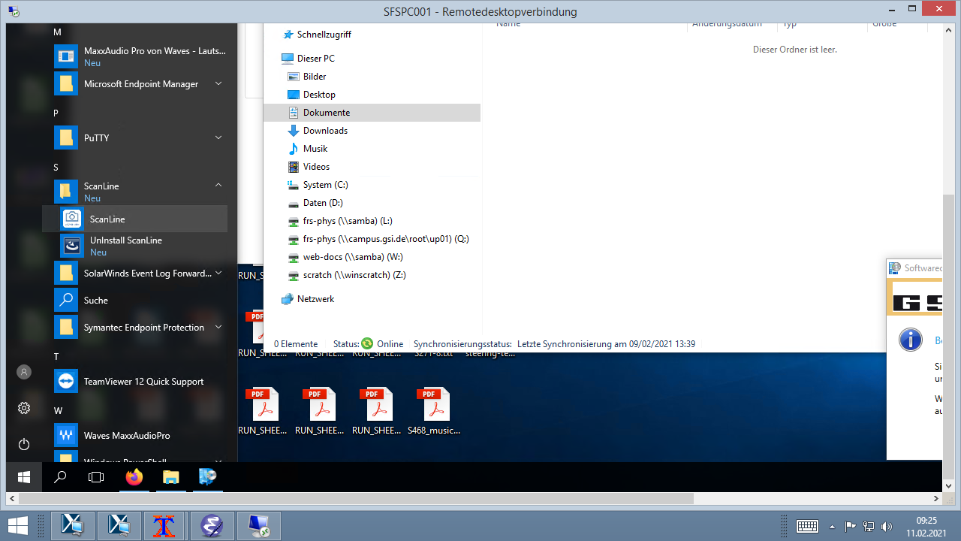The paper log-book can be scanned by the document camera placed next to the phone. This camera is connected to the PC SFSPC001. This PC can be accessed via a remote desktop connection with the frs-phys account.

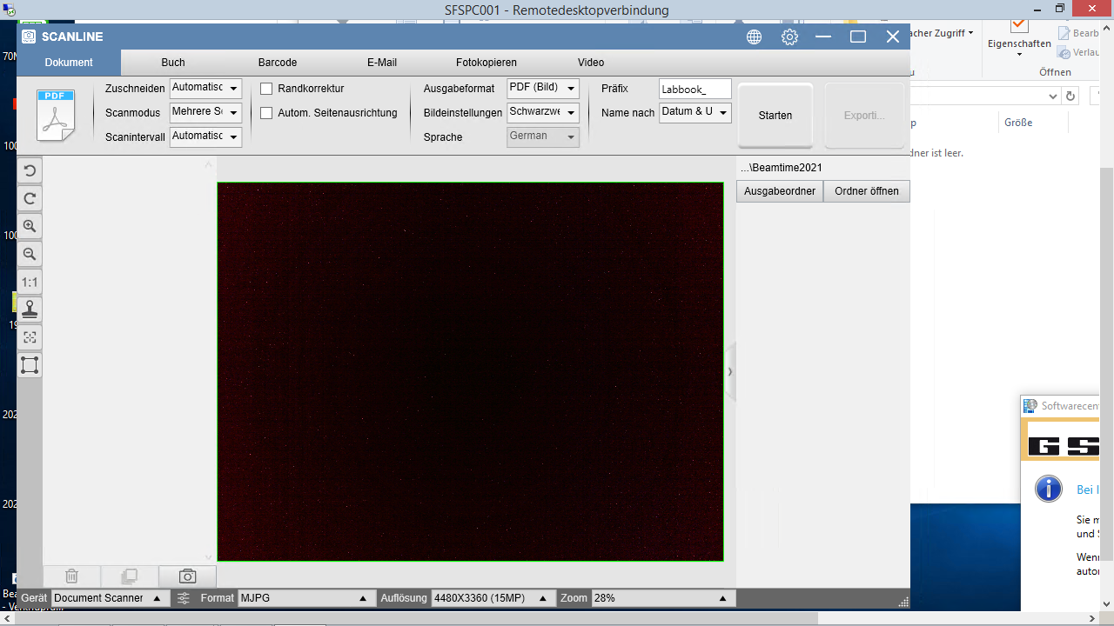On the PC the software ScanLine is installed. It can be found in the start menu. The software is currently in German and I was not able to change it.

After a start of the software the “*Präfix*” and the “*Name nach*” should be changed to “*Labbook_*” and “*Datum und Uhrzeit*”. The “*Ausgabeformat*” should be “*PDF (Bild)*” and the “*Bildeinstellung*” should be “*Farbe (orginal)*”.

The files will be saved in the folder:

*\\campus.gsi.de\root\up01\frs-phys\Documents\Beamtime2021\Scan_Document_Camera*

This folder can be chosen in “*Ausgabeordner*”.

To scan a document one has to press first “*Starten*”, this will start the scan and you will see a count down. The scan can be as well started by pressing the button next to the camera. Afterwards press “*Anhalten*”, this will finish the scan. In order to save the file press “*Exportieren*”.

The scans should be uploaded to “*seafile*”. I could not change my language settings to English.

For this open a browser and use the upload link with the frs-phys (weblogin) password.

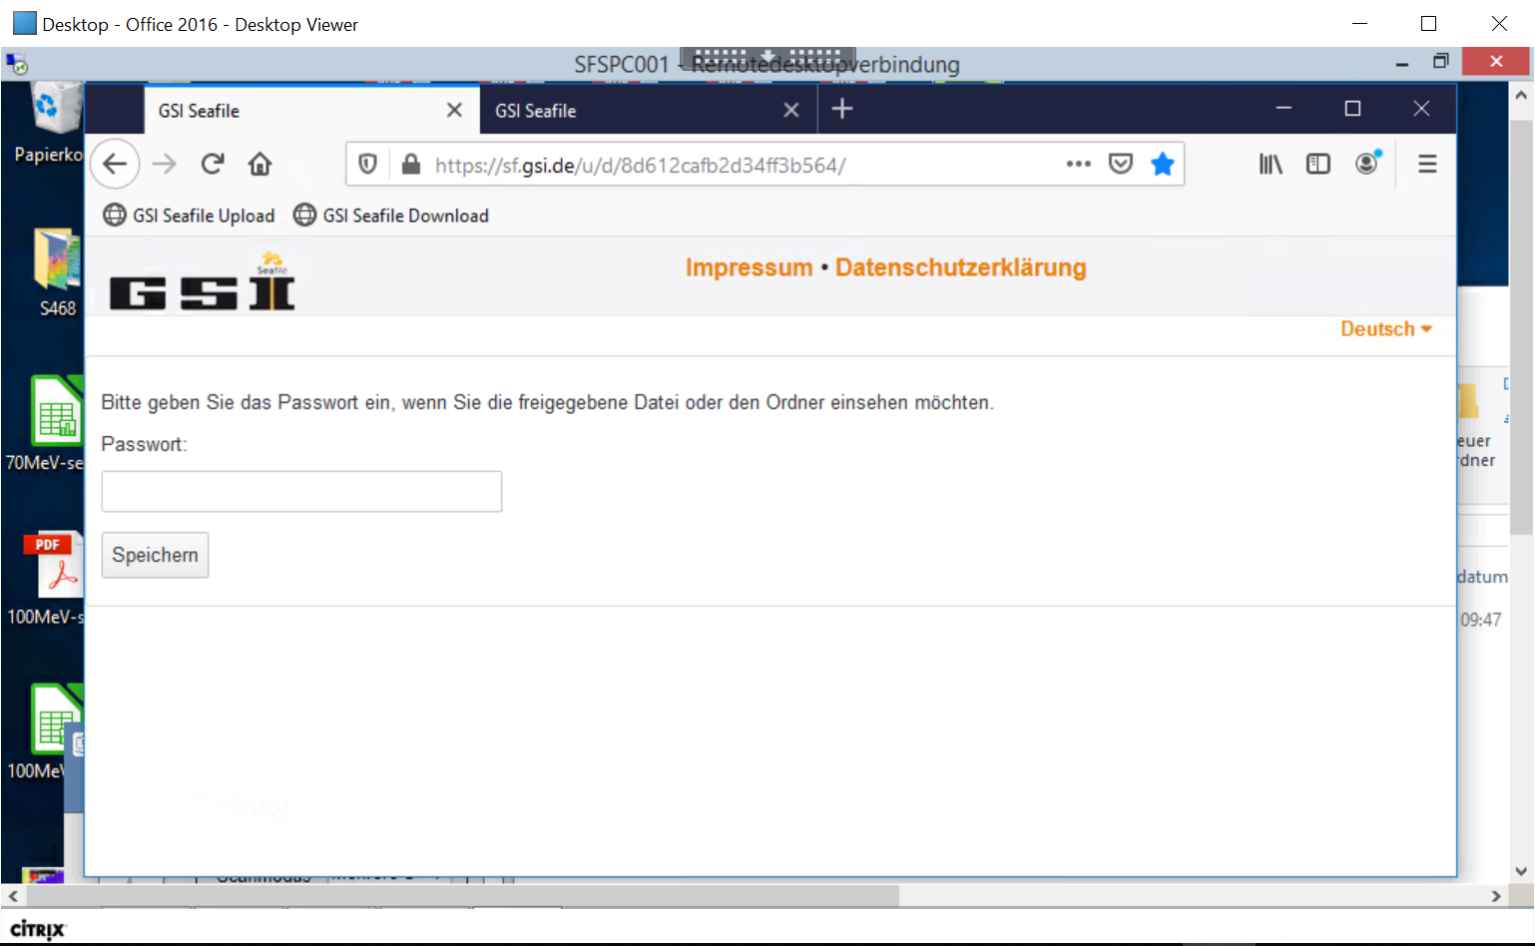Upload link: [*https://sf.gsi.de/u/d/8d612cafb2d34ff3b564/*](https://sf.gsi.de/u/d/8d612cafb2d34ff3b564/)

With “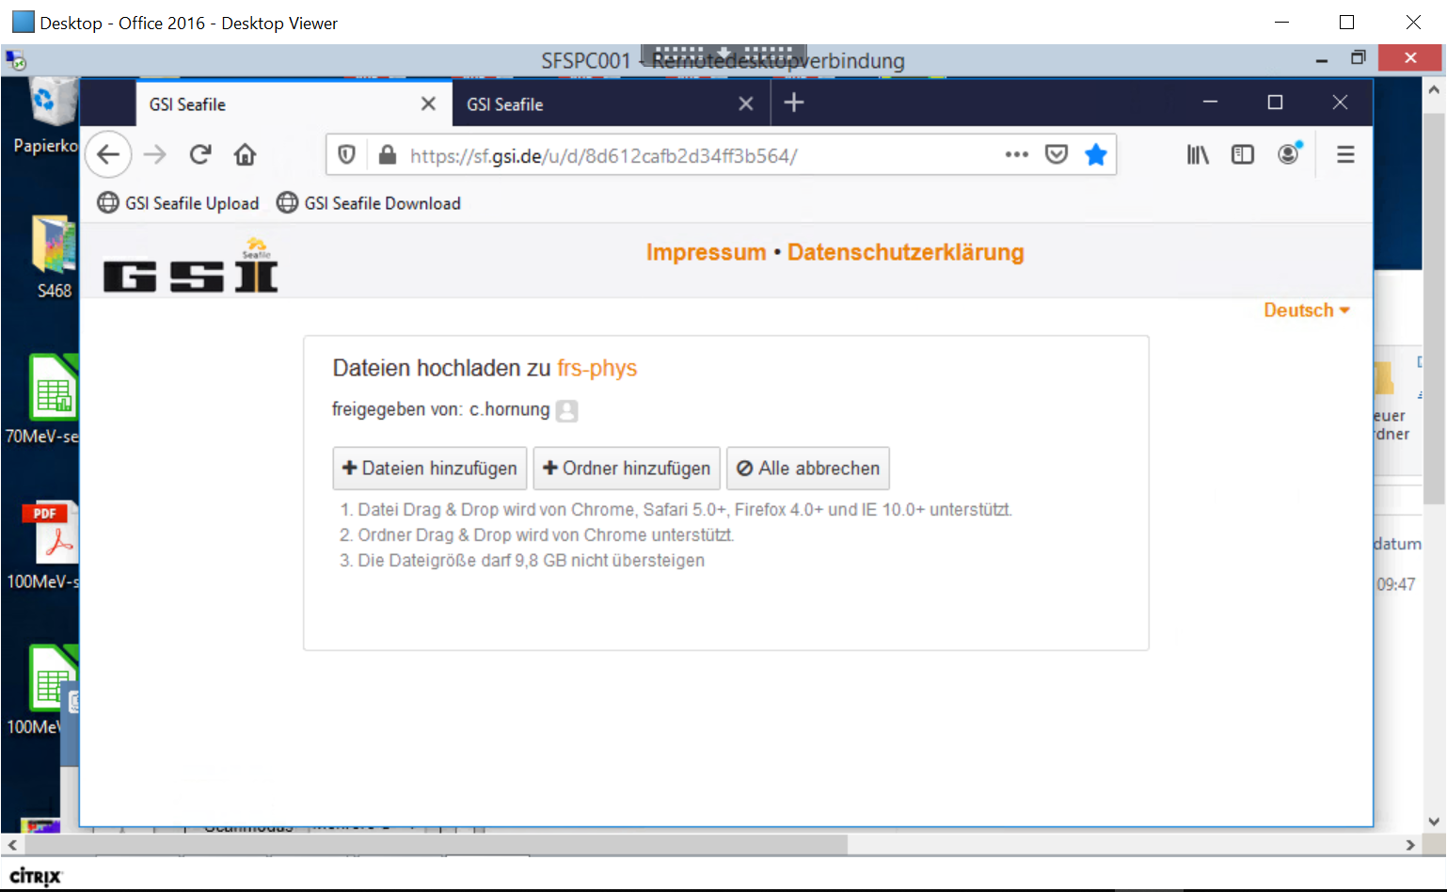Dateien hinzufügen” the new scan can be added. It works as well with drag&drop.

The files on “seafile” can be accessed via a download link in the browser with the Download password. This link and the password can be shared will all participants and collaborators in an experiment.

Download link: https://sf.gsi.de/d/f5457c501f6a4780adaf/